BSSS Student Profiles Online Help

Table of Contents
Purpose 1
Accessing BSSS Student Profiles Online 2
ACT government college students 2
Non-government college students 2
Trouble-shooting access 3
Personal Details 4
Unit Outlines and Assessment Items 4
Academic Record 5
Assessment Item (AI) Results 5
T Units 6
Other Units 6
Unit Results 7
T Units 7
Other Units 8
Course Results 8
VET Progress 9
Tertiary Entrance Statement (TES) 9
Further Questions 9

Purpose
This website is for ACT year 11 and 12 students. It allows them to view the following from any location, using secure authentication:
- personal details
- academic record, including current enrolments
- assessment item results for ‘published’ assessment items
- unit results for completed units
- course results for completed courses (For Year 12 Students)
- Vocational Education and Training (VET) qualifications being done through the school system.
- Tertiary Entrance Statement (TES) for students who have completed a T package, once ATARs are available

Accessing BSSS Student Profiles Online
The way in which you gain access to Student Profiles Online is different depending on whether you are enrolled at an ACT government college or at a Non-government (Catholic, Independent or Overseas) college.

ACT government college students
- Open any browser and go to the URL: https://student-profiles-sso.ed.act.edu.au/
- If you are using a computer at college when you do this, it will log you in automatically.
- If you are not using a computer at college, you will get a login screen. Login with your Student ID and the same password you use at college.
- For example: Logon: 9876543
Password: XXXXXXXXXX

You will then see a screen like:
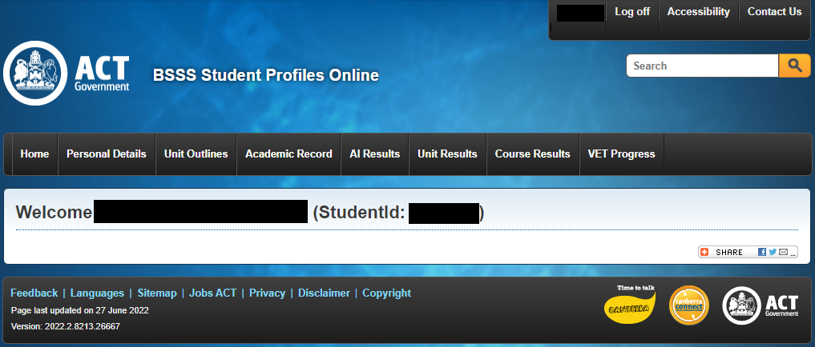

Select ‘Personal details’, ‘Unit Outlines’, ‘Academic record’, ‘Unit Results’, ‘AI Results’, ‘Unit Results’, ‘Course Results’, ‘VET Progress’, or ‘TES’ (after ATARs have been published) to view your information.

Non-government college students
Open any browser and go to the URL: https://student-profiles.ed.act.edu.au/
You will need to register their accounts by clicking on the “Register” hyperlink as shown in the image below.
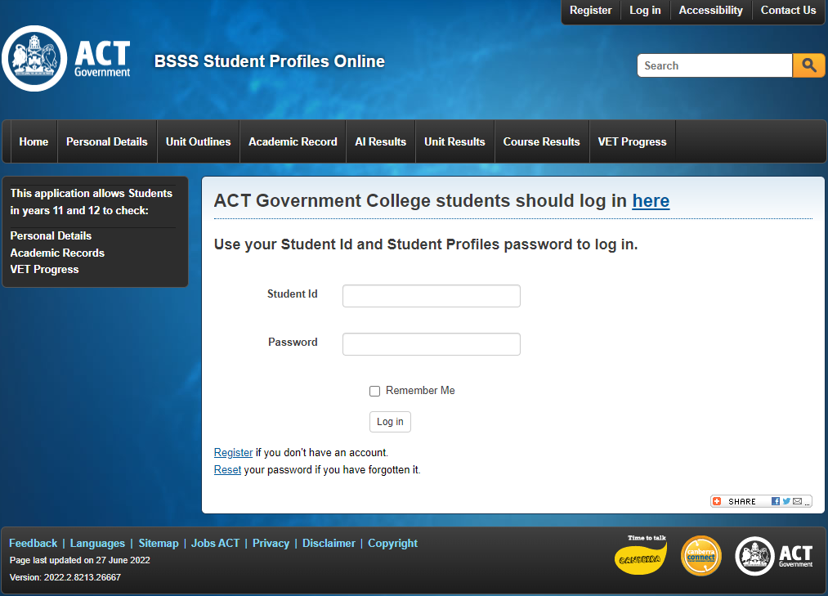

You will then see the following screen, which requires you to enter your 7 digit BSSS student ID number and date of birth. A unique password will then be sent to the email address that was registered by the school for you.
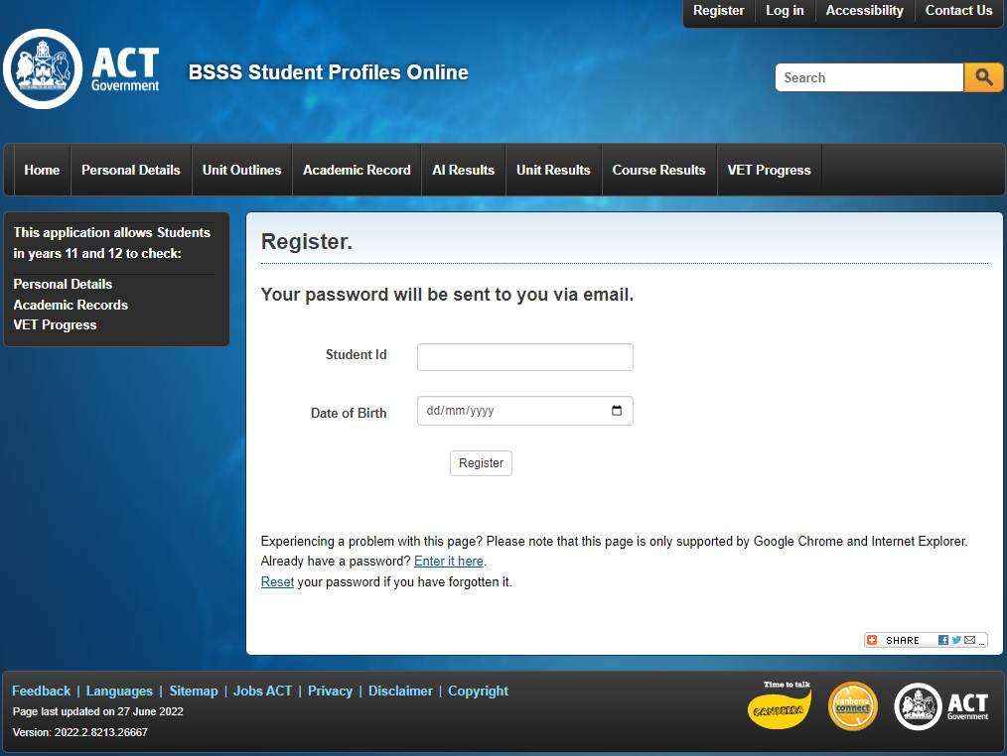

Once the email is received you can log on to this website (using this password and your 7-digit BSSS student id) and view your personal details, academic record, unit or course results or VET record.

If you ever forget your password, you can request a new password be issued online by clicking the ‘Reset’ hyperlink. An email will be sent to your email address registered with your school with a link. Clicking on this link will trigger an email to be sent with a new password.

Trouble-shooting access
- If you see an error like the following, first verify that you have attempted access using the correct links, as provided above for the type of school that you attend.
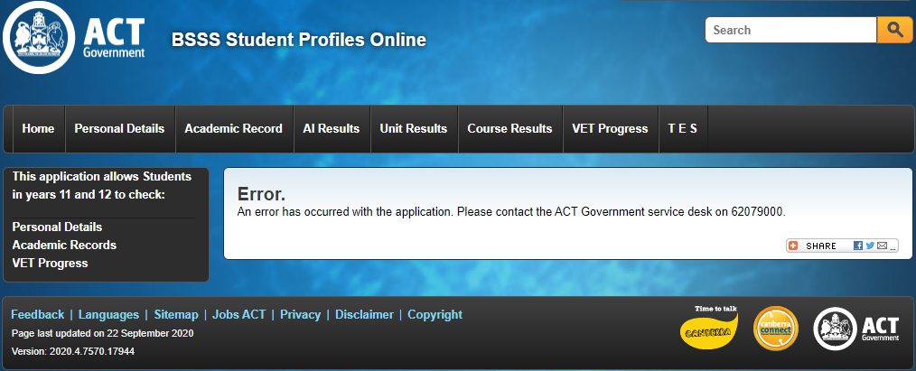
- If you receive an error when registering, check that your browser is supported (note that Safari is not supported for registration purposes).
- If you are attempting to access the link for ACT government college students and are unable to access, visit https://backpack.ed.act.edu.au/ and reset your schoolsnet password.
- If the system tells you that a registration or password reset email has been sent and you have not received it
  - If using Safari, try another browser
  - If using an iOS device, try another device
  - Check your spam filter
  - If using a school email address without access to a spam filter, contact your school’s IT help desk to see if the emails are being blocked. Emails are sent from StudentProfile-Prod@ed.act.edu.au.

Personal Details
Your basic personal details are listed here, including your name, DOB, Sex and contact details. If these details need updating or corrections, please contact student administration at your school.

Unit Outlines and Assessment Items
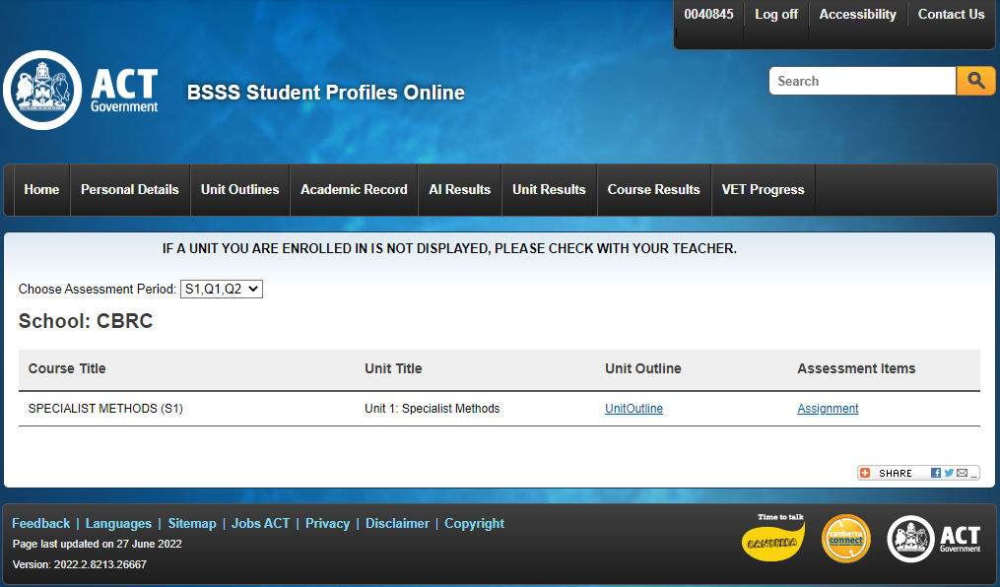
On this tab, you will see a screen similar to what is displayed below.
Once a Unit Outline or Assessment Item has been published by your teacher, a link will appear on this page. Click on the link to access the document.
If a unit you are enrolled in is not displayed in the list, contact the teacher of that class.

Academic Record
On this tab you will see a screen similar to what is displayed below. All current and past unit enrolments will be listed, along with your results in those units and a course score (if you are in Year 12) calculated from the units completed. Click the link at the upper right to view a pdf of your academic record.
If any information is incorrect or missing, please contact student administration at your school.
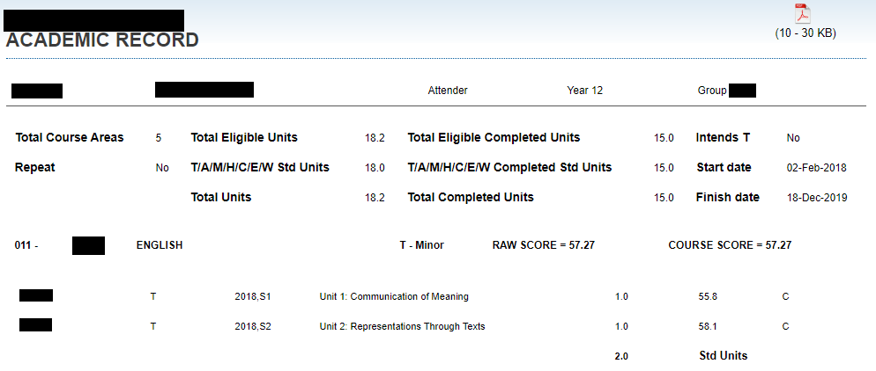

Assessment Item (AI) Results
On this tab you will see your results of any ‘published’ assessment items for the current assessment period. Once assessment items for a given assessment period have been published, you will see a screen like this:
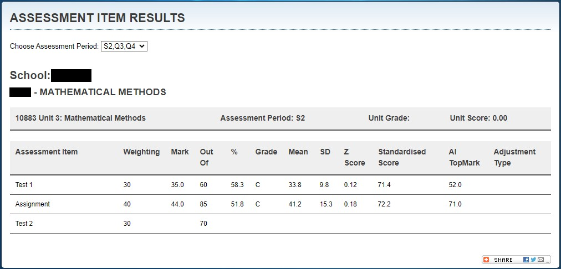
You can also access AI results from a previous assessment period in the same year or from the previous year. For the current assessment period, your teachers should notify you when your results have been published. At the beginning of the semester, you may see a message that no results were found. Unpublished assessment item results will appear as blank. In this example, the first two assessment item results have been published, while the third has not.

T Units
For each published assessment item result, you will see:
- The assessment item weighting
- Your raw mark
- The maximum attainable marks on the assessment item (the ‘Out of’)
- Your mark as a percentage
- Your grade for the assessment task if your teacher has chosen to provide one.
- Any adjustments (e.g. Late) to your score.
Where there are more than five students that have completed this assessment item, you will also see:
- The mean raw mark for the assessment item
- The raw standard deviation for the assessment item
- Your Z-score (how many standard deviations your raw score is away from the mean)
- Standardised score if your school is utilising this feature. The standardised score is a number that is meant to be comparable across assessment items and subjects.
- The top mark achieved on this assessment item

Other Units
For each published assessment item result, you will see:
- Either a mark, a grade, or both, depending on your school and teacher.
- Any adjustments (e.g. Late) to your result.
Where you have been given a raw mark, you will also see:
- The maximum attainable marks on the assessment item (the ‘Out of’)
- Your mark as a percentage
Where there are also more than five students that have completed this assessment item and your teacher has given you a raw mark, you will also see:
- The mean raw mark for the assessment item
- The raw standard deviation for the assessment item
- Your Z-score (how many standard deviations your raw score is away from the mean)
- The top mark achieved on this assessment item

Unit Results
On this tab you will see your results and scaling group information for units you have completed this year. When results have not yet been finalised for an assessment period, you will see a screen like this:
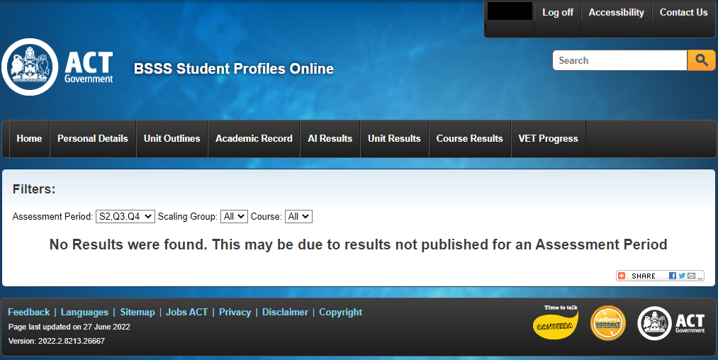
Your school will notify you when results have been published to Profiles Online for a given assessment period.
You can filter what appears on this page by Assessment Period, Scaling Group and Course. The system defaults to ‘S1, Q1, Q2’ Assessment Period. Use the drop-down menu to select a different assessment period. Note that some schools may use different assessment periods. Do not filter on ‘Q1’ or ‘Q4’ unless your school uses the ‘M2’ assessment period.

T Units
Once results have been published for the assessment period, results for Tertiary (T) units will appear as below.
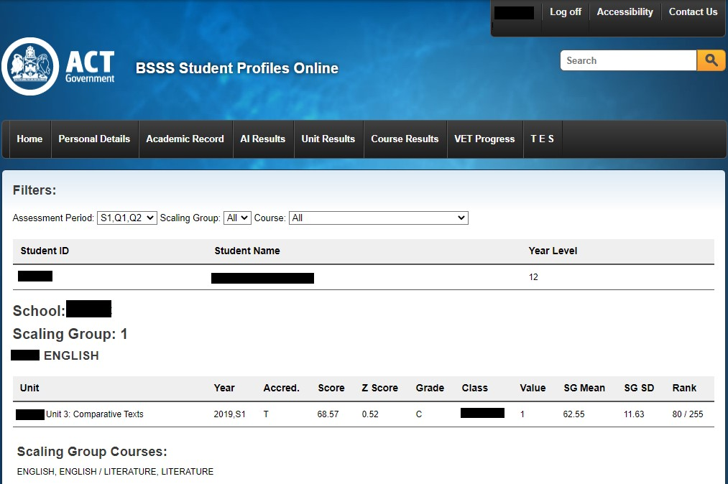
Please note that your score, Z Score and Rank are calculated by Scaling Group, which may include many courses or only one, depending on the school and Scaling Group. The courses in the scaling group at your school are listed below the Scaling Group Courses heading.

Other Units
Once results for a given assessment period have been published, results for non-Tertiary units will appear as below.
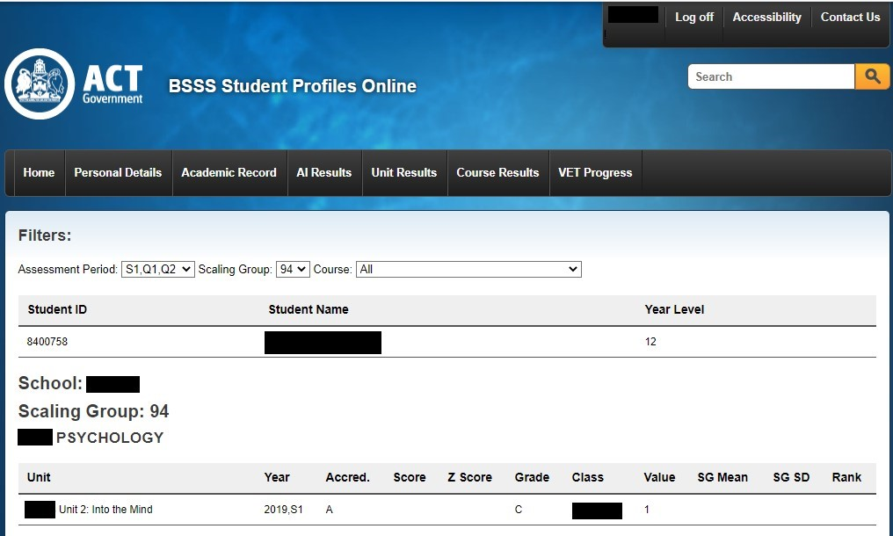
Note that all non-T units will be listed in Scaling Group 94 or 95. For these, the Score, Z Score and Rank fields will be blank, as will the SG Mean and SG SD.

Course Results
Once all Assessment Period results have been published, Year 12 Students will see a screen similar to what is displayed below on the Course Results tab
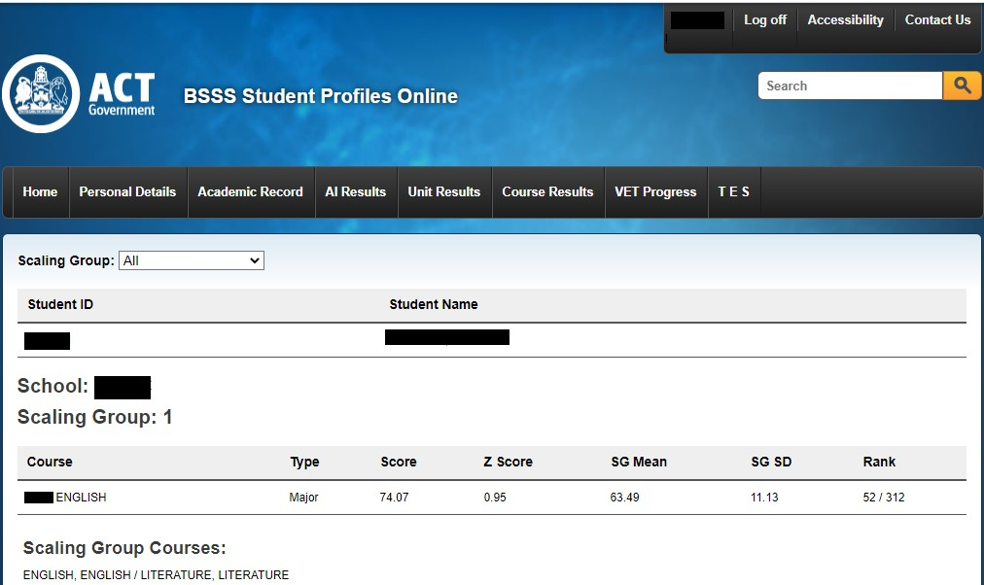
You may filter on Scaling Group. Note that, as for unit results, the Score, Z Score and Rank are by scaling group, not by course and that only Tertiary Course results are displayed.

VET Progress
The VET Progress screen displays progress against VET Qualifications you have enrolled in. Choose a Qualification from the drop-down menu. You will see a summary bar at the top showing the proportion of competencies that have been achieved. Further information about the status of individual competencies is also displayed.

Tertiary Entrance Statement (TES)
At the end of Year 12, once ATARS have been published, Tertiary students who have successfully completed their package will see a new tab called TES, similar to what is displayed below. At all other times, this tab will not appear. This is not intended to replace the certificate you will be given, but allows you the option to access this information as soon as it has been published.
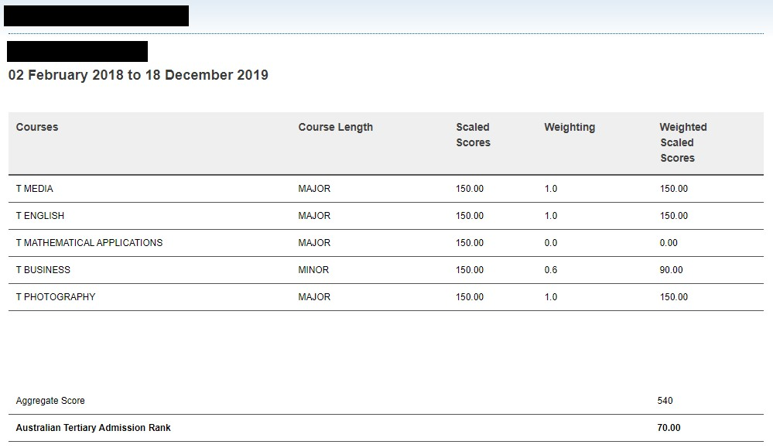
For each Tertiary course that has been completed, you will see a scaled score, its contribution to your aggregate score. At the bottom of the screen you will see your aggregate score and Australian Tertiary Admission Rank (ATAR).

Further Questions
If you have any questions about the content or the information provided on the website, please contact the Assessment Co-ordinator at your college.

Feedback: Please forward suggestions or any problems regarding this system to
BSSSCertification@ed.act.edu.au

Note that Safari is not supported for registering or password resets.

