End of Year Processes

in the ACT Certification System (ACS)

October 2014



Contents

End of Year (EOY) Processing 3

CLD/ Intends T 4

Edit Culturally and Linguistically Diverse Background (CLD) 4

Edit Intends T 5

Enrolment Dates 6

Course Types 7

Set Flags for Certification 8

The ‘On Track’ Flag 8

Certification Check 8

Calculate Course Scores 9

# End of Year (EOY) Processing

The BSSS certification system has been designed so that colleges can ensure that their data meets the BSSS requirements for EOY processing. In ensuring that your data meets the BSSS requirements for EOY processing, the following documents must be referenced:

*Policy and Procedures Manual*

*College Certification Handbook*

*General Schedule*

Only users with access levels of Edit, Transfer or User Control will be able to use the EOY Processes menu options.

Under the **EOY Processes** menu are the main processes for EOY. Some reports that assist in your EOY processing are under **Reports - College** and are explained in detail in **8. Reports**.

# 

# CLD/ Intends T

Editing the CLD and Intends T flags for students are edited from this screen.

## Edit Culturally and Linguistically Diverse Background (CLD)

Students are flagged in the BSSS database as being from a CLD solely for the purpose of sitting AST. If a student does not intend to sit AST then they are not to be flagged as CLD. **In determining which students to flag as CLD please refer to the *Policy and Procedures Manual* section 6.5.7.2.**

* From the menu click on **CLD/Intends T**  and the following screen appears.



* **Closing date** Each year the date by which students from the graduating cohort need to be flagged as CLD is published in the General Schedule. This date will appear on the home page of this application and appears on the screen as shown below

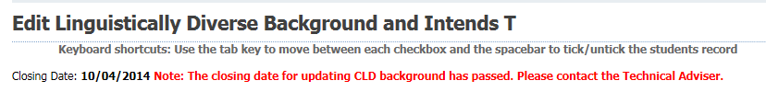

**Note:** that in this instance there is a message indicating that the date for flagging students as CLD has passed. In this case the CLD flag cannot be edited.

* To flag students as CLD, filter the data and then click in the check boxes next to the Student Id as shown below. All ticked student will have a gold background

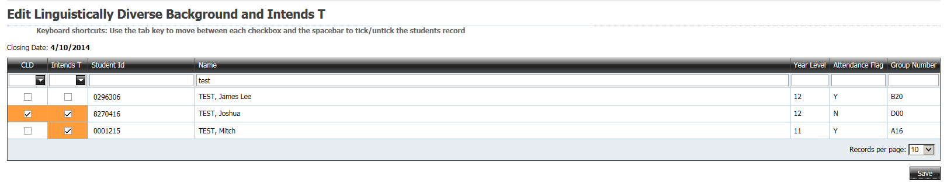

* Click on the **Save** button at the bottom of the screen
* The following message will appear at the top of the screen

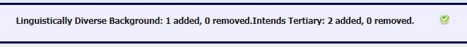

## Edit Intends T

* From the menu click on **CLD/Intends T**  and the following screen appears



* As explained above in 11.1 Edit Linguistically Diverse student records in this screen can be sorted and filtered.
* To flag students as Intends T, filter the data and then click in the check boxes next to the Student id.
* Click **Save** to update the data.

# 

# Enrolment Dates

The enrolment dates for students are set automatically using the unit studied data. The start date comes from the first unit studied record and the end date from the last unit studied record for the student. These dates are important as they are printed on the ACT Year 12 Certificate and Tertiary Entrance Statement.

The Update Enrolment Dates needs to be run as part of your EOY processes. The dates are displayed on Academic Record reports and at the bottom on the **Student Details** screen.

* From the menu click on **Update Enrolment Dates** and the following screen appears

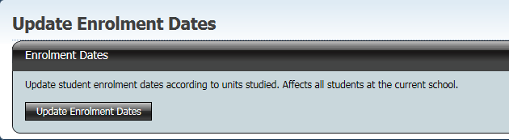

* Click on the button **Update Enrolment Dates** and the following screen appears



**NOTE:**

If a student has had their enrolment dates fixed (using Student Details screen) then this procedure will not overwrite their dates.

# 

# Course Types

This process sets the course types (minor, major, major-minor, double major). Course types must be set before course scores are calculated as the calculation of a course score depends on the course type. Course types are automatically set in the **Units and Courses** screen when units are moved, grades changed etc

In the menu click on **Change Course Type** and the following screen appears

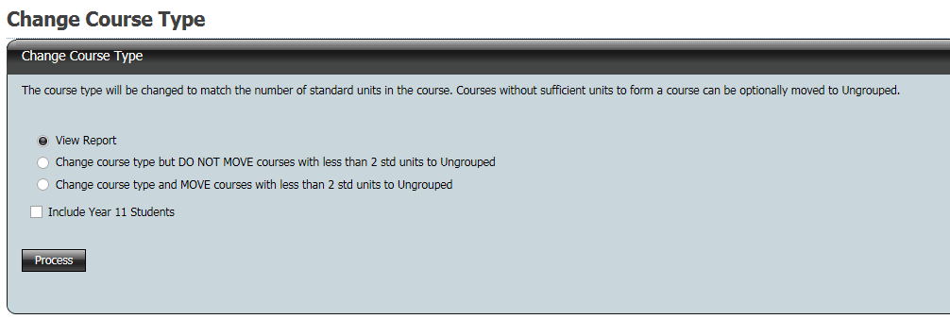

There are four options

* **View Report** - This lists the errors in the data
* **Change Course Type but DO NOT MOVE courses with less than 2 std units to Ungrouped.** This will update the database with the correct course type for all students
* **Change Course Type and MOVE courses with less than 2 std units to Ungrouped**. This will update the database with the correct course type for all students and move the units that do not form a course to Ungrouped
* **Include Year 11 students**

**NOTE:**

If option 3 is run before you have had the S2/Q4 sweep turned off, all current assessment period units that are moved will be duplicated.

* Click in the radio button next to the option you wish to run
* To include year 11 students click the check box
* Click on the **Process** button
* A PDF report will be displayed on the screen which can be printed
* If a course type has been fixed in the **Units and Course** screen, running this process will not change the course type

# 

# Set Flags for Certification

This process will set the ‘On Track’ and Certification flags for the graduating cohort. Before the Certification Check can be meaningfully run, you need to have run **Set Course Types** and **Calculated Course Scores.**

The ‘On Track’ and Certification Check processes can be run in an individual mode in the **Student Details** screen and the **Units and Courses** screen. During EOY processing time, every time you change a record(s) this process should be run individually or for the whole cohort.

The earlier scaling of AST in November uses the flags that are set in the ‘On Track’ process. This early scaling of AST is used for a comparison with last year’s AST results. Details of this comparison are given to each principal. The more accurate your data the more reliable the comparison.

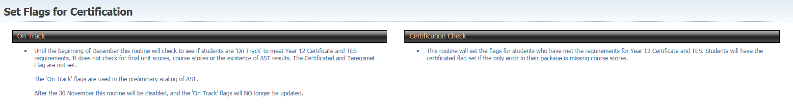

## The ‘On Track’ Flag

The On Track Flag indicates that a student is on track to meet the requirements for a Year 12 Certificate and Tertiary Entrance Statement. It does not take into account missing final assessment period grades and scores, missing course scores and missing AST results.

After 30 November the ‘On Track’ report will be disabled. From this date, a student’s ‘On Track for Year 12’ and ‘On Track for TES’ flags will not be updated.

## Certification Check

This routine will set the flags for students who have met the requirements for the Year 12 Certificate and TES. Students will have the certificate flag set if the only error in their package is missing course scores.

# 

# Calculate Course Scores

This process will calculate or zero course scores. In calculating the course scores, the course type is used. The course type must be correct otherwise the course score will be incorrect for that course. Course scores need to be calculated before the Certification flags can be set. (On Track does not check for course scores)

The calculated course score is written to the raw course score field and is displayed in the **Units and Courses** screen. The 80% field cannot be changed by any of the college processes. This field stores the course score based on the 80% rule. For the majority of students the data in the raw course score field and the 80% course score field are the same. The values in the raw course score field and the 80% course score field will differ if the course score has been manually fixed or when a course score has been rescaled through the Course Score option.

* In the menu click on the **Calculate Course Scores** and the following screen appears

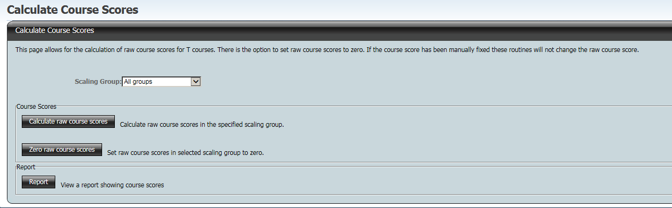

* Select an individual scaling group or all (scaling groups) from the drop down box
* Click on the **Calculate course score** button and the following screen appears

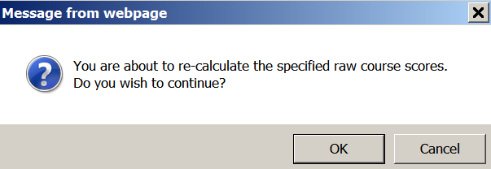

* Click OK and then following message appears at the top of the screen

Message reads " Course scores calculated successfully"

* If a course score has been fixed in the **Units and Course** screen, running this process will not change the course score
* Click on the **Zero course scores** button and the following screen appears

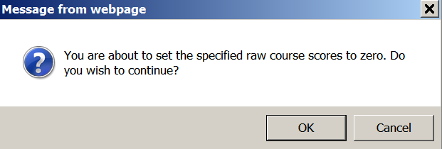

* Click OK and then following message appears at the top of the screen

Message reads "Final course scores successfully set to zero"

* If a course score has been fixed in the **Units and Course** screen, running this process **will** setthe course score to zero
* Click the **Report** button to display the report as a PDF which can be printed

**NOTE:**

If a course score has been fixed and you run the **Zero course score** option and then run the **Calculate course score** option the **course score will be zero.**

Running **Zero course score** option zeroes all course scores.

Running **Calculate course scores** calculates all course scores provided they are not fixed.