MESHING: Part 1 Video Transcript



Welcome
This BSSS presentation on Meshing is the first that will take you through the basics of meshing courses together which are in the same scaling group. By understanding the elements of successfully meshing courses, it is possible to get accurate ranking lists at the end of the semester.

Grades and Scores

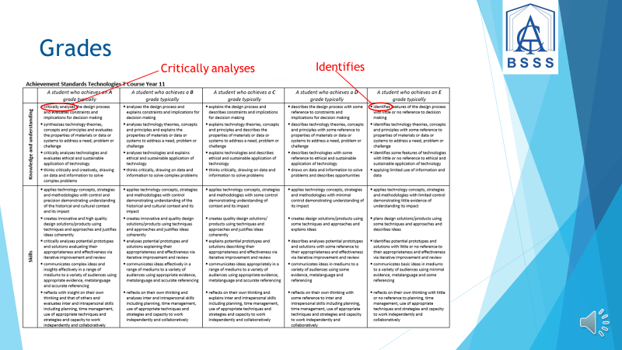

Grades
What is the difference between grades and scores and what relationship do they have with each other?

A grade is awarded to show what level the student has achieved and is linked to the Achievement Standards for that subject. It is an absolute.
An A student exhibits the quality of thinking outlined for an A student, a B student exhibits what is outlined for a B, et cetera. An A grade student will be ‘critically analysing’. An E grade student will be ‘identifying’.



Scores/Marks
The score or mark a Tertiary student receives is an indication of their ranking in the scaling group list. It is a relative score. There is no causal relationship between scores and grades.



To Remember
Remember, having an accurate ranking of student scores for each assessment item that reflects their achievement in what they can do, say or make, is the basis for accurate meshing.
It is important that teachers do not clump student scores together unless the students are of similar performance level. Students who are much higher performing than others should have significantly different scores and be on top of the list.

Meshing
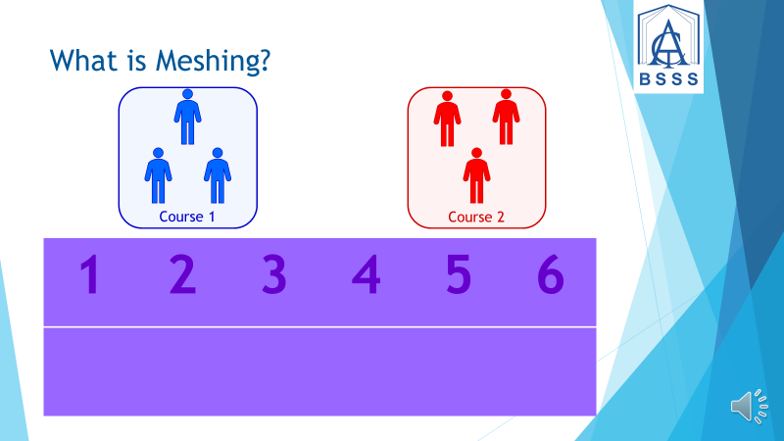

What is Meshing?
Meshing is the process whereby students are allocated their position in the whole scaling group ranking each semester and thereby ending up with all courses meshed together into one group at the end of Year 12. This ranking is used in the calculation of the ATAR so it is important to get it right. Courses in the same scaling group need to have quality assessment items that are equivalent in difficulty across all the courses, so they can be compared.

Steps in the Meshing Process



Step 1: Be Deliberate
Start early and be deliberate. Collaborate with teachers in the subjects that will be meshing their results with yours at the end of the semester. At the start of the assessment period, get together and discuss what types of assessments are being delivered, what points of commonality there are and how you intend to ensure that ranking generates correct results across your courses. Your group should also discuss and establish unit outlines and assessment tasks before delivery to ensure that accurate meshing occurs. Assessment tasks must be similar in their cognitive difficulty. Teachers must ensure that the rigor and approaches to assessment tasks are comparable.

Step 2: Ranking Students
Rank your students. Determine the assessment items for each course by checking assessment and Achievement Standards requirements in the Frameworks involved. Use the same number, type and weightings for assessment items where feasible. Collaboratively establish common agreed criteria for marking student work and develop assessment items and marking schemes or solutions informed by the Achievement Standards.

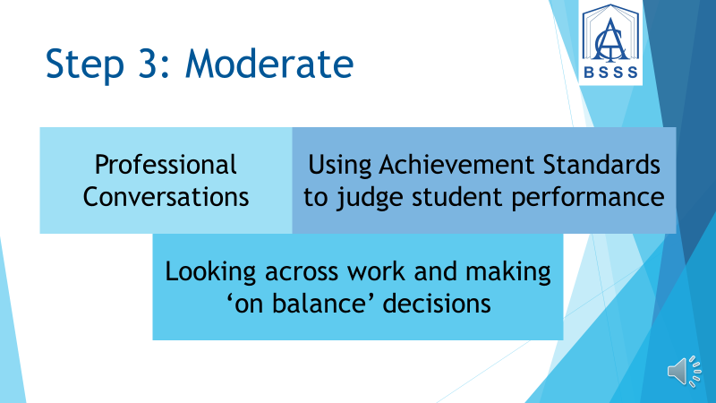

Step 3: Moderate
Moderate your assessment items. This involves having professional conversations, using the Achievement Standards to guide judgements and looking across work to make ‘on balance’ decisions. Compare student work to ensure the ranking is accurate across all the courses involved. Have a common task across your courses which can be moderated collectively.

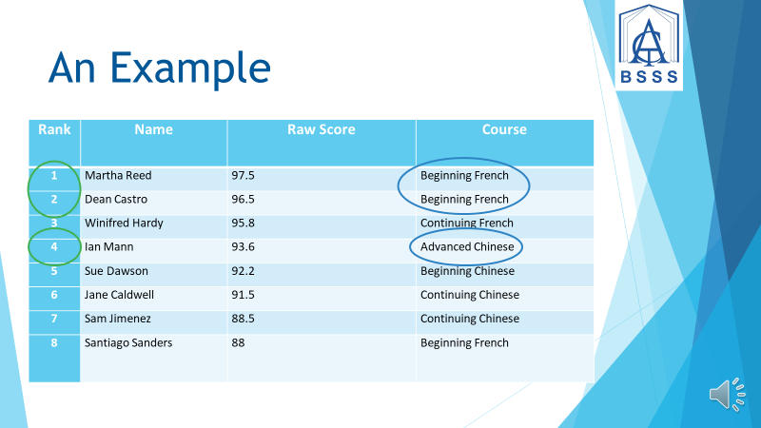

An Example
For example, these languages are grouped in the same scaling group. Look at how the ranking is achieved. The Beginning French students are at the top of the ranking. Their work must be cognitively the same for them as the Advanced Chinese student who is 4th. Marks between the Beginning French, Continuing French and Advanced Chinese students must have been compared to develop this rank order.



Conclusion
Thank you for watching Part 1 of the presentation on Meshing. Watch Part 2 of the BSSS training videos to see more about meshing, both with courses in the same markbook and courses not in the same markbook.
This is a video completed by the Office of the Board of Senior Secondary Studies.

