MESHING: Part 2 Video Transcript



Welcome
This is part 2 of a BSSS presentation about meshing which will take you through the basics of meshing courses together which are in the same scaling group. Part 1 focused on the difference between scores and grades and the steps in the meshing process. Part 2 will focus on courses in the same markbook and courses in different markbooks. By understanding the elements of successfully meshing courses, it is possible to get accurate ranking lists at the end of the semester.

Courses in the Same Markbook
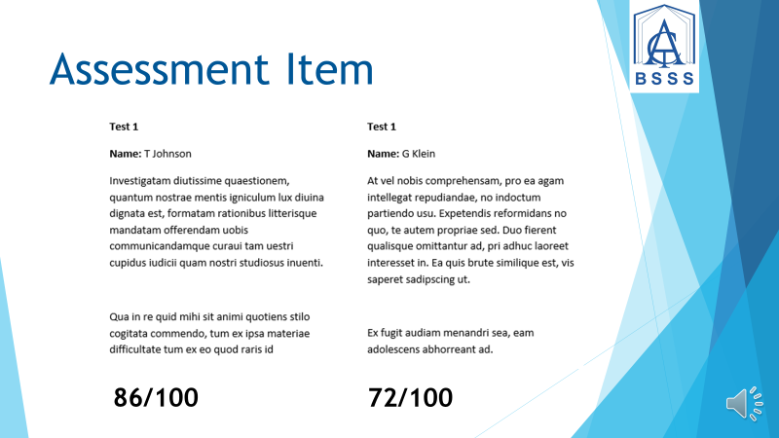

Assessment Item
For courses which share the same markbook, mesh firstly at the assessment item level by moderating and comparing students’ work. Enter all scores, in markbooks, as a number out of 100 to make comparisons easier. Ensure comparable results in each assessment item across courses.



Moderate
Moderate the students’ work across the courses. Student raw scores may need to be changed if two students of similar performance have gained significantly different results. Consult with OBSSS if this becomes necessary. Meshing at the assessment item level ensures that unit scores are generated with the correct rank order of students.

Courses that are not in the Same Markbook

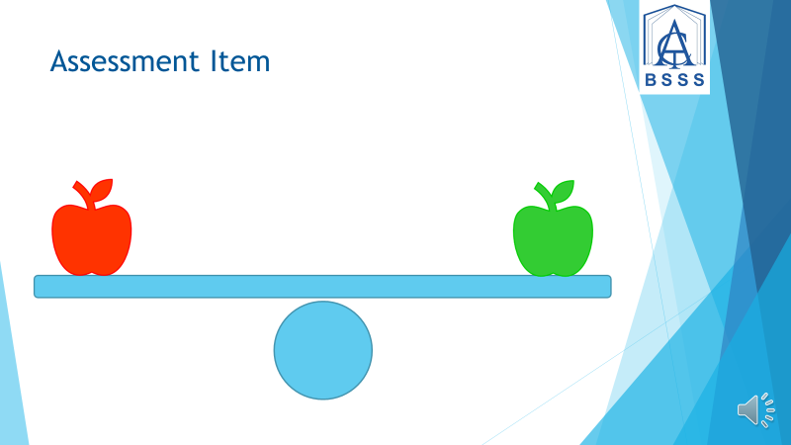

Assessment Item
For courses that are not in the same markbook, follow the same steps as before by meshing at the assessment item level and moderating your work. Find a common scale to mark your student work on. In order to moderate two courses together you can look at: common questions, common students’ marks, common teachers and assessment items.

Draw on Evidence
Draw on evidence, based on prior performance. A variety of data sets may be used such as common testing or trial AST to determine rank. Remember the ranking and the gap between students is important.
In cases of insufficient moderation where the rank order is incorrect after meshing then the school Certification Officer may intervene to adjust the historical parameters in individual courses to ensure that the rank order ends up correct.

Test Your Understanding

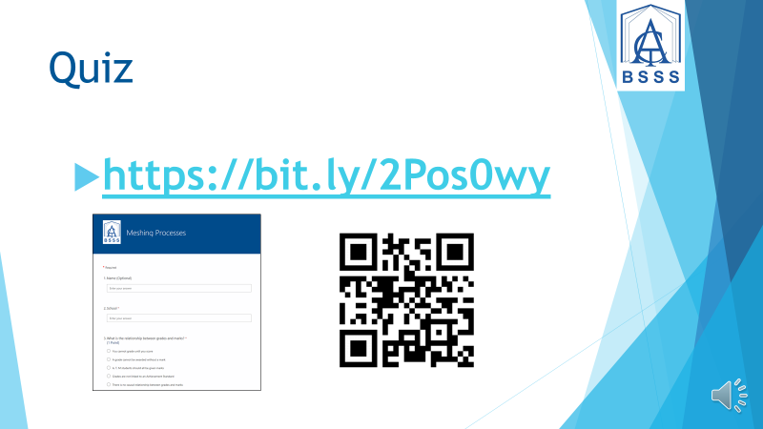

Quiz

In order to see how your understanding of meshing is progressing, take our short quiz. You can access it with this link: https://bit.ly/2Pos0wy

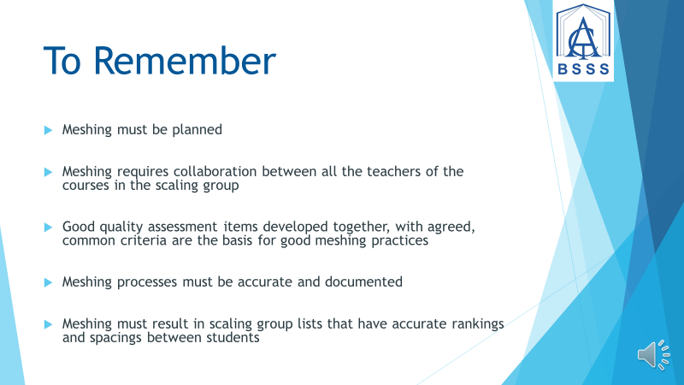

To Remember
Remember:
- Meshing must be planned
- Meshing requires collaboration between all the teachers of the courses in the scaling group
- Good quality assessment items developed together, with agreed, common criteria are the basis for good meshing practices
- Meshing processes must be accurate and documented
- Meshing must result in scaling group lists that have accurate rankings and spacings between students

More Information
Thank you for watching the BSSS Meshing films. If you have any other questions about meshing, you can find information by going to the BSSS website and following the Information For Teachers tab to the Meshing page where there is located a detailed guide to Best Practice in Meshing.



Conclusion
This is a video completed by the Office of the Board of Senior Secondary Studies.

