Below is the checklist information used by BSSS staff to complete Pre-Moderation checks on all school Moderation Presentations prior to Moderation Day.
Notes for use:
This template has been provided for schools to utilise in their own internal quality assurance processes.
The Office of the BSSS will undertake an independent assessment using this template of each presentation submitted which informs the moderation review criterion Provision of Materials.
- This checklist was designed for BSSS staff to check presentations to be able to provide the missing information on a Technical Report. Schools might want to change it so:
  - a checker at your school is marking a box where they have found a requirement to be included and can provide more support to get the presentations ‘complete’ before being submitted.
  - it aligns with your school processes relating to where documents are saved and how you could check ACS info which may not yet have been recorded etc.
- This checklist is for individual presentations, not the overall school submission. Resources are in ACS and on the BSSS website:
  - Moderation Requirements document
  - Missing Course Presentations Report (Reports > Moderation > Missing Course Presentations)
  - Presentation status needs to be ‘Submitted For Approval’. (Moderation > Moderation Presentations, check the status).
Technical Report: Pre-moderation checking form

Introduction | Enter details/comments
Checker name/s | Enter name or initials of checker.
Select the Course Presentation you are checking.  Ensure this is the correct Course AND Accreditation type (A/T etc). | Enter the full Course name and accreditation classification (as recorded in ACS).
PREPARE FOR CHECKING
Dropbox:
- Open the relevant College folder
- Open the Course folder that you selected in the previous question (ensure correct Accreditation type: T/A/C etc).
ACS:
- Navigate to Moderation > Moderation Presentations
- Find and Open using the Edit function the appropriate presentation from your list created. See below

FOLDER ORGANISATION
Is the folder organisation correct such as in the example shown below?  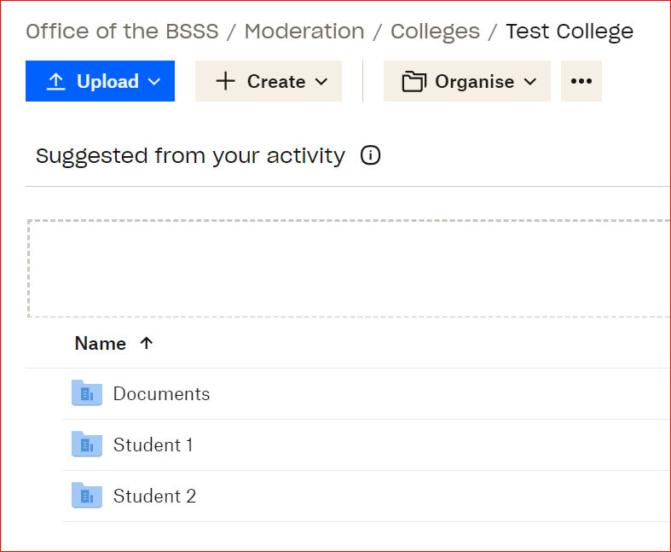 | ☐Yes  ☐No (complete cells below)
Complete this question if answered ‘No’ above:  Folder organisation incorrect  Provide a description of the issue with the organisation of the folder. Be brief, clear and factual.  Examples include:  - Student work not submitted as separate files  - Folder structure or file labelling not per requirements  - Missing student identification on assessment tasks in student evidence folders | Issue/s identified with the folder organisation:  Enter all issues identified with folder organisation here.

Documents folder
DOCUMENTS folder
Open the 'Unit Outline'

Referring to the 'Unit Outline' check the number and type of Assessment Tasks that should be included. This information is under the Assessment Tasks sub-heading in the document.

Check | Response
Does the 'Documents' folder include all of the required files?  (Example below, this will vary depending on unit requirements)  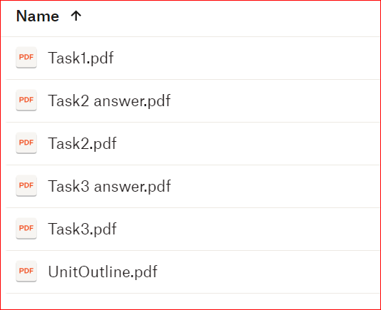 | ☐Yes, all files are included.  ☐No (complete cells below)
Complete this question if answered ‘No’ above:  File/s missing from 'Documents' folder  Note.  Exams or Tests should have answers or solutions included in the task or as a separate document. | 'Documents' folder: Missing files  Tick all that apply.  ☐Assessment task/s Solutions  ☐Unit Outline  ☐Other: Enter any other missing files.
Documents folder:
UNIT OUTLINE
Refer to the 'Unit Outline'
Check each section to ensure that all of the required information is included.

ONLY check a box if the Unit Outline DOES NOT have the detail included. 'Unit Outline' files generated in ACS will include these sections - still check for accuracy.

If all listed items are included, check only the last box: '*ALL REQUIRED INFORMATION IS INCLUDED.
Check | Response
The 'Unit Outline' DOES NOT include: *  Tick all that apply.  ☐ Unit details: Assessment period, Course name, Unit name, Unit Value, Accreditation, Year level  ☐Summary of content  ☐ Assessment Tasks: Due dates, Weightings  ☐ Reference or link to relevant assessment information: meshing, moderation, score calculations, academic integrity, appeals – See BSSS P&P Manual  ☐ Assessment Standards or Assessment Criteria for relevant course (Year level and A/T/M etc)  ☐ C and V Course: VET competencies included are correct. If A-E not used, assessed format is identified. E.g. Ongoing observation  ☐ *ALL REQUIRED INFORMATION IS INCLUDED. | Enter comment if required.
Documents folder:
ASSESSMENT TASKS AND SOLUTIONS
Access the Assessment Task files. Check each section to ensure that all of the required information is included.

ONLY check a box if it is NOT included in the listed Assessment Task file.

Assessment Task 1
Clean copy of the assessment is MISSING the following:

(check the box where this is not evident)

☐Accurate Unit information: Course (including only 1 Accreditation type), Unit name, unit value, Semester and year.  ☐Due date clearly aligns to the Unit Outline (weeks and date range)  ☐ Weight of task matching the Unit Outline.  ☐Instructions to student are clear (In-class tasks must include time allowed).  ☐Blank rubric for non-test/exams: specific to task, specific for A or T (not the Achievement Standards).  ☐ Reference (accessible) BSSS policies relevant to task.  ☐Answers/solutions or marking guide for all questions in tests or exams.  ☐C or V course - all Units of Competency matching those on the Unit Outline.  ☐*ALL REQUIRED INFORMATION IS INCLUDED.  ☐Other: | Enter comment if required.
Assessment Task 2
The file with the clean copy of the assessment is MISSING the following:
(check the box where this is not evident)

☐ Accurate Unit information: Course (including only 1 Accreditation type), Unit name, unit value, Semester and year.  ☐Due date clearly aligns to the Unit Outline (weeks and date range)  ☐ Weight of task matching the Unit Outline.  ☐Instructions to student are clear (In-class tasks must include time allowed).  ☐Blank rubric for non-test/exams: specific to task, specific for A or T (not the Achievement Standards).  ☐ Reference (accessible) BSSS policies relevant to task.  ☐Answers/solutions or marking guide for all questions in tests or exams.  ☐C or V course - all Units of Competency matching those on the Unit Outline.  ☐*ALL REQUIRED INFORMATION IS INCLUDED.  ☐Other: | Enter comment if required.
Assessment Task 3
The file with the clean copy of the assessment is MISSING the following:
(check the box where this is not evident)

☐ Accurate Unit information: Course (including only 1 Accreditation type), Unit name, unit value, Semester and year.  ☐Due date clearly aligns to the Unit Outline (weeks and date range)  ☐ Weight of task matching the Unit Outline.  ☐Instructions to student are clear (In-class tasks must include time allowed).  ☐Blank rubric for non-test/exams: specific to task, specific for A or T (not the Achievement Standards).  ☐ Reference (accessible) BSSS policies relevant to task.  ☐Answers/solutions or marking guide for all questions in tests or exams.  ☐C or V course - all Units of Competency matching those on the Unit Outline.  ☐*ALL REQUIRED INFORMATION IS INCLUDED.  ☐Other: | Enter comment if required.
Assessment Task 4
The file with the clean copy of the assessment is MISSING the following:

(check the box where this is not evident)

☐ Accurate Unit information: Course (including only 1 Accreditation type), Unit name, unit value, Semester and year.  ☐Due date clearly aligns to the Unit Outline (weeks and date range)  ☐ Weight of task matching the Unit Outline.  ☐Instructions to student are clear (In-class tasks must include time allowed).  ☐Blank rubric for non-test/exams: specific to task, specific for A or T (not the Achievement Standards).  ☐ Reference (accessible) BSSS policies relevant to task.  ☐Answers/solutions or marking guide for all questions in tests or exams.  ☐C or V course - all Units of Competency matching those on the Unit Outline.  ☐*ALL REQUIRED INFORMATION IS INCLUDED.  ☐Other: | Enter comment if required.
Assessment Task 5
The file with the clean copy of the assessment is MISSING the following:
(check the box where this is not evident)

☐ Accurate Unit information: Course (including only 1 Accreditation type), Unit name, unit value, Semester and year.  ☐Due date clearly aligns to the Unit Outline (weeks and date range)  ☐ Weight of task matching the Unit Outline.  ☐Instructions to student are clear (In-class tasks must include time allowed).  ☐Blank rubric for non-test/exams: specific to task, specific for A or T (not the Achievement Standards).  ☐ Reference (accessible) BSSS policies relevant to task.  ☐Answers/solutions or marking guide for all questions in tests or exams.  ☐C or V course - all Units of Competency matching those on the Unit Outline.  ☐*ALL REQUIRED INFORMATION IS INCLUDED.  ☐Other: | Enter comment if required.
How many of the Assessment Tasks had issues identified? * | Enter 0 – 5.

STUDENT PORTFOLIOS
Refer to:
Portfolio numbers table (table shown under minimum number question).
- Refer to the relevant course/subject to check number and which are to be provided.

Have the minimum number of Student Portfolios been provided? See Moderation Day requirements document * | ☐Yes  ☐No (complete cell below)
Subject | Portfolio numbers per presentation
 | More than 9 students enrolled | 5-9 students enrolled | 4 or less students enrolled
Mathematics  English (Not EAL) | 3 per course*  (A, B, C) | 2 per course*  (A and C) | 1 per course  (Highest grade)
Visual Art  Photography  Media  Design & Textiles | 1 per course  (Highest grade) | 1 per course  (Highest grade) | 1 per course  (Highest grade)
Design Courses **  (Design and Emerging Technologies, Designed Environments, Engineering Studies, Design and Graphics, Hospitality) | 1 per course  (Highest grade) | 1 per course  (Highest grade) | 1 per course  (Highest grade)
IT Courses **  (Digital Technologies, Data Science, Networking and Security, Robotics and Mechatronics, Digital Products | 1 per course  (Highest grade) | 1 per course  (Highest grade) | 1 per course  (Highest grade)
All Other Subjects | 2 per course  (A and C) | 2 per course  (A and C) | 1 per course  (Highest grade)
C Course | 1 per course | 1 per course | 1 per course
M courses – are only submitted where there are 3 or more students in the course. See All Other Subjects above if this is the case. M courses with less than 3 students are eligible to have an exemption approved on application.
*EAL, Contemporary English and Mathematics submit a maximum of 2 presentations only
** Continued trial of single portfolio submission

Is the selection of Student Portfolios relevant to grade achievement appropriate OR a comment in ACS explains difference?  (Refer to ACS and table) | ☐Yes  ☐No (complete cell below)
Complete this question if answered ‘No’ above:  Portfolio selection issue (where comment did not explain)  ☐ No 'A grade'  ☐ No 'B grade' (Maths and English)  ☐ No 'C grade'  ☐ Highest grade not provided where expected | Enter comment if required.
Student Portfolio checks
Open one Student Portfolio at a time and check each section to ensure that all of the following are included. A portfolio will include between 1 and 5 Assessment Tasks (AT). Only complete the response for each Student Portfolio and AT that is included in the submission.

ONLY check a box if the portfolio DOES NOT have the detail included.

If all listed items are included, check the last box for each Assessment Task (listed as AT1, AT2 etc):
'*ALL REQUIRED INFORMATION IS INCLUDED.

Student Portfolio 1 MISSING elements:  (check the box where this is not evident) | Comment if required:
☐ AT1: student work is clearly from the same student (ID/initials/name) for all the work
☐ AT1: ISP from ACS - document has no handwritten or digitally edited information in the Explanatory Comments
☐ AT1: mark and grade listed on ISP matches exactly as listed on student work. -both mark and grade are on student work
☐ AT1: student work is accessible - files open, legible scans, links active (not recommended)
☐ AT1: required files included for practical/oral tasks (Eg pictures, videos, AV)
☐ AT1: marked rubric / marking scheme provided
☐ *AT1: ALL REQUIRED INFORMATION IS INCLUDED
☐ AT2: student work is clearly from the same student (ID/initials/name) for all the work  ☐ AT2: ISP from ACS - document has no handwritten or digitally edited information in the Explanatory Comments  ☐ AT2: mark and grade listed on ISP matches exactly as listed on student work. -both mark and grade are on student work  ☐ AT2: student work is accessible - files open, legible scans, links active (not recommended)  ☐ AT2: required files included for practical/oral tasks (Eg pictures, videos, AV)  ☐ AT2: marked rubric / marking scheme provided  ☐ *AT2: ALL REQUIRED INFORMATION IS INCLUDED | Enter comment if required.
☐ AT3: student work is clearly from the same student (ID/initials/name) for all the work  ☐ AT3: ISP from ACS - document has no handwritten or digitally edited information in the Explanatory Comments  ☐ AT3: mark and grade listed on ISP matches exactly as listed on student work. -both mark and grade are on student work  ☐ AT3: student work is accessible - files open, legible scans, links active (not recommended)  ☐ AT3: required files included for practical/oral tasks (Eg pictures, videos, AV)  ☐ AT3: marked rubric / marking scheme provided  ☐ *AT3: ALL REQUIRED INFORMATION IS INCLUDED | Enter comment if required.
☐ AT4: student work is clearly from the same student (ID/initials/name) for all the work  ☐ AT4: ISP from ACS - document has no handwritten or digitally edited information in the Explanatory Comments  ☐ AT4: mark and grade listed on ISP matches exactly as listed on student work. -both mark and grade are on student work  ☐ AT4: student work is accessible - files open, legible scans, links active (not recommended)  ☐ AT4: required files included for practical/oral tasks (Eg pictures, videos, AV)  ☐ AT4: marked rubric / marking scheme provided  ☐ *AT4: ALL REQUIRED INFORMATION IS INCLUDED | Enter comment if required.
☐ AT5: student work is clearly from the same student (ID/initials/name) for all the work  ☐ AT5: ISP from ACS - document has no handwritten or digitally edited information in the Explanatory Comments  ☐ AT5: mark and grade listed on ISP matches exactly as listed on student work. -both mark and grade are on student work  ☐ AT5: student work is accessible - files open, legible scans, links active (not recommended)  ☐ AT5: required files included for practical/oral tasks (Eg pictures, videos, AV)  ☐ AT5: marked rubric / marking scheme provided  ☐ *AT5: ALL REQUIRED INFORMATION IS INCLUDED | Enter comment if required.

Student Portfolio 2 MISSING elements:  (check the box where this is not evident) | Comment if required:
☐ AT1: student work is clearly from the same student (ID/initials/name) for all the work  ☐ AT1: ISP from ACS - document has no handwritten or digitally edited information in the Explanatory Comments  ☐ AT1: mark and grade listed on ISP matches exactly as listed on student work. -both mark and grade are on student work  ☐ AT1: student work is accessible - files open, legible scans, links active (not recommended)  ☐ AT1: required files included for practical/oral tasks (Eg pictures, videos, AV)  ☐ AT1: marked rubric / marking scheme provided  ☐ *AT1: ALL REQUIRED INFORMATION IS INCLUDED | Enter comment if required.
☐ AT2: student work is clearly from the same student (ID/initials/name) for all the work  ☐ AT2: ISP from ACS - document has no handwritten or digitally edited information in the Explanatory Comments  ☐ AT2: mark and grade listed on ISP matches exactly as listed on student work. -both mark and grade are on student work  ☐ AT2: student work is accessible - files open, legible scans, links active (not recommended)  ☐ AT2: required files included for practical/oral tasks (Eg pictures, videos, AV)  ☐ AT2: marked rubric / marking scheme provided  ☐ *AT2: ALL REQUIRED INFORMATION IS INCLUDED | Enter comment if required.
☐ AT3: student work is clearly from the same student (ID/initials/name) for all the work  ☐ AT3: ISP from ACS - document has no handwritten or digitally edited information in the Explanatory Comments  ☐ AT3: mark and grade listed on ISP matches exactly as listed on student work. -both mark and grade are on student work  ☐ AT3: student work is accessible - files open, legible scans, links active (not recommended)  ☐ AT3: required files included for practical/oral tasks (Eg pictures, videos, AV)  ☐ AT3: marked rubric / marking scheme provided  ☐ *AT3: ALL REQUIRED INFORMATION IS INCLUDED | Enter comment if required.
☐ AT4: student work is clearly from the same student (ID/initials/name) for all the work  ☐ AT4: ISP from ACS - document has no handwritten or digitally edited information in the Explanatory Comments  ☐ AT4: mark and grade listed on ISP matches exactly as listed on student work. -both mark and grade are on student work  ☐ AT4: student work is accessible - files open, legible scans, links active (not recommended)  ☐ AT4: required files included for practical/oral tasks (Eg pictures, videos, AV)  ☐ AT4: marked rubric / marking scheme provided  ☐ *AT4: ALL REQUIRED INFORMATION IS INCLUDED | Enter comment if required.
☐ AT5: student work is clearly from the same student (ID/initials/name) for all the work  ☐ AT5: ISP from ACS - document has no handwritten or digitally edited information in the Explanatory Comments  ☐ AT5: mark and grade listed on ISP matches exactly as listed on student work. -both mark and grade are on student work  ☐ AT5: student work is accessible - files open, legible scans, links active (not recommended)  ☐ AT5: required files included for practical/oral tasks (Eg pictures, videos, AV)  ☐ AT5: marked rubric / marking scheme provided  ☐ *AT5: ALL REQUIRED INFORMATION IS INCLUDED | Enter comment if required.

Student Portfolio 3 MISSING elements:  (check the box where this is not evident) | Comment if required:
☐ AT1: student work is clearly from the same student (ID/initials/name) for all the work  ☐ AT1: ISP from ACS - document has no handwritten or digitally edited information in the Explanatory Comments  ☐ AT1: mark and grade listed on ISP matches exactly as listed on student work. -both mark and grade are on student work  ☐ AT1: student work is accessible - files open, legible scans, links active (not recommended)  ☐ AT1: required files included for practical/oral tasks (Eg pictures, videos, AV)  ☐ AT1: marked rubric / marking scheme provided  ☐ *AT1: ALL REQUIRED INFORMATION IS INCLUDED | Enter comment if required.
☐ AT2: student work is clearly from the same student (ID/initials/name) for all the work  ☐ AT2: ISP from ACS - document has no handwritten or digitally edited information in the Explanatory Comments  ☐ AT2: mark and grade listed on ISP matches exactly as listed on student work. -both mark and grade are on student work  ☐ AT2: student work is accessible - files open, legible scans, links active (not recommended)  ☐ AT2: required files included for practical/oral tasks (Eg pictures, videos, AV)  ☐ AT2: marked rubric / marking scheme provided  ☐ *AT2: ALL REQUIRED INFORMATION IS INCLUDED | Enter comment if required.
☐ AT3: student work is clearly from the same student (ID/initials/name) for all the work  ☐ AT3: ISP from ACS - document has no handwritten or digitally edited information in the Explanatory Comments  ☐ AT3: mark and grade listed on ISP matches exactly as listed on student work. -both mark and grade are on student work  ☐ AT3: student work is accessible - files open, legible scans, links active (not recommended)  ☐ AT3: required files included for practical/oral tasks (Eg pictures, videos, AV)  ☐ AT3: marked rubric / marking scheme provided  ☐ *AT3: ALL REQUIRED INFORMATION IS INCLUDED | Enter comment if required.
☐ AT4: student work is clearly from the same student (ID/initials/name) for all the work  ☐ AT4: ISP from ACS - document has no handwritten or digitally edited information in the Explanatory Comments  ☐ AT4: mark and grade listed on ISP matches exactly as listed on student work. -both mark and grade are on student work  ☐ AT4: student work is accessible - files open, legible scans, links active (not recommended)  ☐ AT4: required files included for practical/oral tasks (Eg pictures, videos, AV)  ☐ AT4: marked rubric / marking scheme provided  ☐ *AT4: ALL REQUIRED INFORMATION IS INCLUDED | Enter comment if required.
☐ AT5: student work is clearly from the same student (ID/initials/name) for all the work  ☐ AT5: ISP from ACS - document has no handwritten or digitally edited information in the Explanatory Comments  ☐ AT5: mark and grade listed on ISP matches exactly as listed on student work. -both mark and grade are on student work  ☐ AT5: student work is accessible - files open, legible scans, links active (not recommended)  ☐ AT5: required files included for practical/oral tasks (Eg pictures, videos, AV)  ☐ AT5: marked rubric / marking scheme provided  ☐ *AT5: ALL REQUIRED INFORMATION IS INCLUDED | Enter comment if required.

STUDENT PORTFOLIO SUMMARY  How many of the Student Portfolios had issues identified? | Enter 0 - 3.
COURSE PRESENTATION SUMMARY
A 'complete' presentation has no issues or missing elements

An 'incomplete' presentation has minor or significant issues or missing elements.

Is this Course Presentation 'complete' or 'incomplete'? | ☐Complete  ☐Incomplete
Any overall comments about the Course Presentation  (if none in addition to what has been recorded, leave blank). | Enter comment if required.

