Reports in the

ACT Certification System (ACS)

October 2014

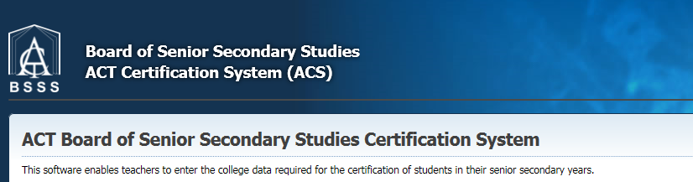
Table of Contents
How to Use this Document 4
The Reports Menu 4
Student 4
Academic Record 4
Application to Sit Modified AST Papers 4
AST Application Form 4
Secondary College Record 5
Student Information - ACT Electoral Commission 5
Student Information - UAC 5
College 5
AST labels 5
AST Rolls 5
Average of Students Unit Scores 6
Course and Units 6
Course List 6
Course Scores by Scaling Group 6
Courses in Scaling Groups 6
Courses Studied 6
Courses/Units from Other Colleges 6
Duplicate Unit Studied 6
Frequency Distribution of Unit Grades 6
Grade Summary 6
Missing Grades and Scores 6
Student List 7
Students Enrolled in Courses 7
Students Enrolled in Units 7
Students with no Units 7
Unit List 7
Markbook 7
Adjusted Assessment Item Marks 7
Adjusted Raw Unit Scores 7
Assessment Items with no results 8
Markbook History 8
Negative TID List 8
Students who Should not have been Graded 8
Unit Studied Records without a Markbook 8
Moderation 8
Individual Student Profile C - W Report 8
Individual Student Profile M Report 8
Individual Student Profile T - A Report 9
Presentation Review Proforma 9
VET 9
ASBA Certificate Final Check 9
ASBA Certificate Receivers 10
ASBA Student Details 10
BSSS Units with Competencies 10
Certificate Receivers 10
Certificate Requirements 10
Competencies in BSSS Units 10
Enrolment in VET Courses 10
Statement of Attainment Final Check 10
Statement of Attainment Receivers 10
Student Qualification Progress 10
Students with No Competencies 11
Students Menu 12
Units and Courses 12
Academic Record Report 12
On Track Report 12
Certificate Check Report 12
Details 12
Scaling Groups Menu 13
Unit Grades and Scores 13
Scaling Group List Report 13
Course Scores 13
Course Scores Report 13
EOY Processes Menu 14
Course Types 14
Check/Change Course Type Report 14
Flags for Certification 14
On Track Report 14
Certification Check Report 14
Calculate Course Scores 14
Calculate Course Scores Report 14

How to Use this Document
This document Using ACS Reports details all of the reports in ACS and where to find them. Note that not all reports are available to all user roles. Reports are available to all user roles unless specified. Most reports in ACS are generated as PDF files and can be saved or printed. Some reports can also be exported as text files (.csv) which can be imported into spreadsheets or databases for further processing.
Most reports are accessed via the Reports Menu although there are many reports which are accessed via other screens.
Most reports print directly from the report option, but many report options open a screen where a range of criteria for the report may be specified.
You will only be able to access reports that are granted to your user level.

The Reports Menu

Student
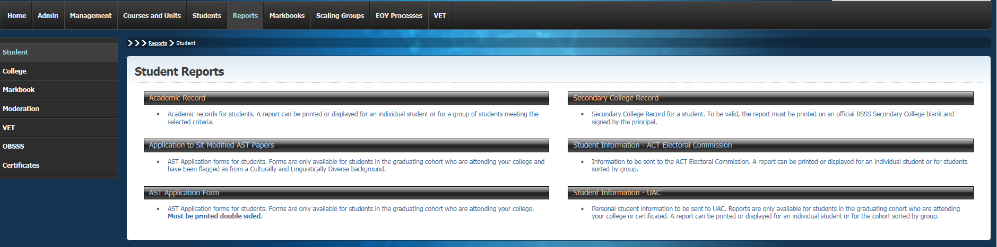

Academic Record
Academic record for students. A report can be printed or displayed for an individual student or for a group of students meeting the selected criteria. The criteria selection screen is shown below. The report is generated when the View Report button is clicked.

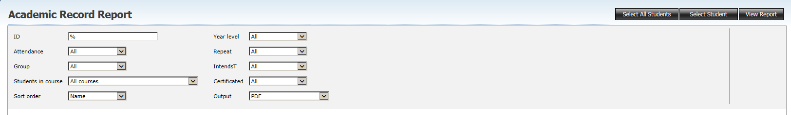

Application to Sit Modified AST Papers
AST Application forms for students. Forms are only available for students in the graduating cohort who are attending your college and have been flagged as from a Culturally and Linguistically Diverse background. A single student can be selected or all students may be selected. The report is generated when the View Report button is clicked.

AST Application Form
AST Application forms for students. Forms are only available for students in the graduating cohort who are attending your college. Must be printed double sided. The selection criteria screen shown below shows the closing date for AST applications. A single student can be selected or all students may be selected. The report is generated when the View Report button is clicked.
This report can only be generated between February and early April each year.

Secondary College Record
Secondary College Record for a student details the units studied and the grades achieved. It can be printed at any time for students. It should be presented to students who do not achieve a year 12 certificate. To be valid, the report must be printed on an official BSSS Secondary College blank and signed by the principal. A single student can be selected or all students may be selected. The report is generated when the View Report button is clicked.

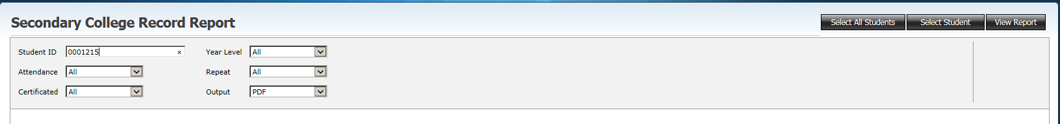

Student Information - ACT Electoral Commission
Information to be sent to the ACT Electoral Commission. A report can be printed or displayed for an individual student or for students sorted by group. The report is generated when the View Report button is clicked.

Student Information - UAC
Personal student information to be sent to UAC. Reports are only available for students in the graduating cohort who are attending your college or certificated. A report can be printed or displayed for an individual student or for the cohort sorted by group.

College
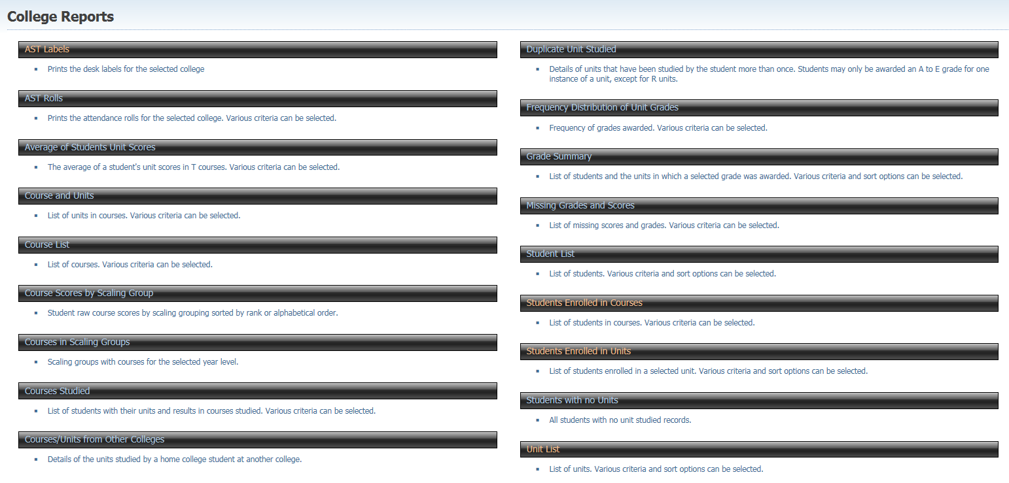

AST labels
The labels that can be used for college trial AST exams.

AST Rolls
The AST rolls that can be used for college trial AST exams.

Average of Students Unit Scores
The average of a student's unit scores in T courses. Various criteria can be selected.

Course and Units
List of units in courses. Various criteria can be selected.

Course List
List of courses. Various criteria can be selected.

Course Scores by Scaling Group
Student raw course scores by scaling grouping sorted by rank or alphabetical order.

Courses in Scaling Groups
Scaling groups with courses for the selected year level.

Courses Studied
List of students with their units and results in courses studied. Various criteria can be selected.

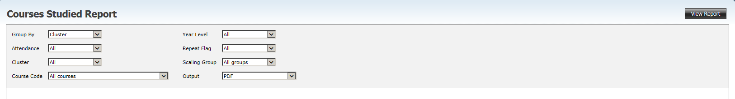

Courses/Units from Other Colleges
Details of the units studied by a home college student at another college. There is no criteria selection for this report.

Duplicate Unit Studied
Details of units that have been studied by the student more than once. Students may only be awarded an A to E grade for one instance of a unit, except for R units. There is no criteria selection for this
report.

Frequency Distribution of Unit Grades
Frequency of grades awarded. Various criteria can be selected.

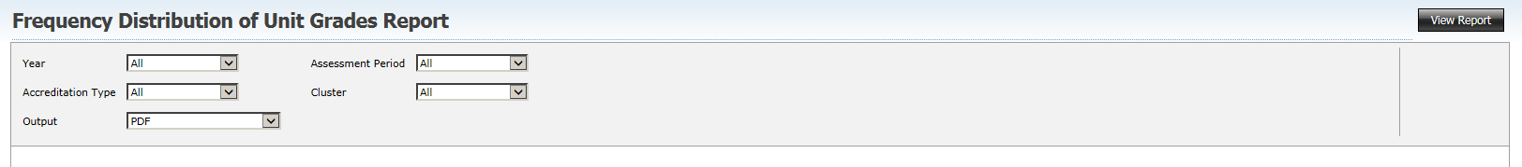

Grade Summary
List of students and the units in which a selected grade was awarded. Various criteria and sort options can be selected.

Missing Grades and Scores
List of missing scores and grades. Various criteria can be selected.

Student List
List of students. Various criteria and sort options can be selected.

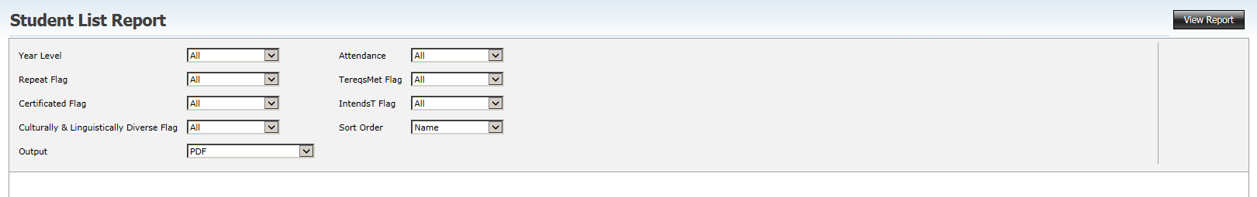

Students Enrolled in Courses
List of students in courses. Various criteria can be selected.

Students Enrolled in Units
List of students enrolled in a selected unit. Various criteria and sort options can be selected.

Students with no Units
All students with no unit studied records. There is no criteria selection for this report.

Unit List
List of units. Various criteria and sort options can be selected.

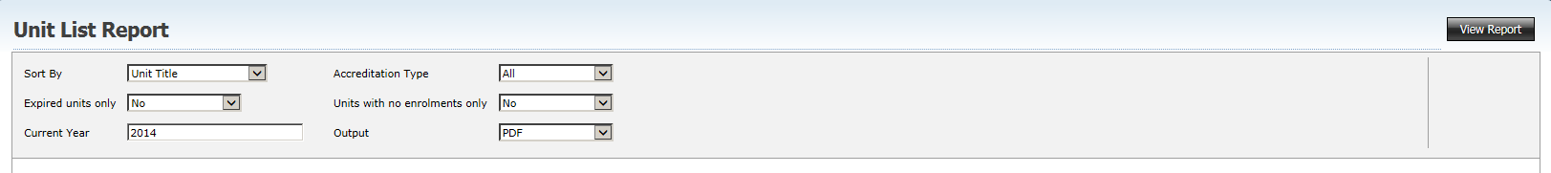

Markbook
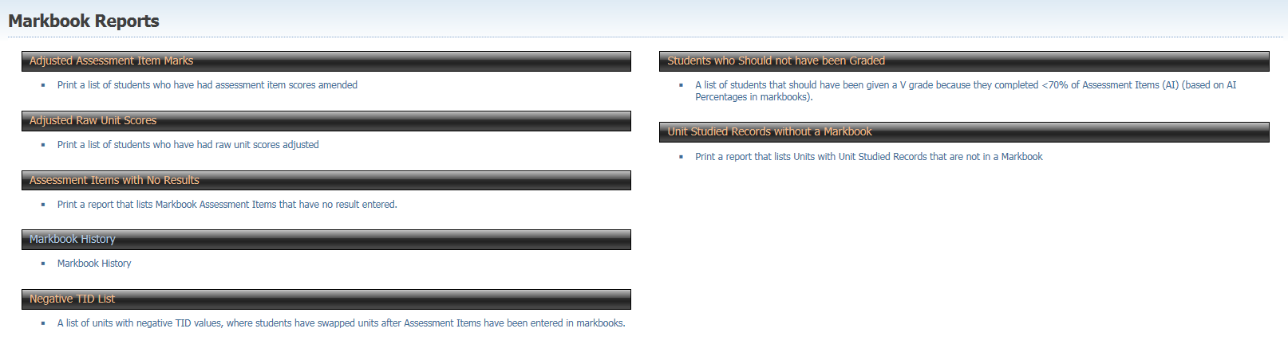

Adjusted Assessment Item Marks
Print a list of students who have had assessment item scores amended.

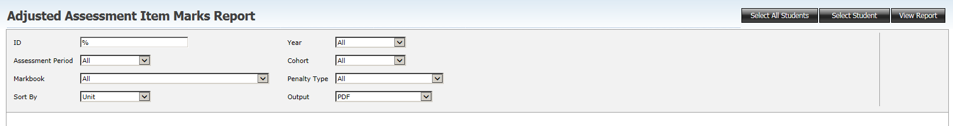

Adjusted Raw Unit Scores
Print a list of students who have had raw unit scores adjusted.

Assessment Items with no results
Print a list of markbooks showing Assessment Items where no results have yet been entered.

Markbook History
Markbook History including adjustments.

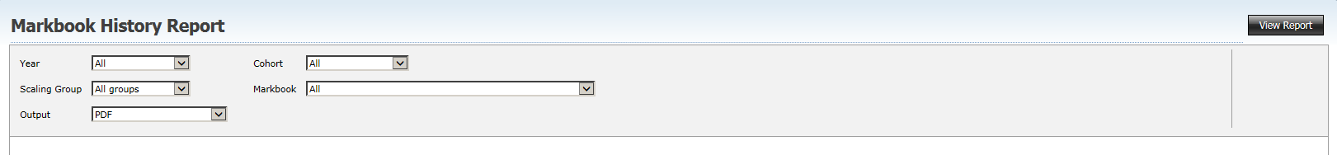

Negative TID List
A list of units with negative TID values, where students have swapped units after Assessment Items have been entered in markbooks.

Students who Should not have been Graded
A list of students that have been awarded A – E grades that have completed <70% of Assessment Items (AI) (based on AI Percentages in markbooks).

Unit Studied Records without a Markbook
Print a report that lists Units with Unit Studied Records that are not in a Markbook. There is no criteria selection for this report.

Moderation

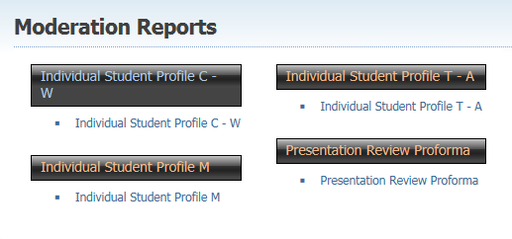

Individual Student Profile C - W Report
Individual student profile for Moderation Day portfolio submission. Select the Moderation Day, then the course, then the unit, then the student as shown below.
The report generated will is the Individual Student Profile populated with the competencies from the appropriate unit.

Individual Student Profile M Report
Individual student profile for Moderation Day portfolio submission. Select the Moderation Day, then the course, then the unit, then the student as shown below.
The report generated will is the Individual Student Profile populated with assessment data from the appropriate Markbook.
Explanatory notes are mandatory for M ISPs. You enter explanatory notes by clicking the down arrow which generates a text box for you to type in.

Individual Student Profile T - A Report
Individual student profile for Moderation Day portfolio submission. Select the Moderation Day, then the course, then the unit, then the student as shown below.
The report generated will is the Individual Student Profile populated with assessment data from the appropriate Markbook.
Explanatory notes are optional for T/A ISPs. You enter explanatory notes by clicking the down arrow which generates a text box for you to type in.

Presentation Review Proforma
Used for generating the moderation day report for a unit.

VET
Only TeachVET users and above will be able to access these reports.

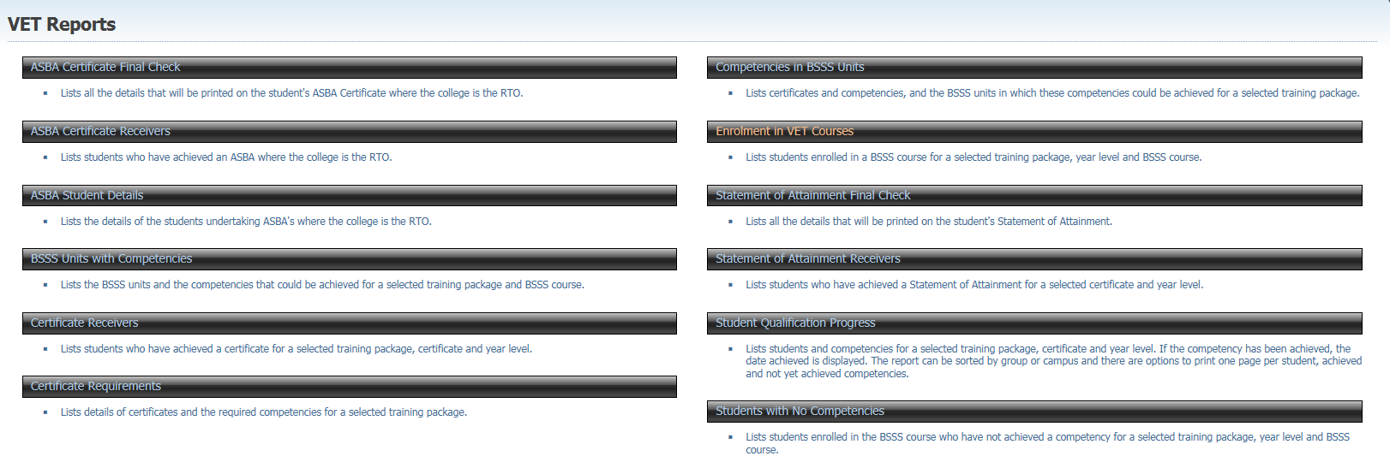

ASBA Certificate Final Check
Lists all the details that will be printed on the student's ASBA Certificate where the college is the RTO. This report should be printed as part of the end of year VET checking processes in colleges. There is no criteria selection for this report.

ASBA Certificate Receivers
Lists students who have achieved an ASBA where the college is the RTO. Includes option to show the competencies achieved. There is no criteria selection for this report.

ASBA Student Details
Lists the details of students undertaking an ASBA where the college is the RTO.

BSSS Units with Competencies
Lists the BSSS units and the competencies that could be achieved for a selected training package and BSSS course.

Certificate Receivers
Lists students who have achieved a certificate for a selected training package, certificate and year level.

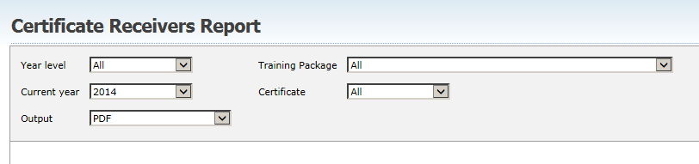

Certificate Requirements
Lists details of certificates and the required competencies for a selected training package.

Competencies in BSSS Units
Lists certificates and competencies, and the BSSS units in which these competencies could be achieved for a selected training package.

Enrolment in VET Courses
Lists students enrolled in a BSSS course for a selected training package, year level and BSSS course.

Statement of Attainment Final Check
Lists all the details that will be printed on the student's Statement of Attainment. This report should be printed as part of the end of year VET checking processes in colleges.

Statement of Attainment Receivers
Lists students who have achieved a Statement of Attainment for a selected training package, certificate and year level.

Student Qualification Progress
Lists students and competencies for a selected training package, certificate and year level. If the competency has been achieved, the date achieved is displayed. The report can be sorted by group or campus and there are options to print one page per student, achieved and not yet achieved competencies.

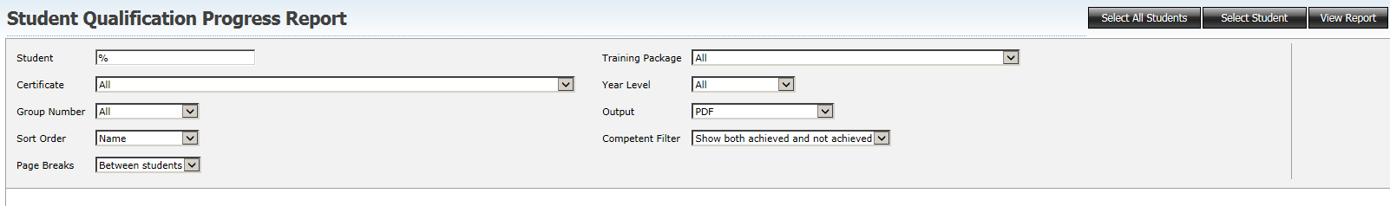

Students with No Competencies
Lists students enrolled in the BSSS course who have not achieved a competency for a selected training package, year level and BSSS course.

Students Menu
Only Edit users and above will be able to access these reports.

Units and Courses
On the Units and Courses screen a Report button provides access to the following reports as shown.

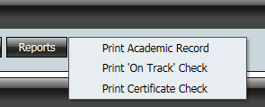

Academic Record Report
Academic record for the current student.

On Track Report
Until the beginning of December this routine will check to see if the student is `On Track' to meet Year 12 Certificate and TES requirements. It does not check for final unit grades and scores, course scores or the existence of AST results. The Certificated and Tereqsmet Flag are not set.
The `On Track' flags are used in the preliminary scaling of AST.
After the 30 November this routine will be disabled, and the `On Track' flags will NO longer be updated.

Certificate Check Report
This routine will set the flags if the student has met the requirements for Year 12 Certificate and TES. The student will have the certificated flag set if the only error in their package is missing course scores.

Details
On the Student Details screen a Report button provides access to the same reports as shown above.

Scaling Groups Menu
Only Edit users and above will be able to access these reports.

Unit Grades and Scores

Scaling Group List Report
Once a scaling group list is selected and displayed in the Unit Grades and Scores screen the Print button action prints the scaling group list.

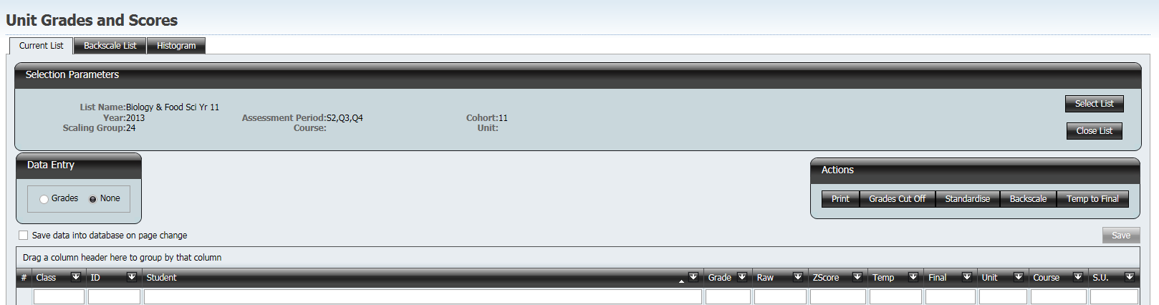

Before the report is printed the criteria screen below allows the selection of columns to be displayed on the report, the sort order of information and the inclusion of histogram graphs.

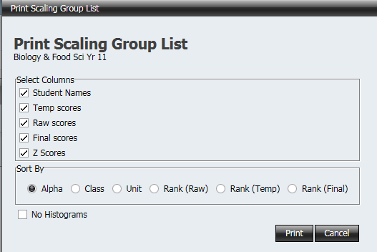

Course Scores

Course Scores Report
The Course Scores Report is accessed by the Print button on the Course Scores screen as shown below.

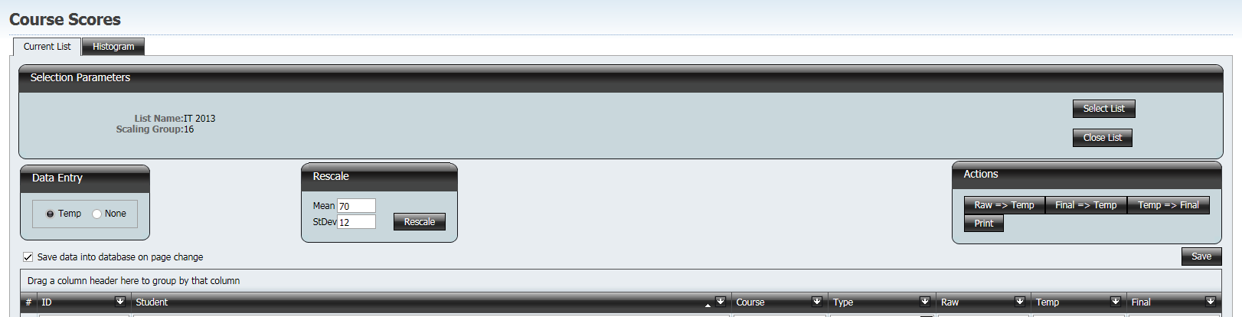

EOY Processes Menu
Only Edit users and above will be able to access these reports.

Course Types

Check/Change Course Type Report
The Check/Change Course Type Report shows the course type (Double Major, Major Minor, Major, Minor or Unknown) for each student’s course.
When the “Change Course Type” options are selected the report includes the processing that has occurred.
The report is generated when the Process button is clicked.

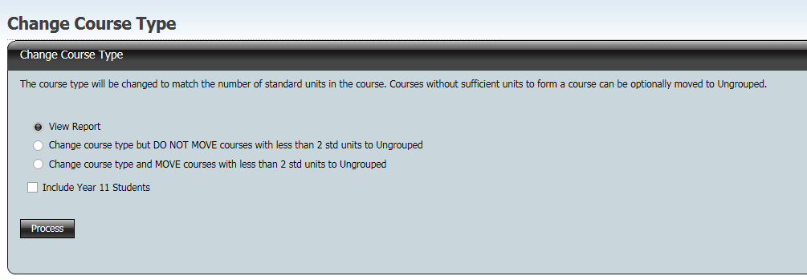

Flags for Certification

On Track Report
Until the beginning of December this routine will check to see if students are `On Track' to meet Year 12 Certificate and TES requirements. It does not check for final unit grades and scores, course scores or the existence of AST results. The Certificated and Tereqsmet Flag are not set.
The `On Track' flags are used in the preliminary scaling of AST.
After the 30 November this routine will be disabled, and the `On Track' flags will NO longer be updated.
The report is generated when the On Track heading is clicked.

Certification Check Report
This routine will set the flags for students who have met the requirements for Year 12 Certificate and TES. Students will have the certificated flag set if the only error in their package is missing course scores.
The report is generated when the Certification Check heading is clicked.

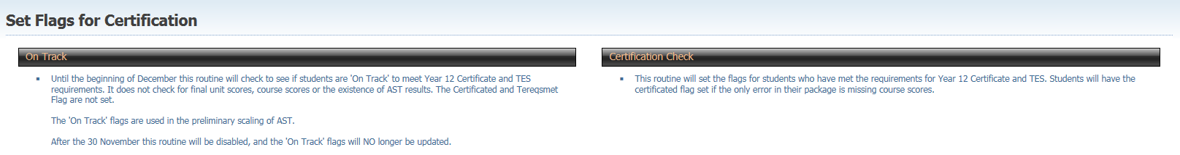

Calculate Course Scores

Calculate Course Scores Report
This report shows the course scores and how they were calculated. The report is accessed by clicking the Report button on the Calculate Course Scores screen.

