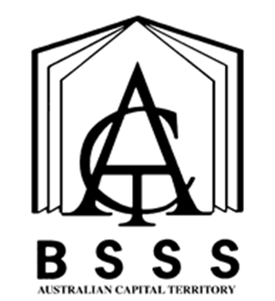

Design & Technology
Integrated Course
A / T / M / V

Cover Art provided by Canberra College student Aidan Giddings

Student Capabilities
All courses of study for the ACT Senior Secondary Certificate should enable students to develop essential capabilities for twenty first century learners. These ‘capabilities’ comprise an integrated and interconnected set of knowledge, skills, behaviours and dispositions that students develop and use in their learning across the curriculum.
The capabilities include:
- Literacy
- Numeracy
- Information and communication technology (ICT) capability
- Critical and creative thinking
- Personal and social capability
- Ethical behaviour
- Intercultural understanding.
Courses of study for the ACT Senior Secondary Certificate should be both relevant to the lives of students and incorporate the contemporary issues they face. Hence, courses address the following three priorities. These priorities are:
- Aboriginal and Torres Strait Islander histories and cultures
- Asia and Australia’s engagement with Asia
- Sustainability.
Elaboration of these student capabilities and priorities are available on the ACARA website at www.australiancurriculum.edu.au.

Course Name
Design & Technology

Course Classification
A/T/M/V

Course Framework
This course is written under the Technologies Framework 2018.

The course consists of a combination of units from the following courses:
Design & Emerging Technologies A/T/M
Design & Graphics A/T/M
Designed Environments A/T/M
Design and Textiles A/T/M/V
Engineering Studies T

Operational requirements
The operational requirements are:
- No negotiated study unit may be included in this course until a student has successfully completed two standard topical units (that is, not negotiated study). Thereafter, one negotiated study unit may be included for every two completed standard topical units.
- Colleges must be aware of policies concerning transfer of units and whole courses (refer section 4.3.5.2.2 Units in Other Courses) to another course and policies relating to moderation scaling groups. (Refer section 5.4.1 Course Combination into Moderation Scaling Groups)
- The above requirements must be clearly identified in student handbooks.

Course Adoption

Conditions of Adoption
The course and units of this course are consistent with the philosophy and goals of the college and the adopting college has the human and physical resources to implement the course.

Adoption Process
Course adoption must be initiated electronically by an email from the principal or their nominated delegate to bssscertification@ed.act.edu.au. A nominated delegate must CC the principal.
The email will include the Conditions of Adoption statement above, and the table below adding the College name, and circling the Classification/s required.

College:
Course Title: | Design and Technology (Integrated Course)
Unit Title(s) | Units as specified in the Design & Emerging Technologies, Design & Graphics, Designed Environments, Design & Textiles and Engineering Studies courses
Classification/s: | A T M | or | A/V T/V M/V
Accredited from: | 2020
Framework: | Technologies 2018

