Managing Units and Courses in the

ACT Certification System (ACS)

October 2020

Contents
User Access Level Edit and Data Sync 3
Students’ Units and Courses Screen 3
Action Buttons 3
Student Package Section 4
Course and Unit Grid 4
Using the Units and Courses Screen 4
Properties of a Unit Studied record 5
Add Units 6
Moving or Deleting Units 8
Move Selected Unit(s) to Another Course 9
Delete Selected Unit(s) 9
Move All Units to Another StudentID 10
Business Rules 10
Sweep Colleges ONLY 10
All Colleges 10
Properties of the Course Studied record 12
Edit Classes 14
Add Course 15
Reports 15

User Access Level Edit and Data Sync
All processes detailed in this section pertain to user access levels ‘Edit’, Transfer’ and ‘User Control’.
Many of the processes here vary on whether the school connects to ACS via the Data Sync system or not. Differences will be noted in the different sections.

Students’ Units and Courses Screen

- From the Students menu select Units and Courses and the Search Student screen appears
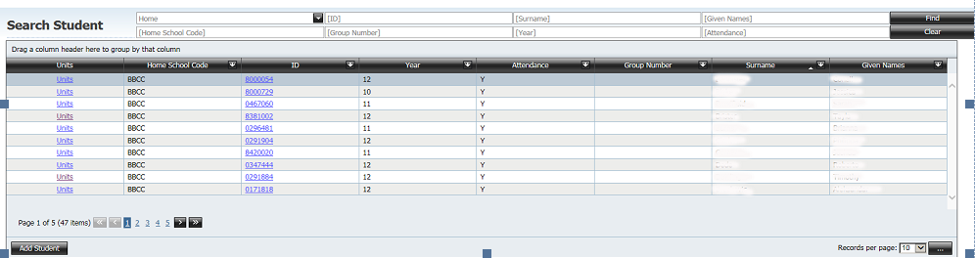

- To edit a student’s package click on the word Units next to the student, or click on the row to highlight it and then click OK.

- From this screen you can select another student by clicking on the Select Student button in the top right

The Units and Course screen has three sections
- Action Buttons
- Student Package – details of the current student’s package
- Course and Unit grid

Action Buttons
Clicking on the
- Edit Classes button displays a list of all classes for a selected assessment period This option is not available to colleges who have a ‘sweep’
- Add Course – allows you to add courses to this student
- Move All Units – moves all units to another student id
- Change Course Type – certification officers can use this button to move units that do not form a course to Ungrouped.
- Reports – allows you to print:
- Academic record
- ‘On-track’
- Certificate requirements
Hover the mouse over the button to see the print options.

Student Package Section
- The Student Package section provides the information on Student id, Student Name, Home School, Year Level, Year 12 Cert requirements met, TES requirements met, Intending to complete a TES, Total of the standard units, whether the student is a repeat, and the number of course areas studied by the student.

Course and Unit Grid
- The course and unit grid shows details of the courses that are being studied
  - Units - Number of standard units in the course
  - Final Score - Raw course score
  - Fixed - If the course type has been fixed
  - Type - Course type

Using the Units and Courses Screen
- Click on the ‘+’ near the course code to expand the course to show all associated units. All courses can be expanded by clicking on the Expand All button
- Once expanded the course and unit can be returned to the course level by clicking on the ‘-‘ sign next to the course code or clicking on the Collapse All button
- The screen below shows the course ungrouped expanded to the unit level

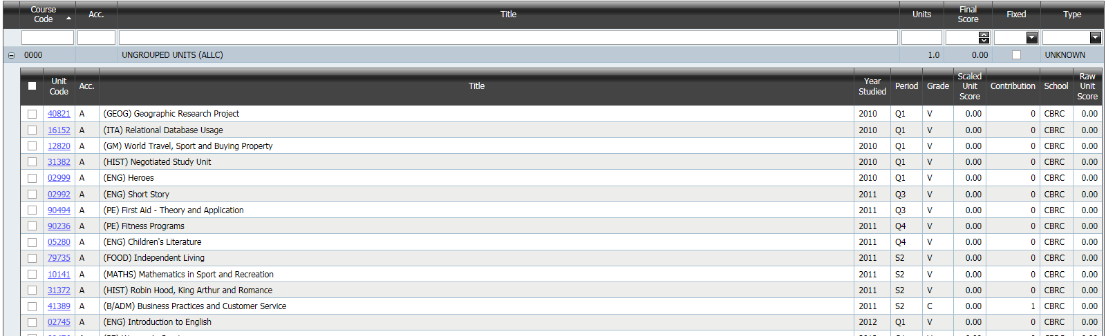

Properties of a Unit Studied record
- Once a course has been expanded to the unit level the properties of the unit can be accessed
- Click on the unit code (hyperlink) and the unit studied details will appear as shown below

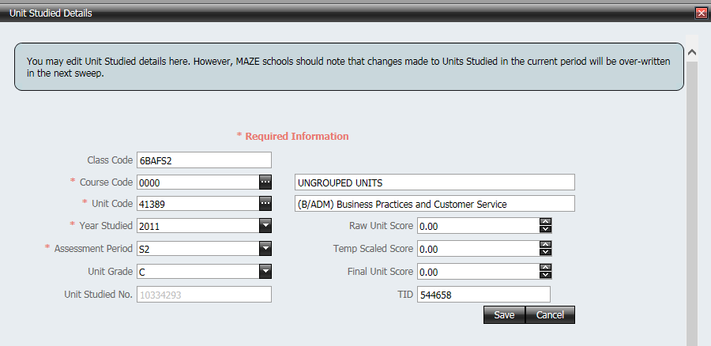

- All details except UnitStudiedNo can be edited. The TID will not be editable for non-Data Sync schools. Once there are markbook entries the Unit Code, Year Studied and Assessment Period fields also become not editable.
- To change the course click on the ellipsis button (the three dots) after the Course Code. Do not type a course code directly into the text box.
- The following screen appears showing all courses adopted by the school.

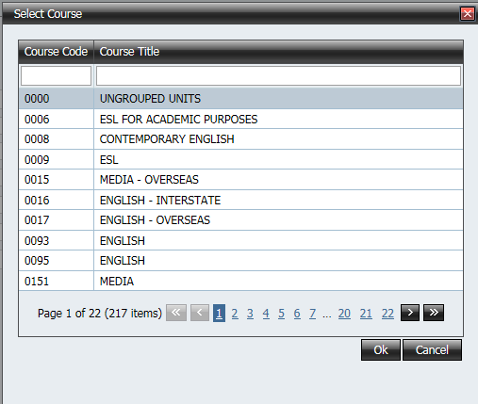

- To search for a course either type in the course code (or part thereof) or the course title (or part thereof) in the white boxes below the column headers
- Select the course by clicking on the row. The selected row will be highlighted
- Click OK to add the course to the student’s package
- A unit is changed in the same way. Do not type a unit code directly into the text box
- Change the Year Studied, Assessment Period or Grade by using the drop down boxes.
- Type in the Raw Unit score, Temp Scaled Score and Final Unit Score or use the up/down arrows to alter a value in these fields

Add Units
Non-Data Sync schools only. Data Sync schools will use their School Management System.

- In the Units and Courses screen expand a course and click on the Add Unit button
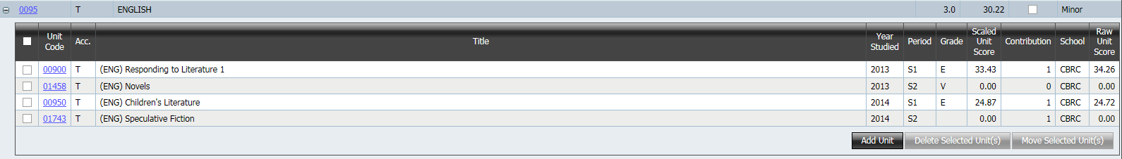

- The Add Unit Studied Details screen is displayed as shown below. The course code for the currently selected course is automatically added

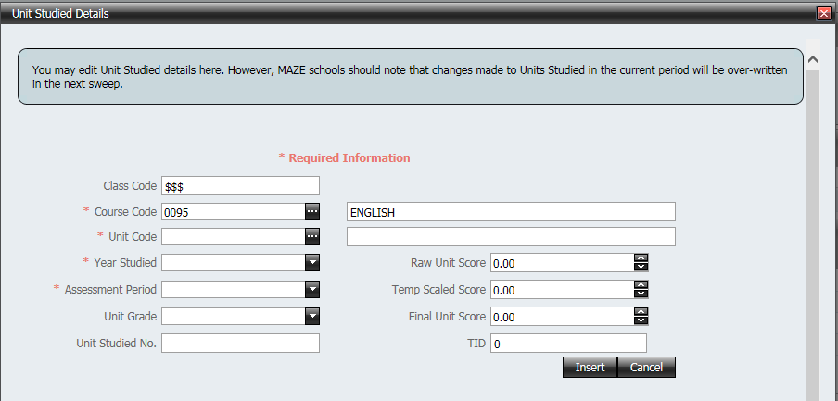
- To find all units in that course click on the ellipsis button. Do not type a unit code in the text box

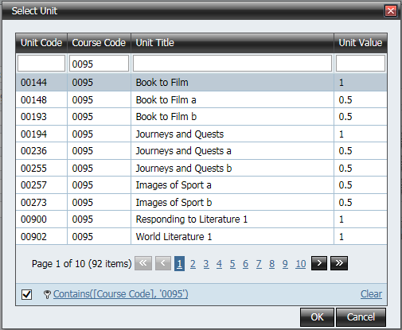

- Select a unit by clicking on the row. The selected row is highlighted
- Units from another course can be accessed by clearing the Course Code filter
- Click the OK button
- Year Studied and Assessment Period data must be entered as they are required fields
- Click the Insert button and click OK to the message that appears

Moving or Deleting Units
Data Sync schools will use their School Management System.

- In the Units and Courses screen expand to the unit level
- To select the units to move or delete click in the check box next to the unit code as shown below

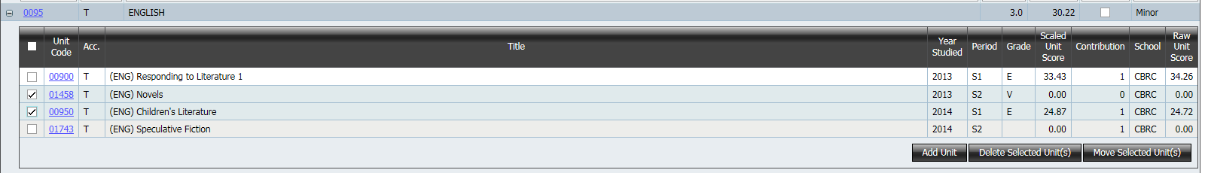

- To move the selected units click on the Move Selected Unit(s) button
- To delete the selected units click on the Delete Selected Unit(s) button

Move Selected Unit(s) to Another Course

- Click on this button and the following screen appears as shown below
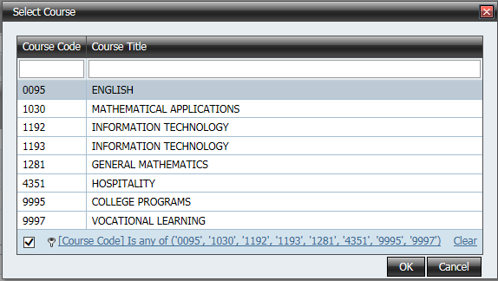

- The list of courses defaults to the current courses for the selected student
- To search for a course either type in the course code (or part thereof) or the course title (or part thereof) in the white boxes below the column headers
- Click on the course to select it. The active course is highlighted
- Click Move to move the selected units to that course
- The course type and raw course score will change to reflect the deletion/addition of the units

Note: If units are selected from more than one course and the Move Selected Unit(s) button is clicked, then only the units from the course where the Move Selected Unit(s) button was clicked will be moved to the new course.

Delete Selected Unit(s)

- Click on this button and the following screen appears as shown below

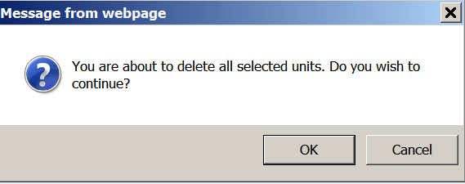

- Click on OK to delete the units and a message will appear at the top of the screen

NOTE:
If units are selected from more than one course and the Delete Selected Unit(s) button is clicked, then only the units from the course where the Delete Selected Unit(s) button was clicked will be deleted.

Move All Units to Another StudentID
This button allows you to move all the units, courses and VET competencies from one student to another student. This is needed when a student is in ACS twice with two different student IDs.

Business Rules
- The ideal situation is that a student should have the same ID from the time that they enter the ACT school system until they exit
- The unique identifier in the BSSS Certification System is the studentid. (This is not the case in most school administration systems)
- Students must have the same ID throughout senior secondary education
- If a student enrols at your college after they have started senior secondary education in the ACT you must use the ID from the previous college, otherwise the student will have their unit, course and vocational competencies spread over two ids.
- International students must use the ID issued by the International Education Section
- Particular care should be taken with students who have received vocational certificates in Year 10. Their details can be found in the database
- If a student has the incorrect ID, it must be changed by the end of May, so that the file that goes to UAC is correct. Once the file goes to UAC, Year 12 ID’s should NOT be changed

Sweep Colleges ONLY
- Change the ID in your school administration system
- This new ID will sweep through to BSSS system

All Colleges
In BSSS database there will now be:
- Unit and course records against the wrong ID
- Unit and course records against the correct ID

The correct ID should be the ID that has the earliest VET competencies or unit studied records, unless there are independent and verified reasons (e.g. Education Directorate records) to set a different ID as the correct ID.

- Open Units and Courses screen and select the incorrect studentid
- Click on the Move All Units button and the following screen appears

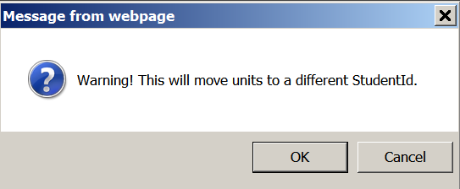

- Click on OK and the Search Student screen appears. Find the correct studentid and click on the Move button at the bottom of the screen
.

- The following screen appears. Click OK

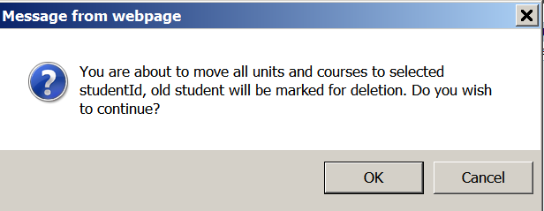

- If all unit, course and VET data has been moved to the correct ID then the following message appears

- If there is an error with moving the data such as duplicate courses or VET competencies then the following screen appears. Contact the BSSS Certification team who will edit the duplicate records in the database

Properties of the Course Studied record
In the Units and Courses screen
- Click on the course code (hyperlink) to expand to the properties of that course
- The screen as shown below appears

In this screen
- Course type can be fixed by selecting the course type from the drop down box. The fixed check box will be automatically checked. Once fixed, a course type is not changed by any of the EOY processes
- Course score can be altered by deselecting the check boxes next to the unit code of the unit you wish to discount. The adjusted course score will appear in the Custom Score box as shown below. The Raw Score is calculated from those unit scores that comprise the best 80% of the minimum number of units required for that course type, excluding discounted units. Colleges cannot change the 80% score

- The Custom Score is calculated on 80% of the selected units
- Press the Copy button near the Custom Score to move the Custom Score to Final Score. The fixed box will automatically be ticked. Once fixed, a course score does not change if Calculate course scores is run. All course scores will be set to zero if the Zero course scores is run
- To unfix a course score click the Copy button near the 80% score to move the Raw Score to Final Score and removes the Fixed flag
- Save before exiting the screen

Edit Classes
This option is available for non- Data Sync schools. It allows selection of classes for any assessment period provided they already exist in the database. To use this function at least one student must have been added to the database who is studying the same unit in the same assessment period.

- Clicked on the Edit Classes button the following screen appears

- Select the Year and Assessment Period
- Click on Refresh
- The Enrolled Classes and Class List grids will populate as shown below
- Select units from the Class List section by clicking in the check boxes next to the class. (You may need to navigate to the next page(s) to find all the classes.) This will enable the Add button

- Click Add and the selected units are added to the student’s package.
- To remove units from a student’s package select units from the Enrolled Classes section by clicking in the check boxes next to the class. This will enable the Remove button
- Click Remove and the selected units are removed from the student’s package

Add Course
- Click on the Add Course button and a blank Unit Studied Details screen appears.

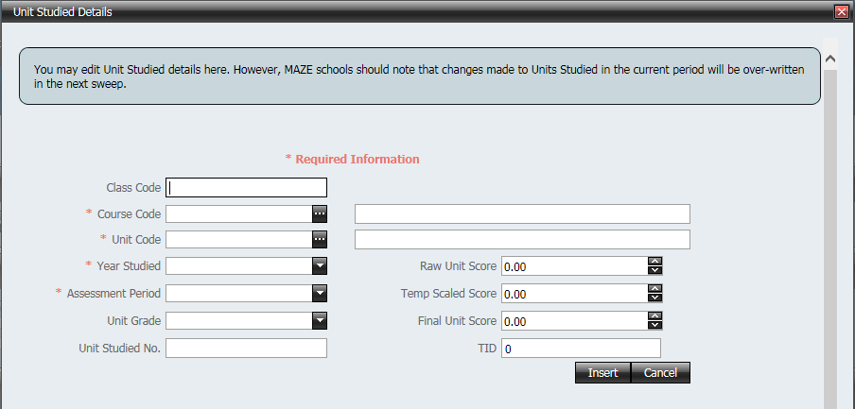

- All details except UnitStudiedNo can be entered. Non-Data Sync schools will also not be able to edit the TID field.
- To select the course click on the ellipsis button after the Course Code
- To select a unit click on the ellipses button after the Unit Code
- Change the Year Studied, Assessment Period or Grade by using the drop down boxes
- Type in the Raw Unit score, Temp Scaled Score and Final Unit Score or use the up/down arrows to alter a value in these fields

Reports
- Hovering the mouse over this button gives you the option to print
- Academic record
- ‘On-track’
- Certificate requirements
for the selected student

