Moderation

Using ACT Certification System (ACS)

April 2024

Table of Contents
Creating Presentations in ACS 3
School Moderation Presentations 3
Moderation Units 3
Exemptions 3
Moderation Create Presentation 5
Adding students to the presentation 8
Bulk Upload 9
Moderation Reports 11
Moderation Attendance 11
Moderation Course Exemptions 11
Teachers Who Have Not Selected a Moderation Subject 11
What Units Were Studied 11
Create moderation presentation workflow 12

Creating Presentations in ACS

ISPs and PRPs are no longer required. The equivalent information is gathered in other ways.

Before creating a moderation presentation, the following items need to be completed for the unit:
- Markbook complete including
  - Assessment grades and marks, and
  - Unit grades and scores
- Unit outline created in ACS
- Assessment coversheet is created in ACS including the conditions of the task, the upload of the task and any required files, and the marking scheme
- A digital copy of the assessment task solution
- A digital copy of the relevant student assessment is available

School Moderation Presentations

Moderation Units

Under the menu item called Moderation, select School Moderation Presentations to display the School Moderation Presentations page and the Moderation Units tab.

Ensure the correct Moderation Day and Year is selected.

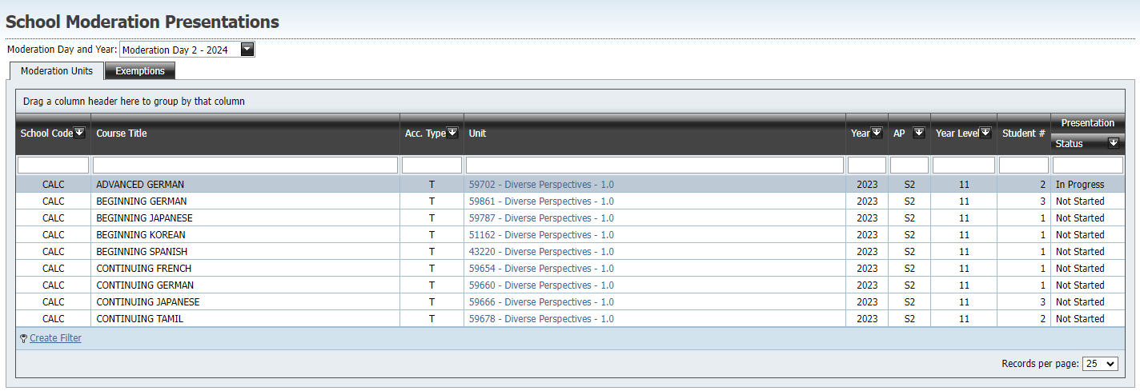

All units required by the relevant Moderation Day rules and that you have markbook access to, appear on the page. The course, accreditation type, unit title, year, assessment period, year level, number of students enrolled, and the status of the presentation is displayed.

Before a presentation has been started the Status is listed as ‘Not Started’, once a unit has been clicked on, the status changes to ‘In Progress’.

Select the unit you wish to create a moderation presentation for.

Exemptions

The Exemptions tab on the School Moderation Presentations page is used to display units exempted from the given Moderation Day process and to apply for units to be exempted.

All users can view exemption requests and their current state.

ModerationCoordinator users can apply for exemption of a unit by clicking on the Apply for Exemption button.

Select the desired Course, Unit and Reason for exemption. If a unit does not appear, check with OBSSS as it may not be eligible for exemption.

A detailed reason is required and instances based on teacher workload require the teachers name to be entered.

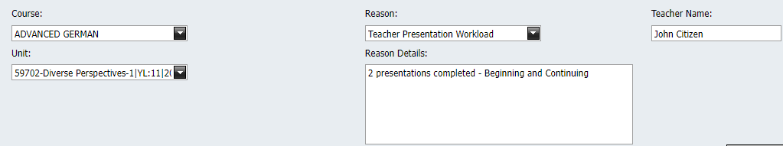

Click Save as Draft and Submit to BSSS to submit the exemption request to the BSSS. The status will change to ‘Submitted’.

The BSSS may decline an exemption, which sends the exemption request back to the school for further information. The ModerationCoordinator can then make edits and re-submit to the BSSS.

The BSSS may also reject an exemption which means that the presentation is required.

Lastly, the BSSS may approve an exemption which will then remove the unit from the Moderation Units tab.

Moderation Create Presentation

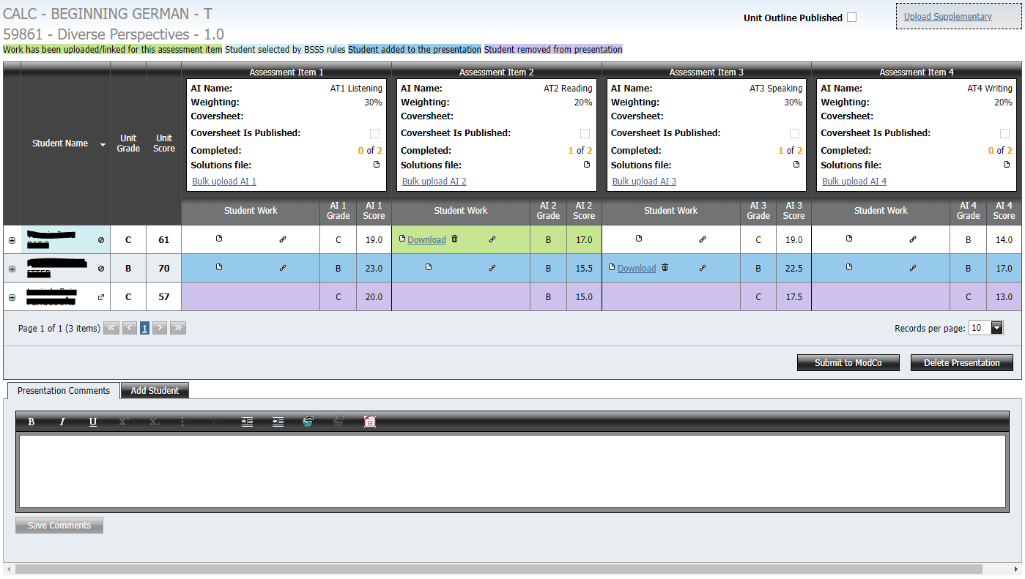

The Moderation Create Presentation page for a unit displays the following information:

- Unit information including school code, course title, accreditation type, unit code, and unit title
- A read-only flag on whether the unit outline is published
- A link to upload any supplementary material for the unit that may be useful to reviewers
- A colour code for colours that appear in the grid:
  - Green highlights assessment tasks selected by ACS that have been uploaded
  - Light blue shows the students selected by ACS following application of the Moderation Day rules
  - Dark blue highlights students that have been custom added by the teacher compiling the presentation (see Add Students)
  - Purple highlights students that were either selected by ACS or were added to the presentation that have been removed by the teacher compiling the presentation. Note that these students remain in the grid.
- The left most column of the grid displays student names, unit grades and unit scores

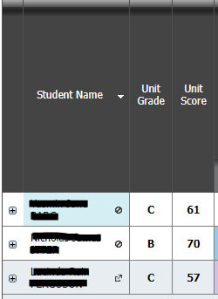

  - Hovering over the student name will display the student ID
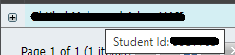
  - Click the symbol to remove a student from the list. A popup will ask for a reason for why this student is being removed.
  - Click the to re-add a student that has been removed.
  - Click the plus sign to expand a table of the individual’s assessment item information.

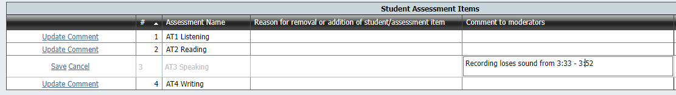

    - Click Update Comment to make any comments to reviewers about individual student responses.
    - Click Save to save the comment

- Each column represents an assessment task. The following information is displayed in the column heading.

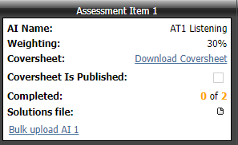

  - The assessment item name as defined in the markbook
  - Weighting as per the markbook
  - A link to download the coversheet if generated (link does not appear if coversheet not completed)
  - A read-only checkbox displaying whether the coversheet has been published
  - A completed count that displays the number of uploaded assessment items out of the number of assessment items expected as per the Moderation Day rules and any students additionally added by the teacher
  - A link to upload any solutions file for the assessment item to assist reviewers
  - A link to the Bulk upload AI function (see Bulk Upload section below)
- Each cell in the grid displays the following symbols and information before student work is uploaded
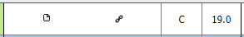

  - The file symbol can be clicked to upload one or more files to ACS for that student. If multiple files are selected, they will be zipped into a single file by the system. A popup will appear where the file can be selected. There is currently a 50 MB limit per student per assessment item
  - The chain link symbol can be clicked to enter a URL (for large files greater than 50MB)
  - The assessment item grade and score as per the markbook
- Below the student and assessment grid are the buttons Submit to ModCo and Delete Presentation

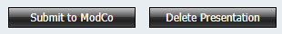

  - Once all required solution files and student work are uploaded, and any whole presentation or individual response comments entered, the unit coordinator can submit the presentation to the school’s moderation coordinator for approval. Once this is done, a Basic user will not be able to make any changes to the presentation unless a ModCo user at the school, rejects the presentation
  - The Delete Presentation button allows a presentation to be deleted and regenerated if required. This is useful if the unit grades have changed and the students should be selected again. This will delete any work uploaded and the presentation will need to be started again.
- Once a presentation is submitted to the ModCo, a ModCo user will see the buttons Submit to BSSS and Reject.
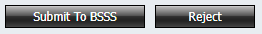

  - Submit to BSSS sends the presentation to the Office of the BSSS for approval to be viewed at Moderation Day. No edits can be made to the presentation by non-BSSS users after this time unless further school action is required after review.
  - If the moderation coordinator requires the unit coordinator to amend the presentation, clicking Reject allows Basic users with access to make changes to the presentation.
- At the bottom of the page is a tab titled Presentation Comments. Use this section to make any comments about the presentation to reviewers, including any software requirements

Adding students to the presentation

At the bottom of the page is a tab titled Add Student.

To add a student to the presentation, select this tab and a grid of possible students will appear.

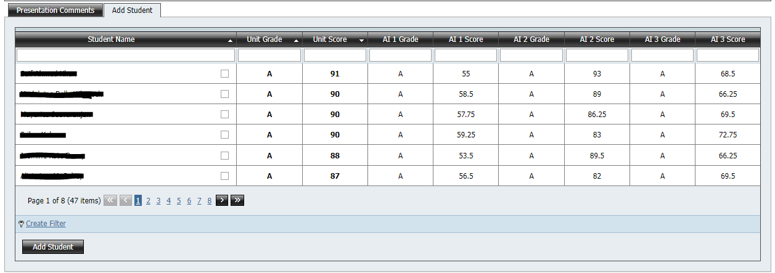

This grid can be sorted by any of the column headings and can be filtered by typing into the boxes at the top of each column. Use these to assist in locating the desired student to be added to the presentation.

Once the desired student has been found, click the checkbox next to the student’s name and click the Add Student button. The student will then be added to the required students for the presentation (denoted by the dark blue highlighting).

Bulk Upload

Clicking on the Bulk upload AI link will open the following popup

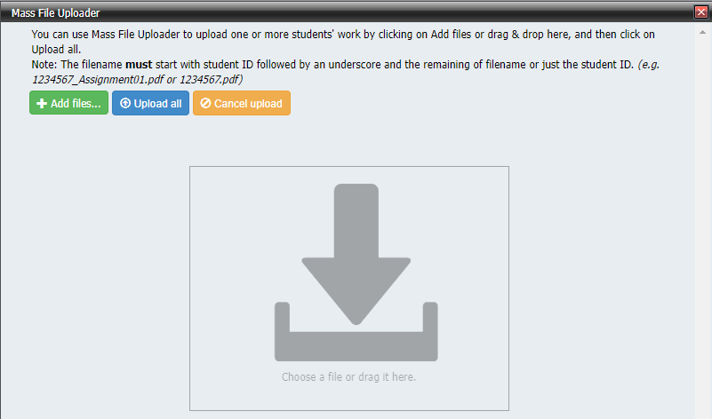

Files can be dragged and dropped onto the popup, or added by clicking the Add files button. As explained in the popup, files uploaded with this method require the student ID as the first 7 characters of the file name so that the system can identify which files belong to which students.

When the files have been dropped on the screen, the popup will display something similar to this.

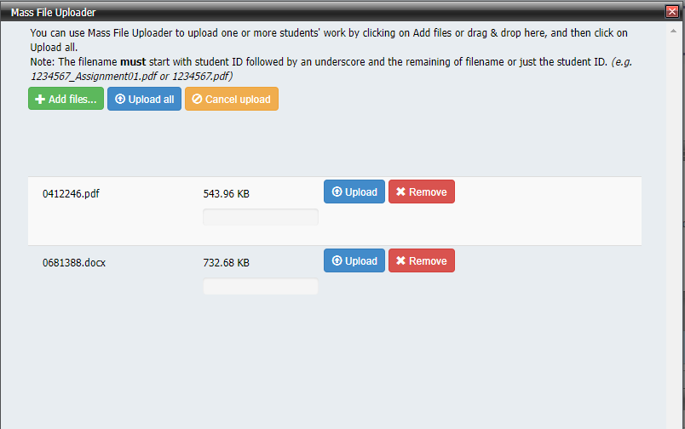

Individually clicking Upload on an assessment response, or clicking the Upload all button will then upload the files and allocate them to the corresponding student in the grid.

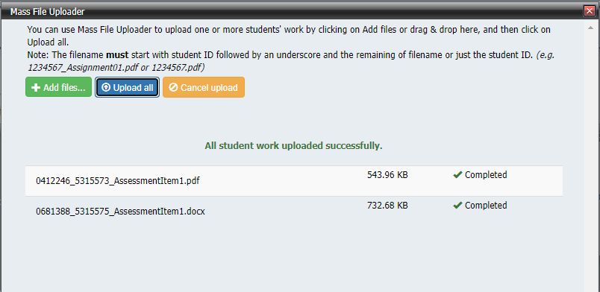

Moderation Reports

In the Reports, Moderation section of ACS, you will see a list of reports that will be useful to run regularly in preparation for Moderation Day.

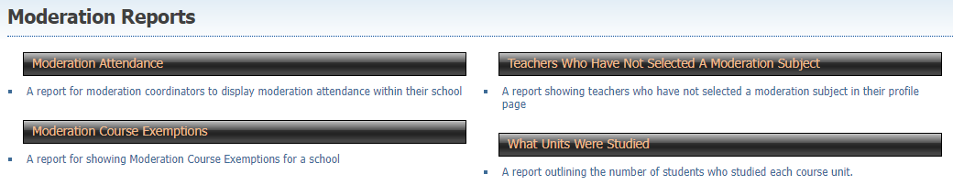

Moderation Attendance

The Moderation Attendance report will show you which venue and course grouping staff members from your college have chosen for the next Moderation Day.

Please double check that all teachers’ names appear on this report and that there are no extra names.
Please add the number of observers and the Principal’s signature to the bottom of the report when it is correct and send a copy to the Quality Assurance officer.

Moderation Course Exemptions

The Moderation Course Exemptions report shows all units with granted exemptions.

Teachers Who Have Not Selected a Moderation Subject

The Teachers Who Have Not Selected a Moderation Subject report will show you the names of the teachers who need to update their courses taught and Moderation Day attendance sections in their Profile.

What Units Were Studied

The What Units were Studied report shows which courses and units were studied by particular year levels in specified assessment periods. You should use this report to ensure that all expected Presentations are prepared for the next Moderation Day.

Create moderation presentation workflow

