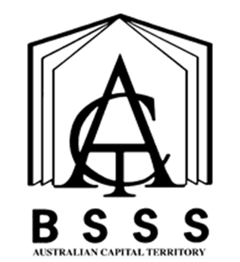

History

Integrated Course
  - A / T / M

Front Cover Art provided by Canberra College student Aidan Giddings

Student Capabilities
All courses of study for the ACT Senior Secondary Certificate should enable students to develop essential capabilities for twenty-first century learners. These ‘capabilities’ comprise an integrated and interconnected set of knowledge, skills, behaviours and dispositions that students develop and use in their learning across the curriculum.
The capabilities include:
- Literacy
- Numeracy
- Information and communication technology (ICT) capability
- Critical and creative thinking
- Personal and social capability
- Ethical behaviour
- Intercultural understanding
Courses of study for the ACT Senior Secondary Certificate should be both relevant to the lives of students and incorporate the contemporary issues they face. Hence, courses address the following three priorities. These priorities are:
- Aboriginal and Torres Strait Islander histories and cultures
- Asia and Australia’s engagement with Asia
- Sustainability
Elaboration of these student capabilities and priorities are available on the ACARA website at www.australiancurriculum.edu.au.

Course Name
History

Course Classification
A/T/M

Course Framework
This course is presented under the Humanities and Social Sciences Framework 2019.

The course consists of a combination of units from the following courses:
Ancient History A-T-M
Modern History A-T-M
Pre-Modern History A-T-M
All units from these courses may be included in an Ancient History, Pre-Modern History and Modern History course providing there is no duplication of content.
A History minor consists of a combination of 2-3 units from these courses.
A History major consists of a combination of at least 3.5 units from Ancient History or Pre-Modern History or Modern History.
A History major minor consists of a combination of at least 5.5 units, from either Ancient History or Pre-Modern History or Modern History.
A History double major consists of a combination of at least 7, from Ancient History or Pre-Modern History or Modern History.

Operational requirements
The operational requirements are:
- Colleges must be aware of policies concerning transfer of units and whole courses (refer section 4.3.5.2.2 Units in Other Courses) to another course and policies relating to moderation scaling groups. (Refer section 5.4.1 Course Combination into Moderation Scaling Groups)
- The above requirements must be clearly identified in student handbooks.

Course Adoption

Conditions of Adoption
The course and units of this course are consistent with the philosophy and goals of the college and the adopting college has the human and physical resources to implement the course.

Adoption Process
Course adoption must be initiated electronically by an email from the principal or their nominated delegate to bssscertification@ed.act.edu.au. A nominated delegate must CC the principal.
The email will include the Conditions of Adoption statement above, and the table below adding the College name, and circling the Classification/s required.

College:
Course Title: | History (Integrated Course)
Unit Title(s) | Units as specified in the Ancient History, Modern History and Pre- Modern History courses
Classification/s: | A T M
Accredited from: | 2014
Framework: | Humanities and Social Sciences 2019

