School Assessment Information in the ACT Certification System (ACS)

May 2021

Table of Contents
User Access Level 3
School Assessment Information Screen 3
School Logo 3
Uploading a School Logo 3
School and BSSS Assessment Policies 4

User Access Level
All processes detailed in this section pertain to user access levels ‘Transfer’ and ‘User Control’.

School Assessment Information Screen

- From the Unit Information menu select School Assessment Information

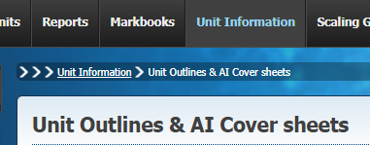

The following screen should then appear.

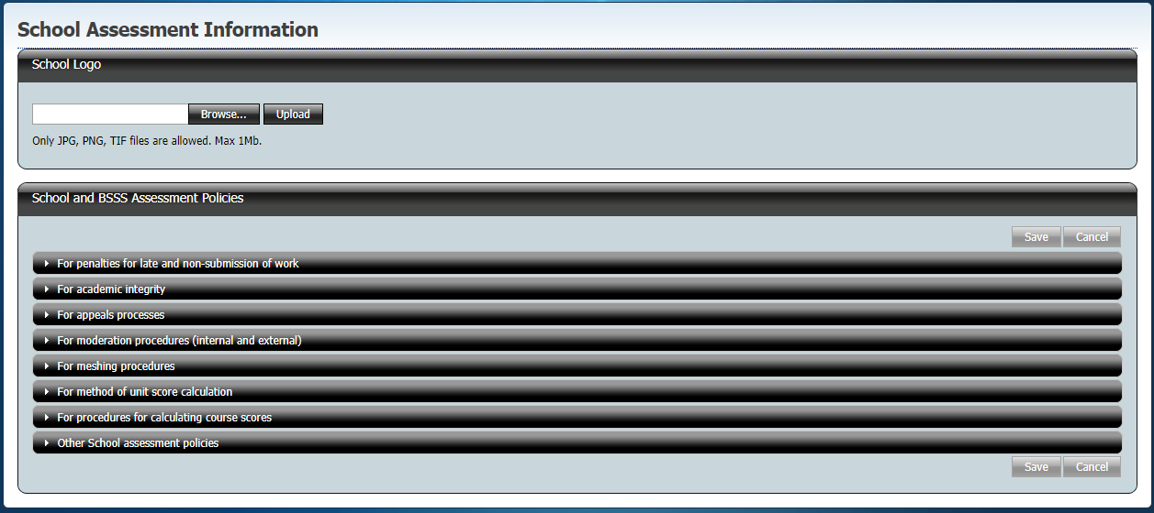

The School Assessment Information screen has two sections:
- School Logo
- School and BSSS Assessment Policies

School Logo
This section is used to upload the school logo that will appear on Unit Outlines generated by ACS for the school.

Uploading a School Logo
- Ensure you have a JPG, PNG or TIF file containing your school logo. This will need to be less than 1 MB in size.
- Click Browse and a popup window of your computer’s directory should appear.

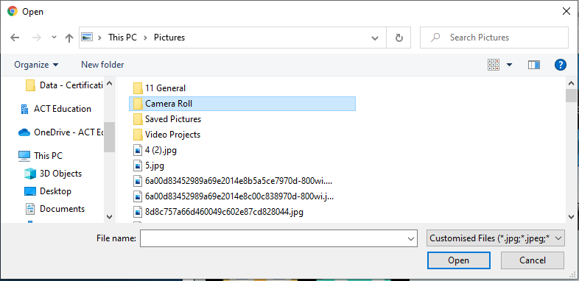
- Select the image you wish to upload and click Open
- Click Upload
The new school logo image should appear on the School Assessment Information screen. For example like this.

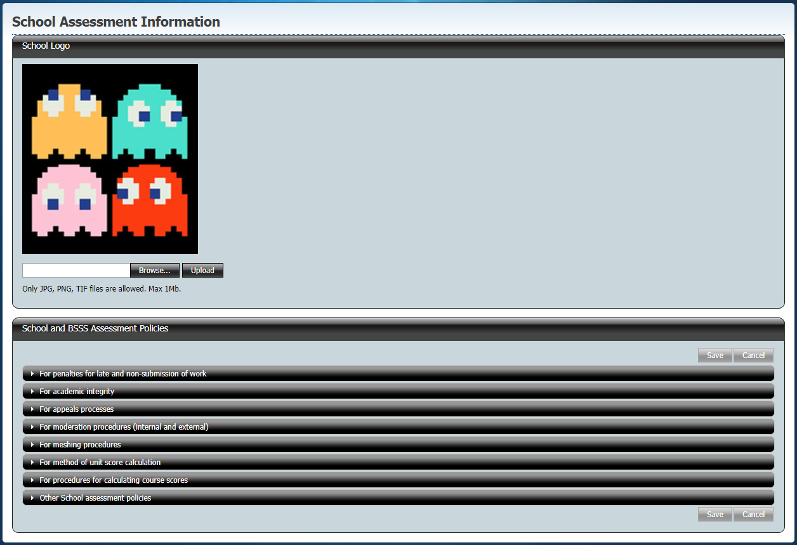

School and BSSS Assessment Policies
The School and BSSS Assessment Policies section contains a number of expandable and collapsible accordions. The information entered here will appear on all Unit Outlines generated by ACS for the school. These are:

- For penalties for late and non-submission of work
- For academic integrity
- For appeals processes
- For moderation procedures (internal and external)
- For meshing procedures
- For method of unit score calculation
- For procedures for calculating course scores
- Other School assessment policies

- Click on an accordion header to expand or collapse the text box under it

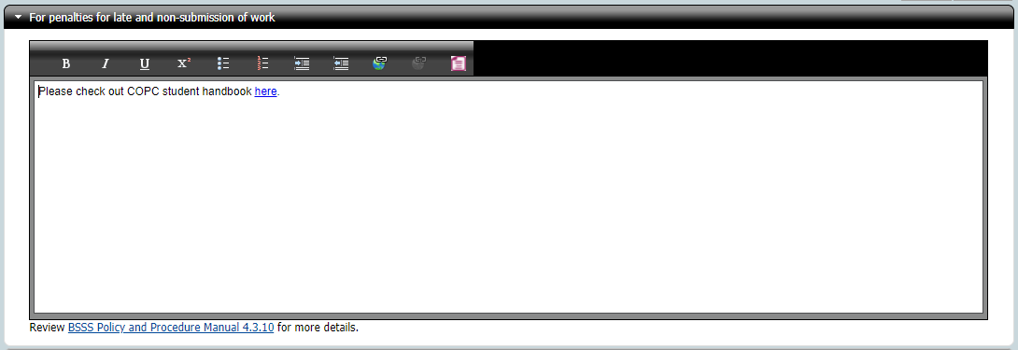

You can have one accordion open at a time. Clicking on another accordion will collapse one and open the other. The content in one section will be kept while you are on the page but it will not be saved.

- Enter the school policy you wish to be displayed on all school Unit Outlines under the heading. You have some common limited text editing options available such as bolding, dot points and hyperlinks.
- To remove all text editing from the text, click the Convert to plain text icon

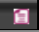

Note that many sections will automatically include the reference to the relevant BSSS Policy and Procedure Manual section. For example, For penalties for late and non-submission of work will include “Review BSSS Policy and Procedure Manual 4.3.10 for more details.”

- When you have entered all desired school assessment policies, click Save. If you wish to revert to the previously save policies, click Cancel.

