Managing Student Data

Using ACT Certification System (ACS)

October 2014

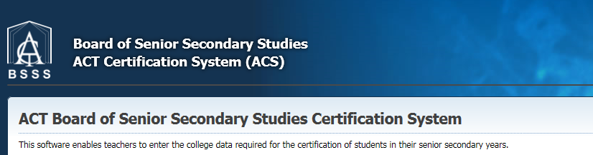
Table of Contents
User Access Level Edit and Data Sync 3
Manage Student Screen 3
Student Details Screen 5
Editing Existing Student Data 6
When a Student Leaves Your College 6
Claiming a Student 7
Adding Data for a New Student 8
Adding New Students Directly into ACS 8
Adding New Students into the School Administration System (SAS) 9
Resolving Duplicate Students 9
Business Rules 9
Data Sync Colleges ONLY 9
All Colleges 9
Deleting Existing Student Data 10
Deleting a Student 11
Fixing Enrolment Dates 12

User Access Level Edit and Data Sync
All processes detailed in this section pertain to user access level ‘Edit’ and above (‘Transfer’ and ‘User Control’).
Many of the processes here vary on whether the school connects to ACS via the Data Sync system or not. Differences will be noted in the different sections.

Manage Student Screen
Under the Students menu select Manage Student and the following screen will appear
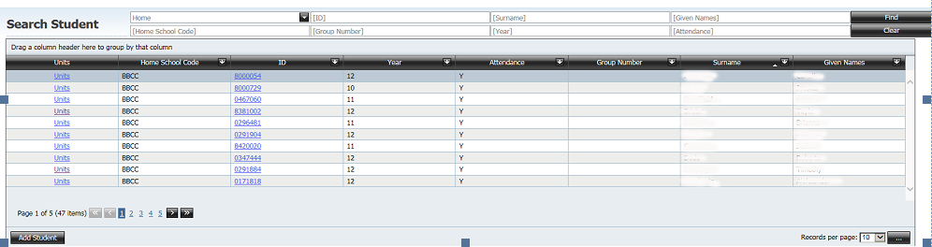

This screen is used throughout the application to find an individual student for reports, data entry of personal details, course, units, VET competencies etc.
Functionality: The group, sort, filter and field chooser functions are available in this screen.
Group: Drag the column header to the top to group by that field (all fields)
Filter:
      - Type in the white text boxes in the filter section to filter by Studentid, Surname, Given names, Home Schoolcode, Group Number, Year level or Attendance
- Use the drop down box next to Home to select Home (default), Non Home (has unit studied records from your college), All (student is in the system).

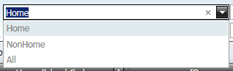

- Once all criteria have been selected click on Find button
- Click the Clear button to clear your filter
Sort: Click on the column headings and the arrows will appear. Click on the arrows to change the sort order (all fields)
Field Chooser: The fields Date of Birth and Suburb can be added to this screen. Any of the fields can be removed
For more detail on manipulating these types of screens see ACS Tips and Tricks 2011.

NOTE:
Search by All (filter as required) to check for the studentid of the student prior to enrolling any new student.

At the bottom of the Search by Student screen you can change the number of records displayed on each page as shown below. The default is 10. Options available are 5, 15, 20, 25, 50, 100, 200, 500

- In a student record click on the word Units (hyperlink) and the Units and Courses screen appears as shown below (See 4. Managing Units and Courses for more information)

- Click on the studentid (hyperlink) and the Student Details screen will appear, a part of which is shown below

Student Details Screen
- Click on the add student button and a blank Student Details screen will appear

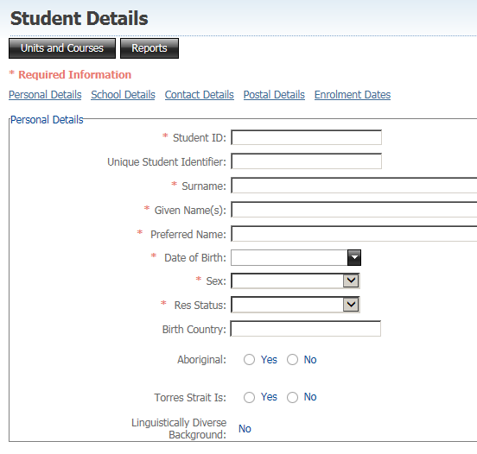

The Student Details screen as shown above has seven sections
- Personal Details
- School Details
- Contact Details
- Postal Details
- Disability Details
- Previous Qualifications Achieved
- Enrolment Dates
Each section can be accessed by scrolling or clicking on the links

The Student Details screen as shown above has four action buttons
- Units and Courses button takes you to this student’s Units and Courses screen
- Reports button allows you to print:
- Academic Record report
- ‘On track’ report
- ‘Certificate requirements’ report for this student
- Add Student button takes you to a blank Student Details screen
- Select Student button takes you to the Search Student screen

This screen is for the manual data entry of student personal details into the database and to update data for a particular student. However if this data is part of your sweep when the sweep runs it will overwrite the data.

Editing Existing Student Data
Any field that has a red asterisk in front of the name is a required field. Data must be entered for these fields
- Data can be edited on this screen by either
- Typing in the field
- Select from the drop down list. If the field has a drop down list then you cannot type data into this field
The Studentid and HomeschoolCode fields cannot be edited

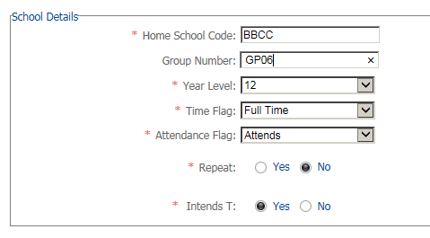

- If you change any data on this screen you must press the Save button at the bottom of the screen. The following message will appear

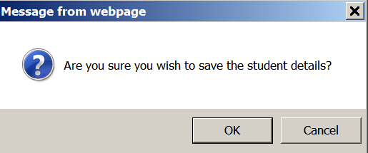

- Clicking OK a message will appear at the top of the screen as shown below.



When a Student Leaves Your College
When a student leaves your college before the end of year 12 the student must be flagged as ‘Left’ so that they can be ‘Claimed’ by another college (see below). Non Data sync colleges flag a student as left by updating the School Details Attendance Flag from ‘Attends’ to ‘Left’. Data Sync colleges should change the flag in their school admin system

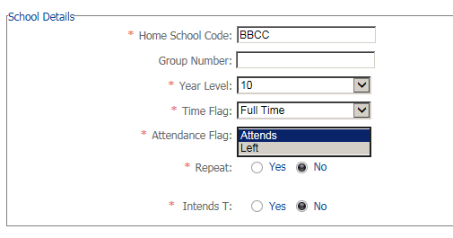

Claiming a Student
When a student leaves another college and enrols at your college, before entering any data in the BSSS database or the school administration system use the Search Students screen to see if they exist in the BSSS database. Doing this should reduce the number of duplicate student records. If they exist and they have been marked as left by the previous college you can claim the student. If they have not been marked as left by the previous college contact that college and ask that they update their student data in ACS and/or their school administration system.

- From the Students menu select Manage Student. The Search Student screen appears
- Select the All option from the Home pull down menu
- Filter the data eg year level, surname, attendance. You will only be able to claim students if the college have flagged them as ‘Left’ and their attendance as ‘N’

- Once you have found the student click on the studentid which takes you to the Student Details screen
- Scroll to the bottom of the screen and click on the Claim Student button

- The Homeschool for this student is now your college. Once you have added your college units to their package you should be able to see all their unit studied records

NOTE:
You cannot print an academic record for the student until they have unit studied records at your college.

Adding Data for a New Student
Before you add a new student to ACS make sure the student does not already exist in ACS. Do this by searching for the student with ‘All’ selected to search all students in ACS. If you find the student already exists in ACS do not add them again, rather ‘Claim’ them as explained in the previous section.

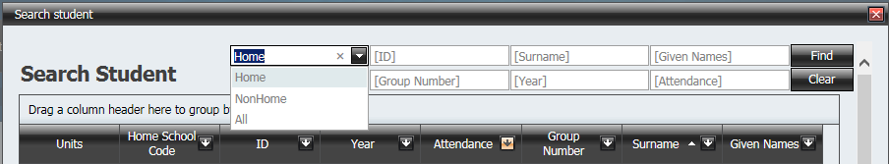

There are two ways new students can be added to ACS:
- Added directly to ACS.
If the student does not already exist in ACS the student data can be added directly as explained below. For non Data Sync colleges, the unit and course data is added directly to ACS. For Data Sync colleges unit studied records should sync in from school administration systems (SAS) once the student is attending your college.
- Added to the School Administration System (SAS).
If the student does not already exist in ACS the student data can be added to the SAS and brought in via Data Sync along with all of their course and unit data.

Adding New Students Directly into ACS
- To add a new student, from the Students menu select
- Manage Student or
- Details
- The Add Student button is on the bottom of the Search Student screen (accessed via menu Manage Student) or at the top of the Student Details screen. Both are linked to the following screen
- Type in the details for the student.
Add a unique (unused) student ID number from the bank of numbers allocated to your college.
If you do not enter data for a required field then when you move to the next field a warning is shown as below. You will not be able to save this record until the error is fixed

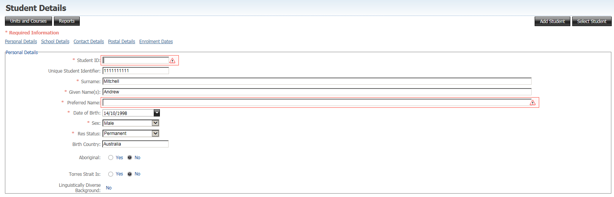

- When entering the date of birth for a student who is younger than 14 and older than 19 you will get a warning message. This is not an error message and you can continue
- Once all details are entered press Save
- After saving you are returned to the Search Student screen. A message at the top of the screen will tell you that the student details have been saved

NOTE:
If you use an ID that already exists, when you press save the following message will appear.

Adding New Students into the School Administration System (SAS)
All of the student data required by ACS must be added to the SAS.
Add a unique (unused) student ID number from the bank of numbers allocated to your college.
The student data will then be swept into ACS via Data Sync.

Resolving Duplicate Students
If a student that already exists in ACS is added again with another studentID number then this student is known as a ‘duplicate student’.

Business Rules
- The ideal situation is that a student should have the same ID from the time that they enter the ACT school system until they exit
- The unique identifier in the BSSS Certification System is the studentid. (This is not the case in most school administration systems)
- Students must have the same ID throughout senior secondary education
- If a student enrols at your college after they have started senior secondary education in the ACT you must use the ID from the previous college, otherwise the student will have their unit, course and vocational competencies spread over two ids.
- International students must use the ID issued by the International Education Section
- Particular care should be taken with students who have received vocational certificates in year 10. Their details can be found in the database
- If a student has the incorrect ID, it must be changed by the end of May, so that the file that goes to UAC is correct. Once the file goes to UAC, Year 12 ID’s should NOT be changed

Data Sync Colleges ONLY
- Change the ID in your school administration system
- This new ID will sweep through to BSSS system

All Colleges
- In BSSS database there will now be:
- Unit and course records against the wrong ID
- Unit and course records against the correct ID
NOTE: The correct ID is defined to be the ID that has the earliest VET competencies or unit studied records.

- The student ID which has the earliest unit studied or VET data recorded against it in ACS is the number that must be retained.
- Any unit studied or VET data recorded against the second student ID must be transferred to the first student ID. This process is explained in the ‘How to’ document Managing Students’ Units and Courses.

Deleting Existing Student Data
- To mark a student for deletion use the Student Details screen
- Students are marked for deletion by either
- changing the year level to 99. The Attendance Flag field is automatically changed to Left and the field is greyed out as shown below

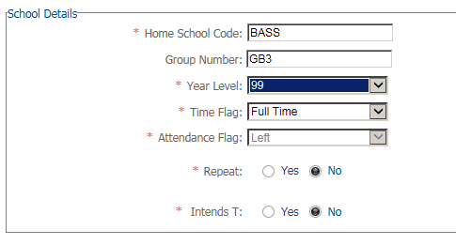

- or click on the delete button at the bottom of the screen as shown below

- Click OK to the message

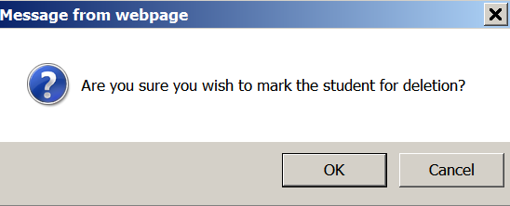

- You are returned to the Search Student screen and the message at the top of the screen will tell you that the student has been updated.

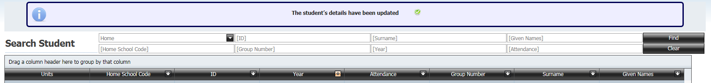

Deleting a Student
This will permanently remove the student and their unit studied records and VET competencies from the database.
- From the Students menu select Delete Students. The following screen appears

- Select the students to delete by ticking in the check boxes next to their name and press the Delete Selected button

- Click on the OK button

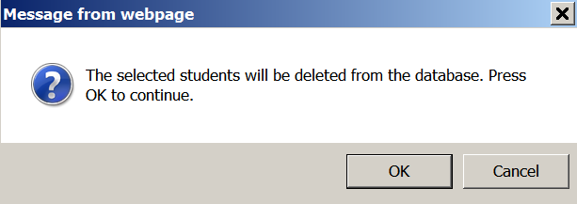

- The following message will appear at the top of the screen

Fixing Enrolment Dates
The enrolment dates for a student come from the unit_studied records. The start date is set from the date the term commenced for the student’s earliest assessment period from the unit_studied records. The end date is set from the last date in the term for the student’s latest assessment period from the unit_studied records. These are known as the Default dates. The enrolment dates are incorrect when students start/leave a few days later/earlier or when you award R (Recognition) grades for studies completed elsewhere. The enrolment dates need to reflect the period of time the student was enrolled in your college.

- From the Students menu select Details and the Search Student screen appears
- Click on the studentid (hyperlink) and the Student Details screen will appear
- Click on the link to Enrolment Dates

- The following screen will appear

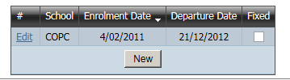

- Click on New and the following screen will appear

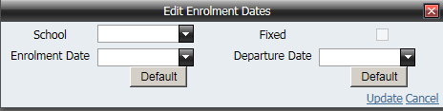

- To edit the Enrolment Date/Departure Date click on the drop down box and select the date. The fixed box will tick automatically
- To reset the dates to the Default date click on the Default button
- Press on the Update link to save the changes
- Press save button at the bottom of the page

