Generating Assessment Item Coversheets in ACT Certification System (ACS)

January 2024

Table of Contents
Rationale 3
Pre-requisites 4
Access 4
Starting the coversheet 4
Select the course 5
Select the unit 5
Select the Coversheet to create 7
Creating the coversheet 7
1. Assessment Item Summary 7
2. Assessment Item Settings 7
3. Optional Blank Fields to include 8
4. Additional Date Information (optional) 9
5. VET Competencies 9
6. Assessment Policies 9
7. Assessment Conditions 10
8. Submission Information 11
9. Assessment Instructions or Additional Information (optional) 12
10. Assessment Attachments 13
Other Features/considerations when generating coversheet and assessment item 14
Same Assessment Item for Multiple Units 14
Limited Formatting Capability 15
Appendix 1: Assessment Item – PDF (‘Print’) 17
Appendix 2: Student Profiles Online 19
2a: Student Profiles Online view 19
2b: Student download example based on ‘Coversheet Only Published to SPO’ option in ACS 20

Note: if you need to return to the place you were reading after clicking on a link in this document, press ‘alt’ and ‘←’ at the same time.

Rationale

The purpose of assessment item coversheets is to provide students with all the information required to ensure they know how that they can succeed on a given assessment item. Given that much of this information is already in ACS, having assessment item coversheets created in ACS will make it more likely students get the information that they are entitled to.
Further, the integrity of system moderation relies on teachers at Moderation Day being able to access assessment item coversheets to see that students are indeed getting this information. This new system ensures that they are easily accessible, giving teachers the ability to see exactly what the students get to see for each assessment item.
As such, it is now compulsory to create assessment item coversheets in ACS for all assessment items in all units in all schools.

Pre-requisites
To generate a coversheet for an assessment item for a unit, you will need:
- a markbook that has already been set up for that unit, with assessment item names and weights
- unit outline generation for that unit has commenced (see the Generating Unit Outlines in ACS manual for help on generating unit outlines)
- at least one of the assessment items on the unit outline has been given a due date
Note that to complete an assessment item coversheet, the unit outline must be published. If the unit outline has not been published, you will see this error message:
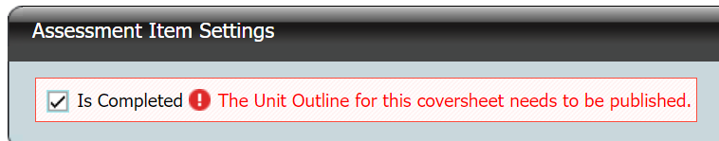

Access
Access control is the same as for the generation of unit outlines. Any ACS user who has access to the markbook that contains the unit will be able to access and edit unit outlines and assessment coversheets for that unit. ‘Transfer’ and ‘User Control’ users are able to view and edit all coversheets at their school such as the Certification Officer or a Head of Faculty.

Starting the coversheet
Go to the Unit Outlines & AI Coversheets page
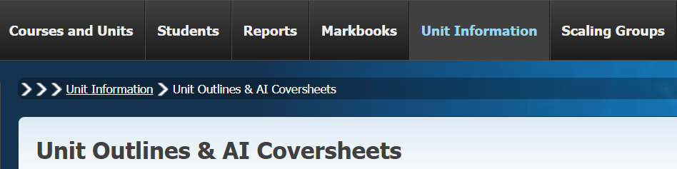
If the correct courses are not displayed on the page, select the correct year and assessment period in the search boxes and click Find.
The list of courses will look like this:
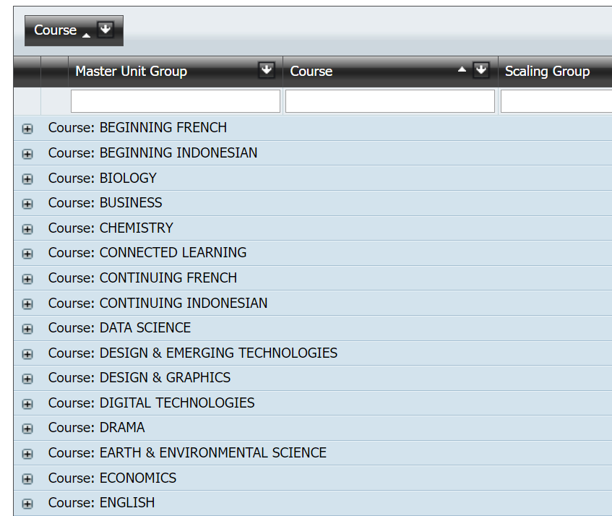

Select the course
In this document we will use the creation of a coversheet for an assessment for Unit 1: Communication of Meaning unit in the English T course as an example.
If the number of courses displayed is large, you can
- sort the courses alphabetically by clicking on the ‘Course’ button or column header
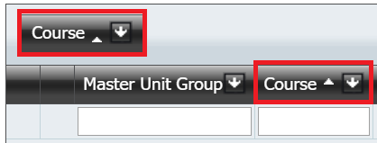
- select the course needed by clicking on the down arrow next to ‘Course’
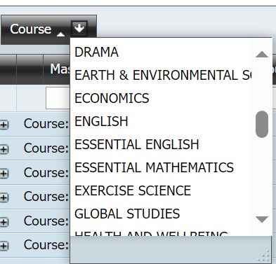
- filter by typing the course name into the filter box row. Any column can be filtered this way.
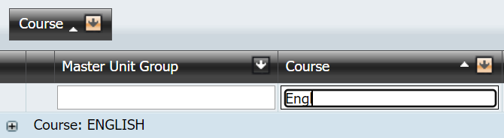

Select the unit
Click on the “+” symbol next to the course to display the units being offered, and then click on the “+” symbol next to the Unit Group name. These Unit Group names will in general be the same as the actual unit name. Sometimes when a unit name is long the group name may have abbreviations or modifications in it, but will allow identification of the group that contains the unit.

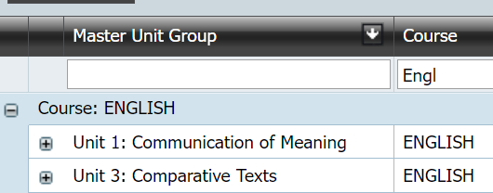
Expand the group to see the list of units. It is a good idea to check the:
- Unit code
- Unit name and value
- Accreditation type
- Year level
to verify that you are generating the cover for the correct unit.
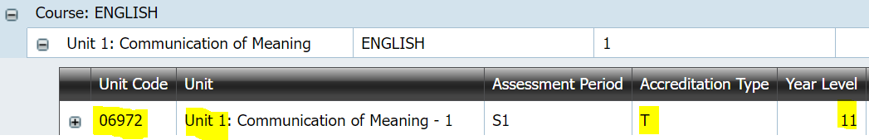
Then click on the “+” next to the unit code.
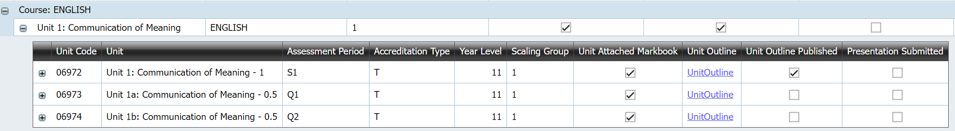

This displays the assessment items that are connected to that unit. Click on ‘Coversheet’ for the one that you want. (Note that the ‘Complete’ and ‘Publish’ buttons will not be ticked at this stage.)

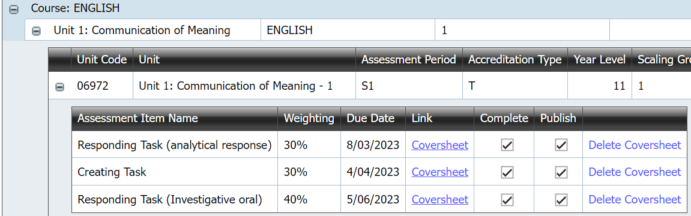

Further, these links will not exist until you have entered due dates for the assessment in the unit outline generator.

Select the Coversheet to create
In this example, a coversheet will be generated for the Responding Task (analytical response) assessment. Click on the Coversheet link. This takes you to the Assessment Item Coversheet generator page.
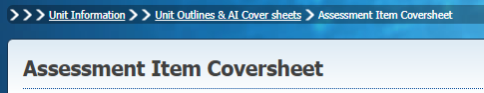

Creating the coversheet

Assessment Item Summary

This section is prefilled for you. It displays summary information for the assessment. The assessment item name, weight and maximum mark are read from the markbook. The due date is read from the unit outline.
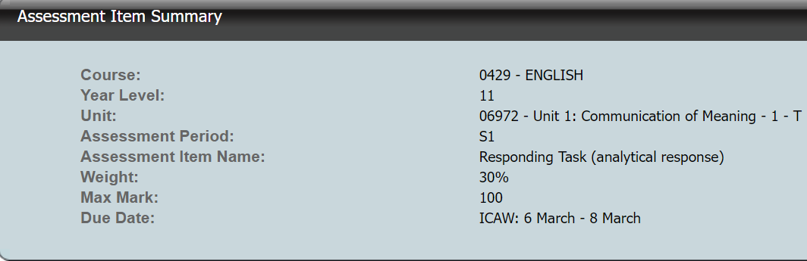

This information will be displayed as the top section in the generated coversheet.

Half-unit assessment item weights
If the assessment is for a 0.5 unit and the weight in the markbook is for a 1.0 unit, ACS automatically displays the corrected weight. For example, if the 1.0 unit had three assessment items with weights 30%, 30% and 40%, but the 0.5 unit had only the first two items attached to it, then the weights for the items would display as 50% for each.

Assessment Item Settings

Action | Description
Save | The only button active initially. Other actions become possible after the coversheet has been saved for the first time.
Print | Generates a pdf that can be downloaded and viewed or printed.
Delete | Completely removes the coversheet.
Check box selected | Description
Is Completed | Flag to primarily let other teachers of the unit know that the coversheet has been finalised. The coversheet must be Saved after the checkbox is ticked or unticked.
This is what you tick if the assessment item is an assignment:
Note that ‘SPO’ stands for ‘Student Profiles Online’.
Coversheet and Attachments Published to SPO | The coversheet must be Saved after this checkbox is ticked or unticked.  The coversheet including any appended pdfs and attached documents is visible to students via Student Profiles Online (SPO).
This is what you tick if the assessment item is a test:
Coversheet only Published to SPO | The coversheet must be Saved after this checkbox is ticked or unticked.  The coversheet ONLY is visible to students via Student Profiles Online (SPO). Students can not see or access and files added in the attachments section in ACS. This is for when you might want to notify students of an upcoming assessment and its associated conditions but not show them the test.

Appendix 2b displays the difference in what a student can download in Student Profiles Online (SPO) depending on which publish option is selected.

Optional Blank Fields to include

The Coversheet allows teachers to choose to include a blank field for the following on the Assessment Item when printed or published:
- Mark / Grade: blank boxes with the possible mark included as in the markbook (e.g., /100). This provides space for a teacher to write in the mark and grade. It is not populated from the markbook.
- Student Name / ID: blank box for the student to write or annotate their name
- Teacher Name: blank box for the student to record their teacher’s name (e.g., in a crossline testing situation).
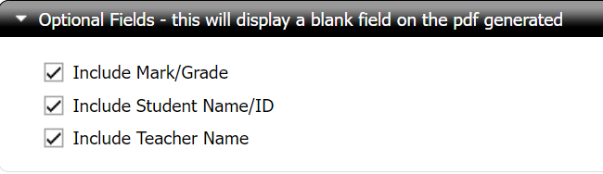
Where a box is not checked in this section, no field will appear on the PDF file downloaded.

Appendix 1 displays how this will show when selected on the PDF report.

Additional Date Information (optional)
This is an optional field that lets you put in further information about the dates of an assessment task. In the below example, the unit outline allows dates from the 6th to the 8th of March for an in-class assessment run across multiple classes. If we know the dates that it will be run in each class, we can include that information here:
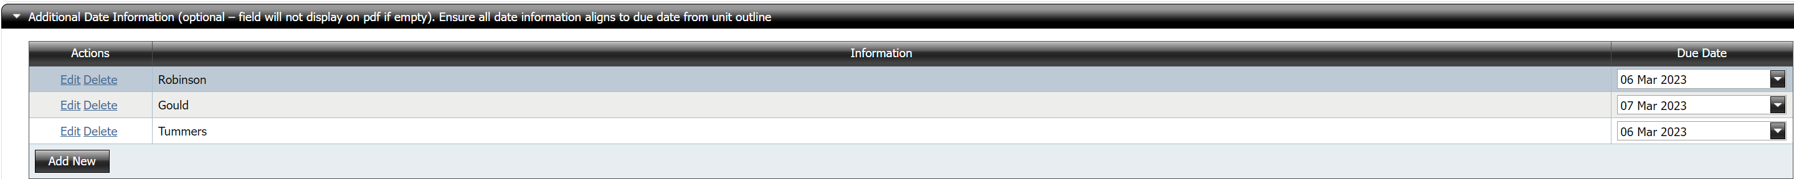
You could also have drafts due on a particular date with the final assessment piece due on another date.
Appendix 1 displays how this will show when selected on the PDF report.

VET Competencies

If your unit includes VET competencies (not the case for English T), they will be displayed in a table:
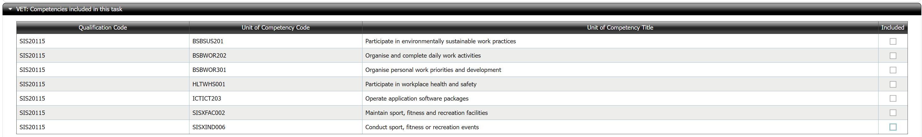
If a competency is included in the assessment task, check the box adjacent to that competency. For example:
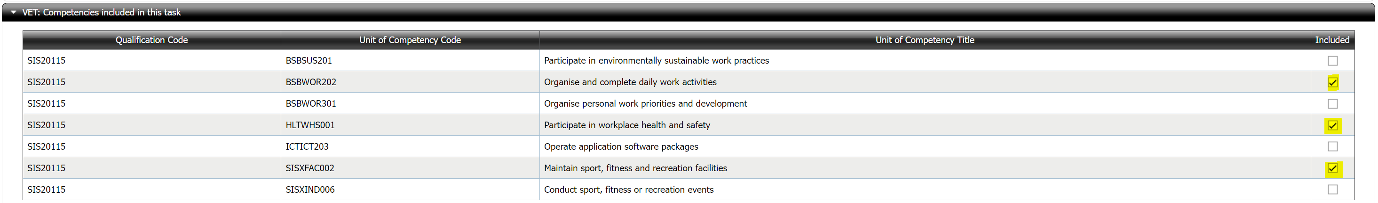
Appendix 1 displays how this will show when selected on the PDF report.

Assessment Policies
This section enables you to add the relevant policies on academic integrity and late submission to the assessment item coversheet.
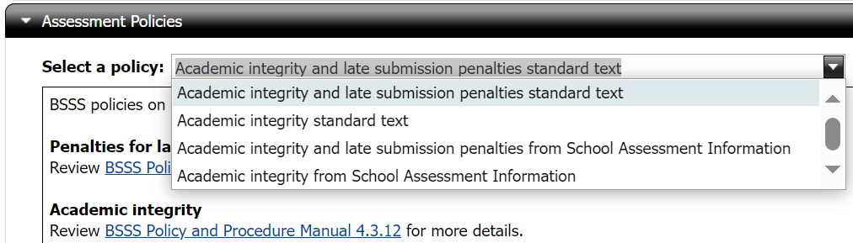

The first key difference—the one late submission penalties information and the other does not—is because this is not relevant to tests (there would be no late submission for a test).
The second key difference—standard text versus School Assessment Information—is that one is automatic and the other is created by the school. The school ones are entered here by the certification officer or faculty head at your school:
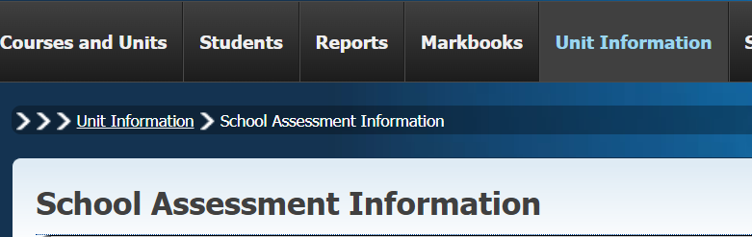
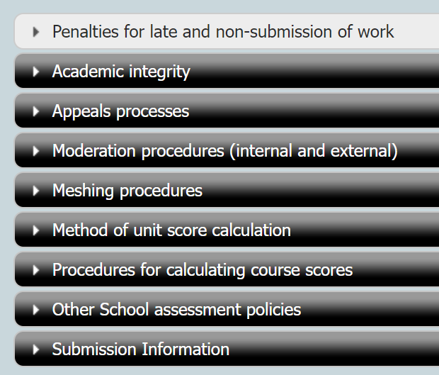
Appendix 1 displays how this will show when selected on the PDF report.

Assessment Conditions
This is where you enter all the conditions of the assessment item. Please note that the formatting capabilities are limited and that if you are copying and pasting you may lose some of the formatting. See the formatting information below.
Here is an example that shows some of the conditions for a mathematics test:
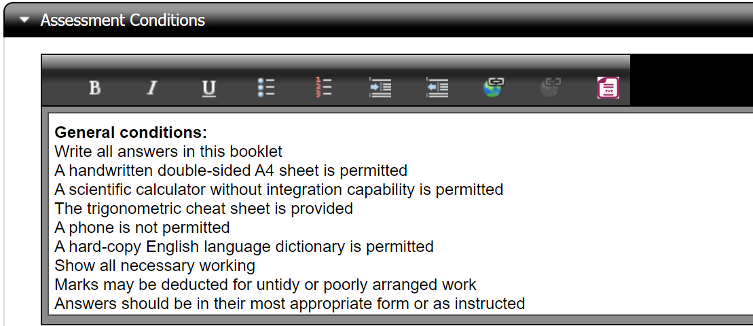
Here is an example that shows some of the conditions for an assignment:
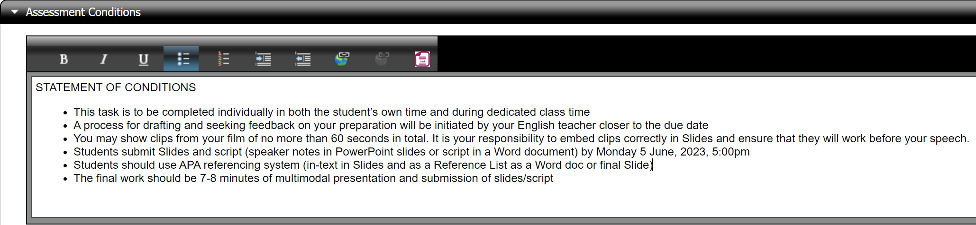
Here is the much briefer example for the assessment task that we are looking at:
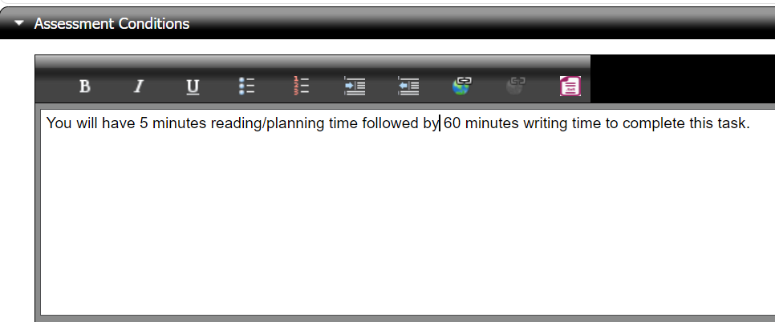
Appendix 1 displays how this will show when selected on the PDF report.

Submission Information

This is where you put information about the submission requirements. You can either enter it here or bring in a school policy. Again, there are limitations on formatting. See the formatting information below.
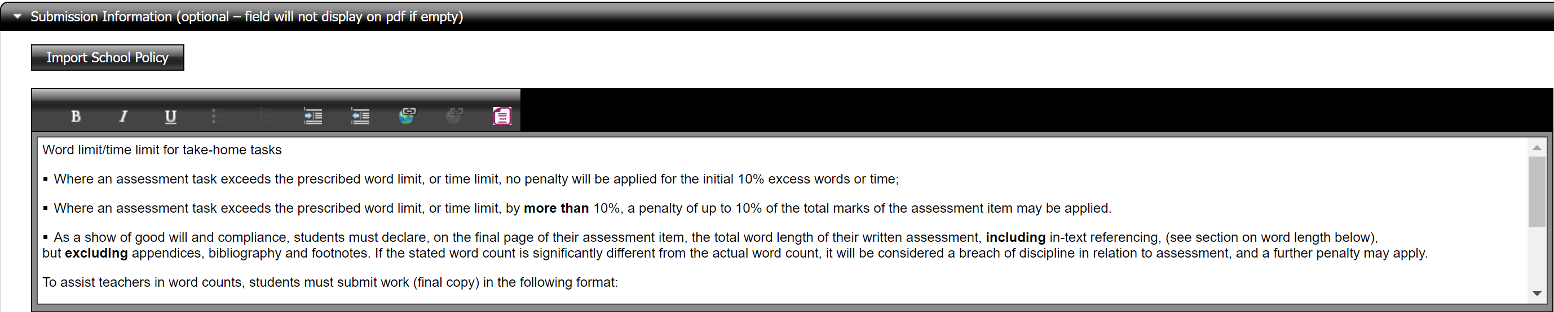
Note that if this information is a school policy, it comes from here:
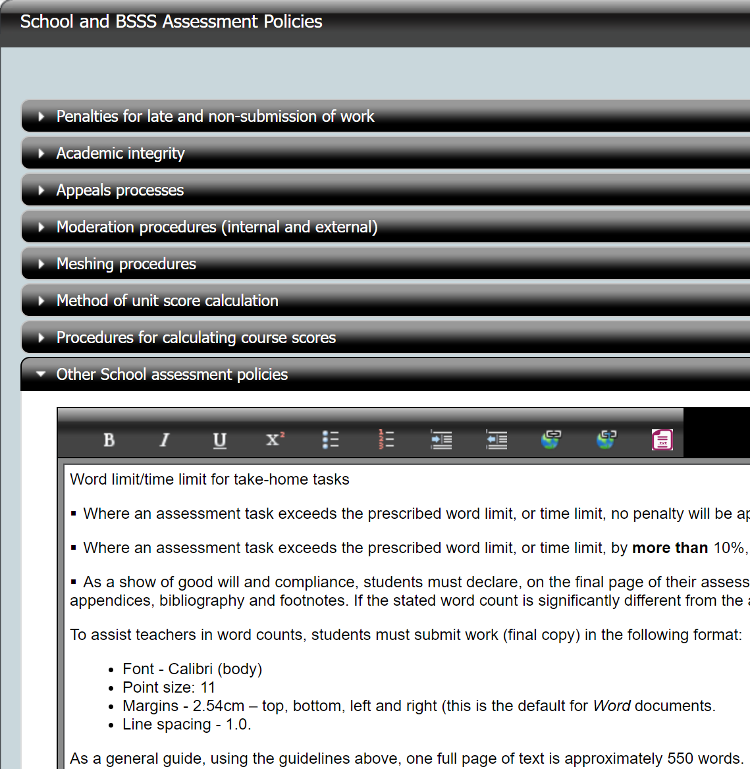
Appendix 1 displays how this will show when selected on the PDF report.

Assessment Instructions or Additional Information (optional)

This is an optional section. Assessment conditions (e.g. time limits) should not be entered in this section. However, if, for example, students were advised to read a particular set of references before attempting the assignment, that would be appropriate for this section.

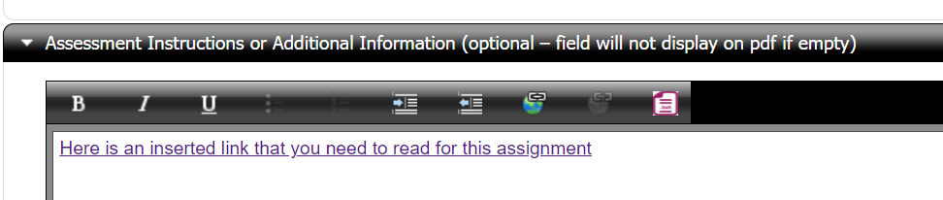
Note that it is possible to insert hyperlinks. If there was a particular web page or online video that students should refer to when attempting the assessment, the link to that resource can be included in this section. See the formatting information below.
Appendix 1 displays how this will show when selected on the PDF report.

Assessment Attachments

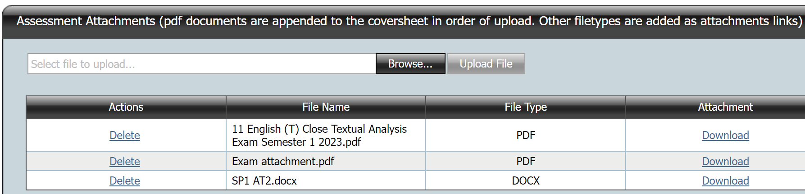

This section allows the upload of files students will need to complete the assessment. For example, this could be a PDF document with the actual task and a XLXS template file to record data in a particular way.

Note that PDF files are the only files that are appended to the coversheet, and they are appended in order of upload; all other files are links.

You could use this instead of other optional fields. Take care that the information on uploaded attachments is consistent with the unit outline and coversheet.
Appendix 1 displays how this will show when selected on the PDF report.
Features to note are:
- Multiple files can be uploaded. Files are uploaded one at a time.
- There is a size limit of 5 MB per file.
- A variety of file types can be uploaded. (e.g. Word, Excel, PowerPoint, JPG, other commonly used file types)
- Once a file has been uploaded, the section underneath displays the file name and file type, the username of the person who uploaded the file, and the time the file was uploaded. It is possible to download the file, for instance to check that the upload was successful and that the correct file was uploaded. A Delete option becomes available in the Actions column to remove the attachment.
- Uploaded PDF documents are appended to the coversheet. When the Print button is used, a single PDF is generated with the coversheet at the beginning and appended files following.
- If non-PDF files have been uploaded, when the Print button is pressed, a PDF file is generated where, following the coversheet, hyperlinks are available to download the attachments.

NOTE: hyperlinks for teachers and students are distinct and not interchangeable.
This is due to the authentication of attachments which happens in two ways:
- A teacher generates and downloads the PDF file (Print) and clicks on a hyperlink, when not logged in to ACS, they will be required to log in before the download commences.
- A student downloads the PDF file from Student Profiles Online and clicks on a hyperlink, it uses their Profiles authentication to download the attachments.
Therefore, a student will not be able to use the hyperlinks in a PDF downloaded from ACS by the teacher. Similarly, a teacher will not be able to download using a hyperlinks in a document downloaded from Student Profiles Online. This means that if you as a teacher download the coversheet and publish that on a Learning Management System these attached documents will not open for students via these links and will therefore need to be uploaded separately.

As a way around this, there is the option to include such links in the ‘Assessment Instructions or Additional Information’ field. For moderation purposes, however, you will need to include them as attachments as well so that the documents are actually in ACS, instead of being somewhere external.

Other Features/considerations when generating coversheet and assessment item

Same Assessment Item for Multiple Units

When multiple units are in the same markbook, and a coversheet has already been created for this assessment item but for a different unit, then ACS offers the option of automatically filling in information from an existing coversheet.
Here is an example of a markbook that contains multiple units:
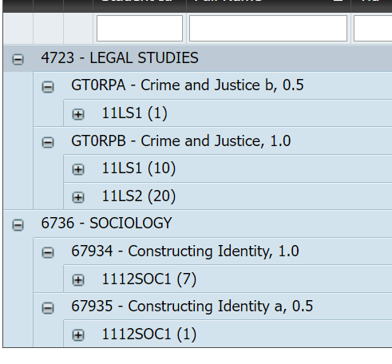
We have created coversheets for the assessment items in the Legal Studies unit:
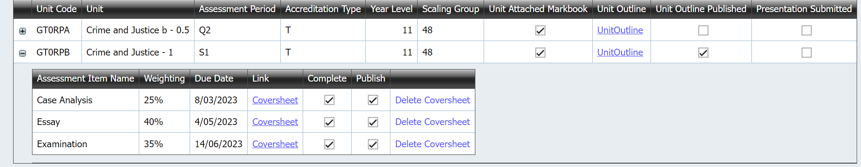
However, we have yet to create all of the coversheets for the assessment items in the Sociology unit:
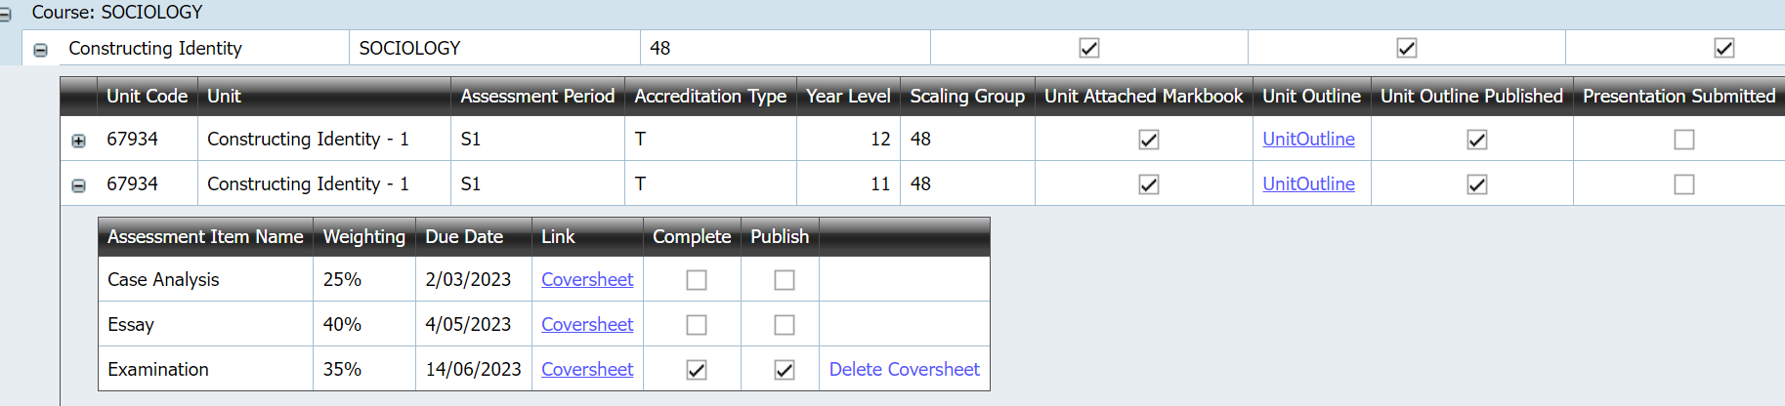
If we click on the Coversheet link for the Essay, we will see this:
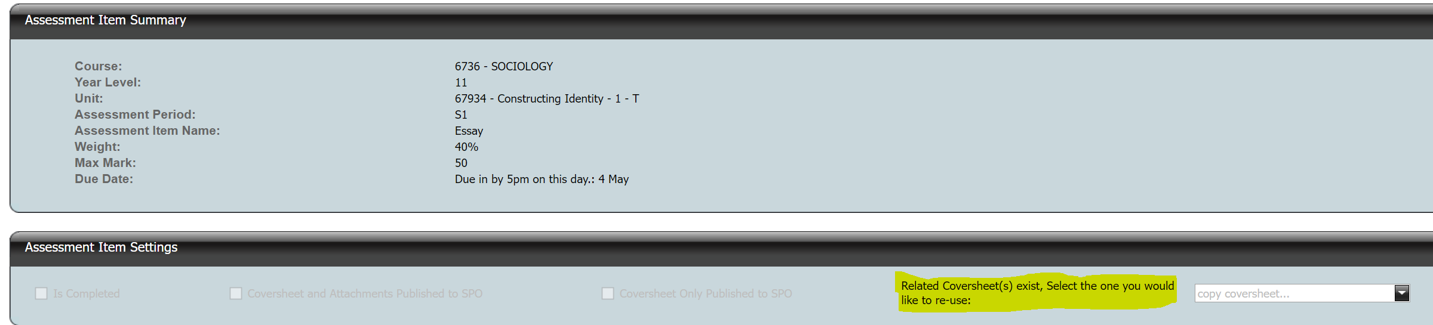
Using the dropdown menu, we will see the following:
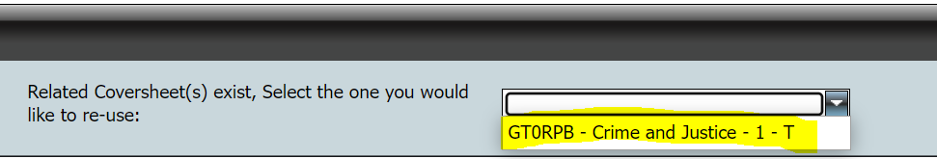
Selecting this unit from the dropdown menu will pre-fill all sections, including any additional due dates, from the chosen coversheet. It even brings in any attachments:
It is possible to edit any of the pre-filled information if you wish. The coversheet still needs to be saved. All functionality on the coversheet generation page is identical to when the pre-fill option is not available (that is, for a stand-alone coversheet).

Limited Formatting Capability

It is not possible to change the layout or formatting of the overall document, for example, the colour scheme, the placement of the school logo and name, or the sequence in which the sections of the document appear.

The headers of text boxes allow a limited amount of formatting of the entered text. These consist of

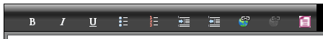

- Font styling: Bold, Italics and Underline
- Lists: Bulleted and Numbered
- Layout: Indent and Outdent

It is possible to insert hyperlinks by clicking on the link icon. The icon to the right of it removes a selected link.

A pop-up window opens where the URL can be entered. It is also possible to enter alternative text description and a tool tip (the text that is displayed when the mouse cursor hovers over the link).

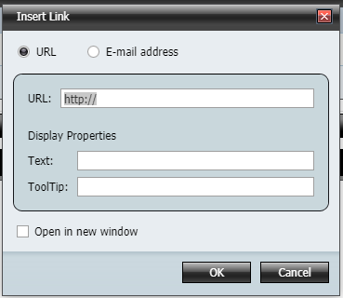

Extraneous formatting in pasted text
If the text is entered into text boxes by copying and pasting from another document (e.g. a Word document), then it is highly recommended that the Convert to plain text feature be used, by clicking on the red document icon after text has been pasted.

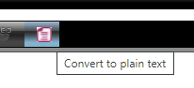
There are often tags belonging to the parent document format (e.g. Word), that may not be visible when pasted into the text box, but affect formatting when the PDF document is generated. It is safer to convert to plain text first, and then re-apply any of the available formatting if desired.

Appendix 1: Assessment Item – PDF (‘Print’)
Below is the first part of the PDF coversheet created by the above process. You can see this by using the print button. This is also what students will see via Student Profiles Online.

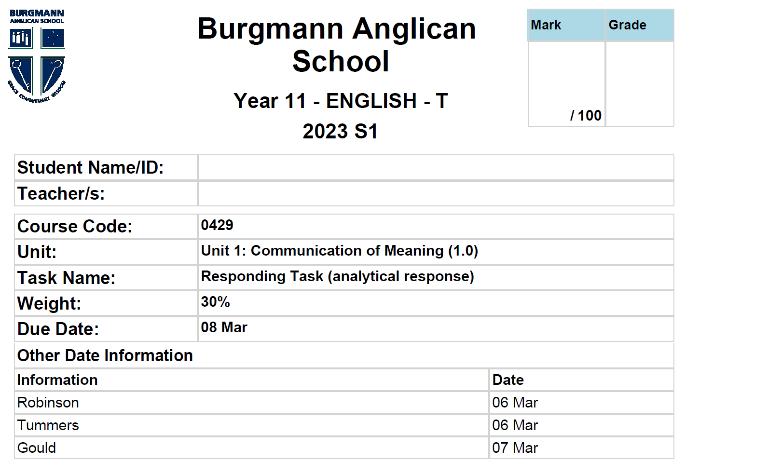
The Other Date Information comes from what we included here: Additional Date

Student Name and Teacher fields are here because we selected them here:
Student Name and Teacher Name
Highlighted entries are from the unit outline.
The Mark and Grade boxes appear because we selected it here: Mark/Grade

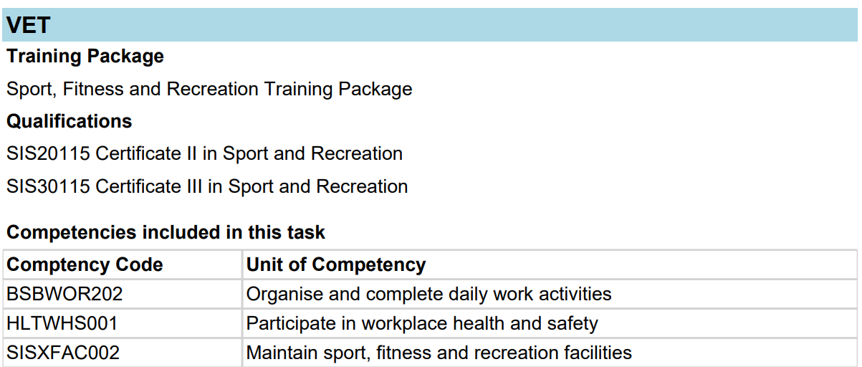
The VET information comes from the unit outline and the competencies comes from what we selected here:
VET Competencies

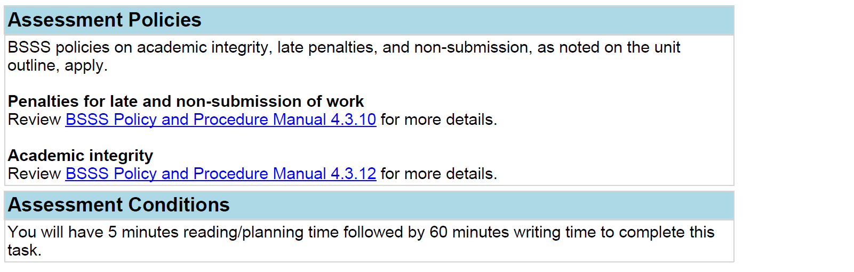
The Assessment Policies were included by what we selected here: Assessment Policies
The Assessment Conditions were included by us here: Assessment Conditions

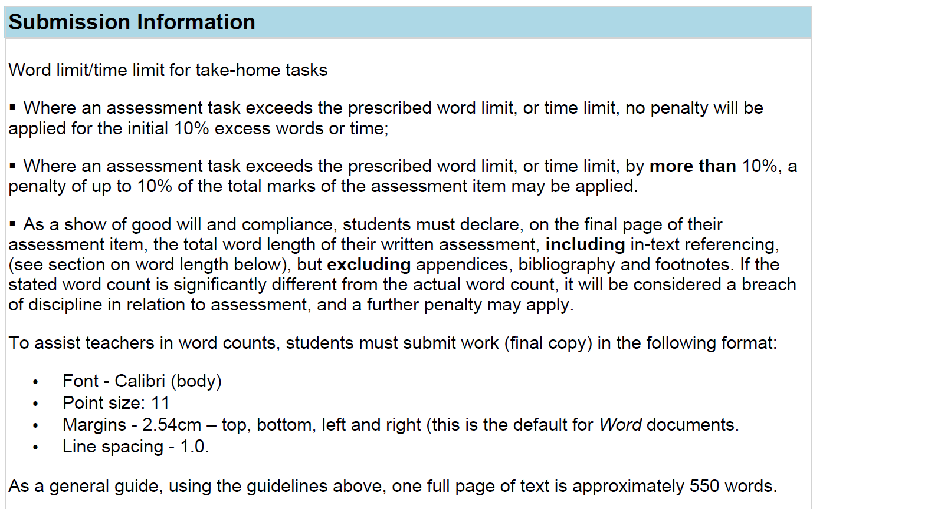
Submission Information was included by us here: Submission Information
Assessment Instructions of Additional Information was included by us here: Assessment Instructions
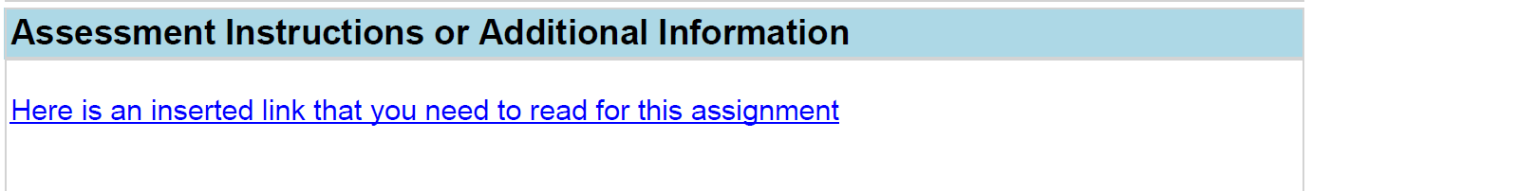

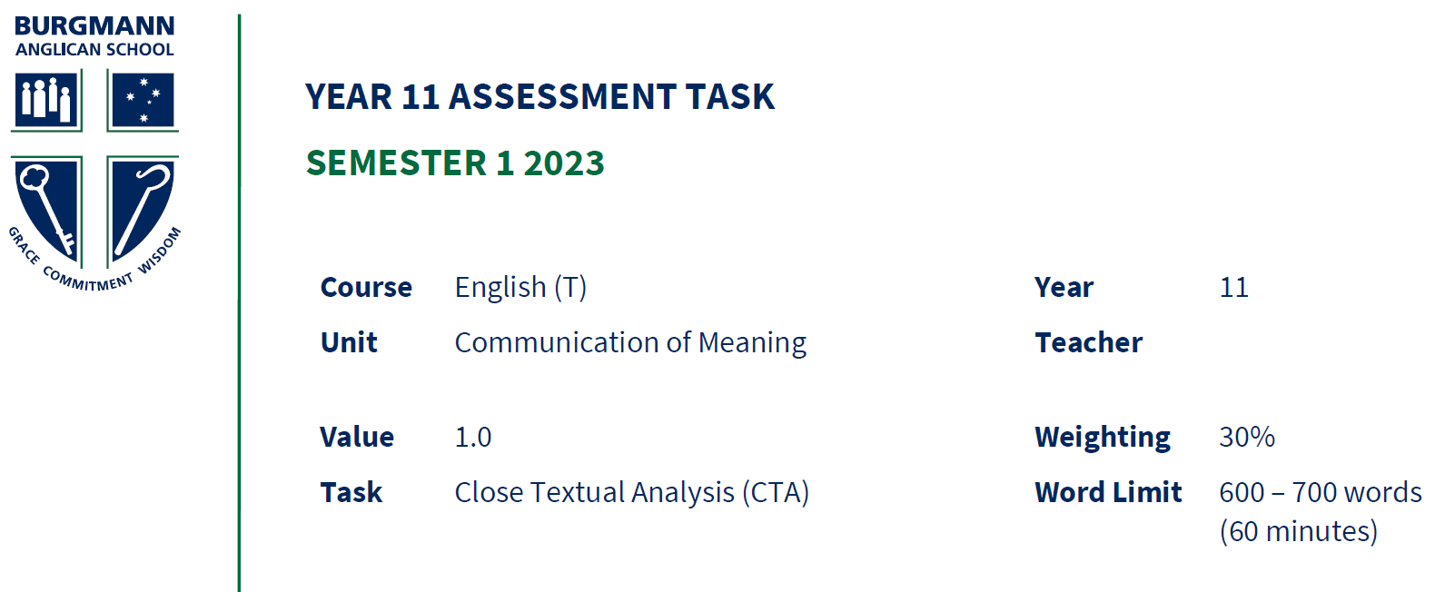
These three attachments were included by us here:
Assessment Attachments
This is attachment 1:
This is attachment 2:
This is attachment 3, which was not a pdf and so was included as a link:

Reminder: if you have chosen to publish the coversheet and attachments, this Coversheet pdf is what students will see when they download in Student Profiles Online. You can select to have them see all of this OR to only see the information entered in the Coversheet itself. This means that they will not see the attachments. See 2b: Student download example based on publishing option in ACS.

Appendix 2: Student Profiles Online

2a: Student Profiles Online view
When a student accesses Student Profiles Online and selects the Unit Outline menu tab they can see any Unit Outline or Assessment Item that has been ‘published’ in ACS.
In the example below, the three English Assessment Items are accessible to the student.

Depending on which option was selected in ACS for publishing, when they click the link the file that downloads will include either the coversheet alone or the coversheet with all appended and/or attached files.

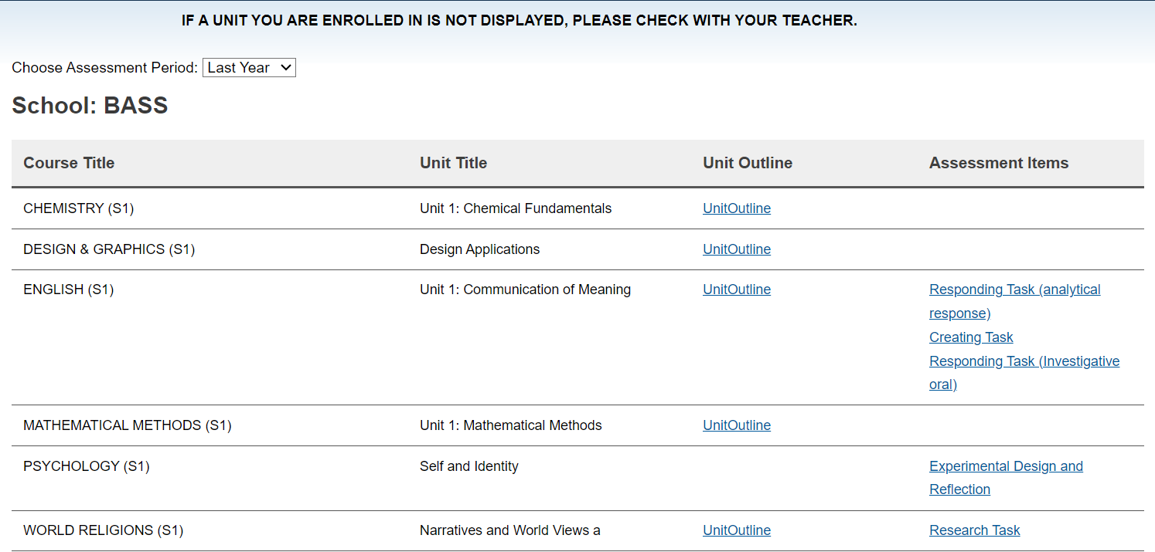

2b: Student download example based on ‘Coversheet Only Published to SPO’ option in ACS
If you want to publish the coversheet only, you tick the below:
The student will see only the below information, and not the other sections (those can be provided at the time of the assessment by changing the button you tick above or by printing it):
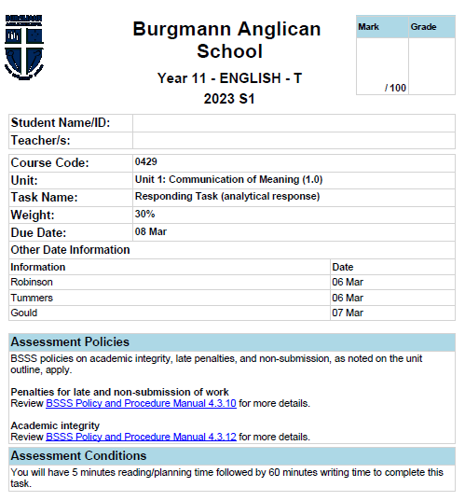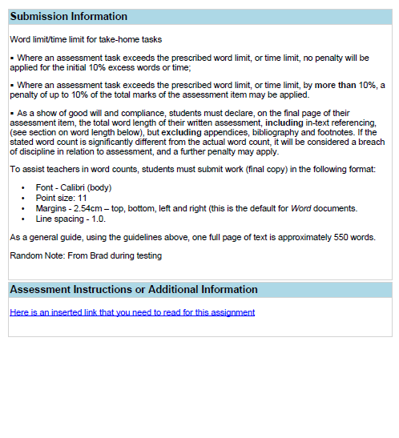
If you select the ‘Coversheet and Attachments Published to SPO’ option, the students will see the pdf as outlined through Appendix 1.

