VET Data in the

ACT Certification System (ACS)

October 2021

Contents
USI verification 3
Qualification Progress Screen 3
Qualification Progress Bar 4
Qualification Groups and Rules 4
Qualification Exceptions 6
Editing Qualification Exceptions 6
Qualifications Progress Report 7
Permissions to Enter VET Competencies 8
Competencies by Unit Screen 8
Entering the Assessment Outcomes for the Competencies 9
Individual Student 9
Multiple Students 10
Student Competency Details 10
Adding a Grade to a C Unit 11
Competencies Screen 12
Competencies by Training Package 12
Entering Competencies 12
Removing a Student from a Certificate 14
Competencies by Student 14
Entering Competencies 14
Removing a Student from a Certificate 15
Certificate completion check 16
Creating an ASBA Certificate 16
Adding Training Contract Number 17
Create the Training Plan in the database 17
ASBA Completion Date 19
Removing an ASBA Certificate 19
Adding a Certificate to a Student 20
Vocational Certification of Year 10 Students 21
Adding a Student to a Certificate 21
Entering Competencies 22
Running a completion check 22

USI verification
Students cannot be awarded VET qualifications unless they have a valid Unique Student Identifier (USI). It is the responsibility of the RTO and college to verify that the USI provided by a student is a valid USI and belongs to the student, and to ensure that the USI has been entered into ACS.

There is a report in ACS, under Reports > VET > USI verification, that will show a list of students and their USIs in ACS, and note any that are not set or are invalid. It is important to note that the validation ACS performs relates solely to the pattern of numbers and letters in the USI and that ACS cannot verify that any given USI belongs to a particular student.

ACS will not allow competencies to be awarded to students who do not have a USI that has passed ACS’s validation check.

Qualification Progress Screen
The Qualification Progress Screen provides a clear overview of a student’s progress in a certificate. The link to this page will only appear to TeachVET users and above.

- Select VET > Qualification Progress Screen
- If a student is not currently selected you will be prompted to select a student from the Search Student popup window. Only students enrolled in a VET qualification will appear in this window.

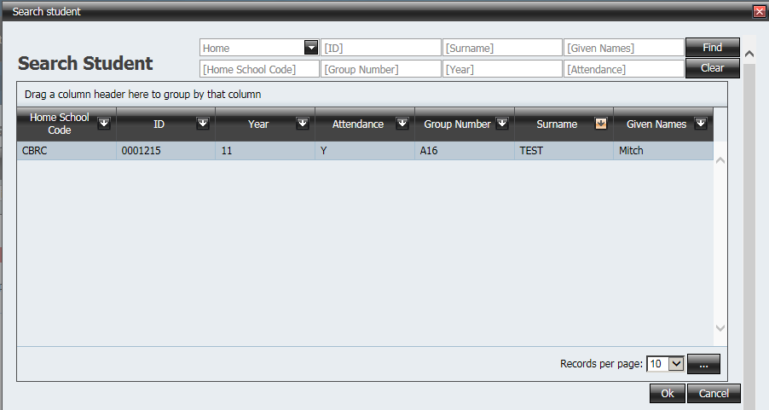

- When a student is selected the following screen should appear

- Should you wish to select another student push the Select Student button
- All VET qualifications that the student is enrolled in should appear in the drop down list labeled Qualification.
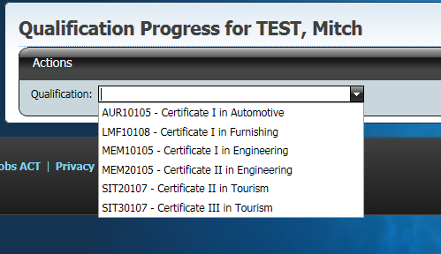

- Select the desired qualification and a screen similar to the following should appear

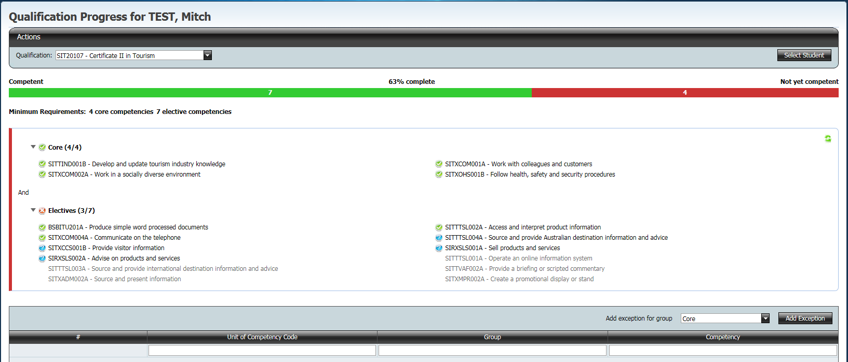

This screen displays the following sections

- Qualification progress bar
- Qualification groups and rules
- Qualification exceptions

Qualification Progress Bar
The Qualification Progress Bar displays a simple visualisation of the student’s progress in a certificate.
The number of competencies achieved are represented by the green bar and the percentage complete.

Qualification Groups and Rules
- By default this section should show all the groups in the qualification and the rules required to complete the qualification
- The number of achieved competencies and the number of required competencies in each group is represented in the brackets at the end of the group name. If the number of achieved competencies meets the requirements a green tick will appear next to the group.

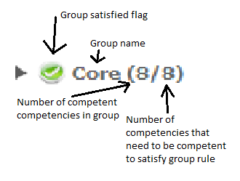
- Certificate rules are also represented by the use of the logical operators and/or between groups.
  - AND means both groups need to be satisfied for the rules to be satisfied
  - OR means either group can be satisfied for the rules to be satisfied

- In some more complex qualification rules, rule groups and rule conditions may be used to facilitate the qualification rules.

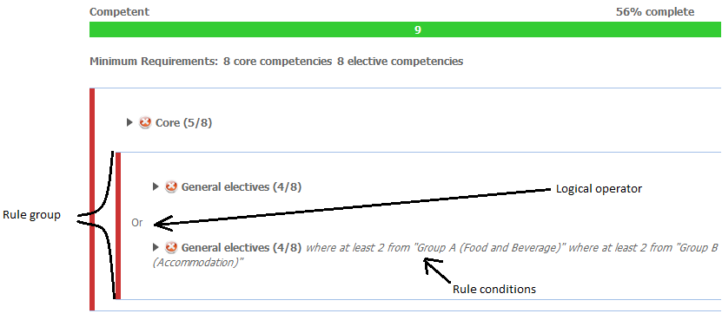

- Pressing on the group name displays competencies in that group. Achieved competencies are flagged, as are competencies that the student is currently enrolled in but has not yet achieved. Competencies that the student is not enrolled in (ie. competencies that are not attached to any enrolled unit) are displayed in grey.

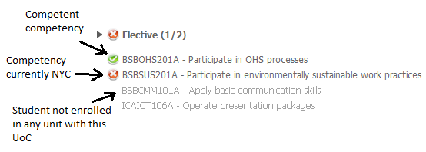

Qualification Exceptions
The Qualification Exceptions section is used to detail competencies that are being used by this student for this qualification but aren’t in the usual BSSS delivery for the qualification. Exception must still follow the training package rules for the qualification.

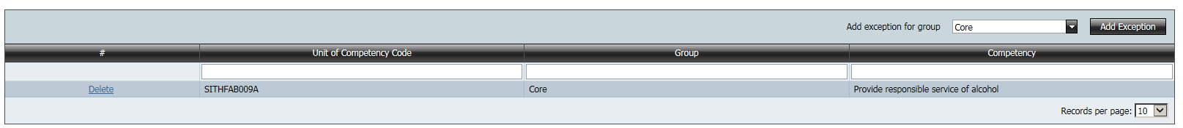

Editing Qualification Exceptions
This can be completed by SchoolVET users only.

- In the Qualification Exceptions section, select the group you want to add the exception to from the dropdown menu and push the Add Exception button.

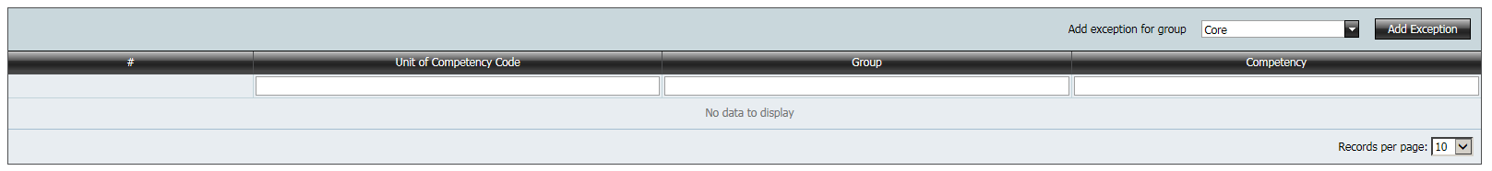

- The following window should appear.

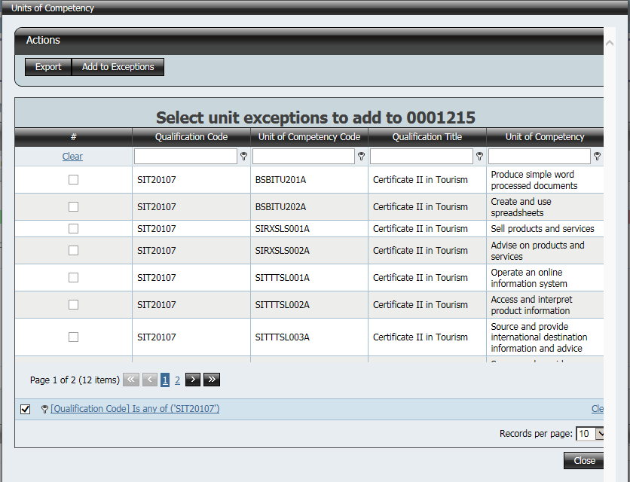
- From here, units of competency can be selected with checkboxes.
- Push the Add to Exceptions button to save the changes.
- Competencies selected should now appear in the Qualification Exceptions section for that student

Qualifications Progress Report
The report available under Reports > VET > Student Qualification Progress will provide a snapshot of VET achievement for groups of students who meet various selection criteria that can be set by the user.

Permissions to Enter VET Competencies
There are two ways VET competency data can be entered for students
- Competencies by Unit Screen for TeachVET and above
- Competencies Screen for SchoolVET, Transfer and above

Competencies by Unit Screen

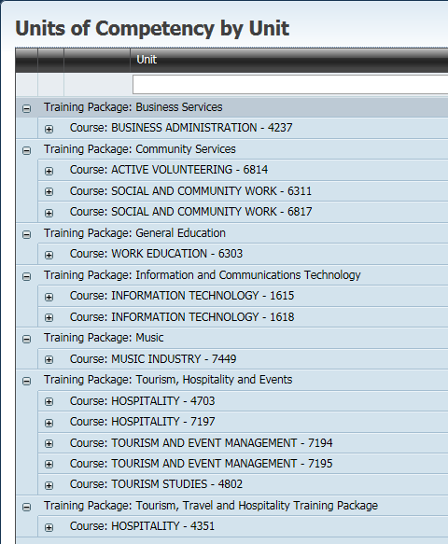

This screen shows the VET courses accredited to an RTO college grouped by training package, course then unit. Each grouping can be expanded to see the students enrolled in the units, and record their assessment, by clicking on the plus signs.

NOTE:
Students undertaking an Australian School based Apprenticeship (ASBA) will appear in RED. The assessment outcome of any competency that is in the student’s Training Plan cannot be edited in the Competencies by Unit screen. An error message will appear if you attempt to edit the assessment outcome of any of these competencies.

- The Training Packages and associated BSSS courses for your college are shown. Click on the plus sign near the word Course and the course will expand to the unit level

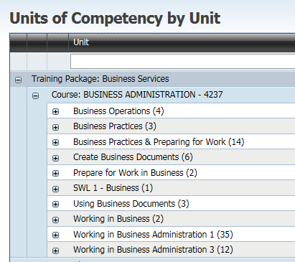

- The number in brackets after the unit title is the number of students who have enrolled in that unit (eg Automotive Electrical systems (55) – means there are 55 students who have enrolled in this unit)
- Students who do not have a valid USI in ACS will be highlighted in dark green. ACS will not allow any edits to be performed to their competency status.
- Click on the plus sign near the unit title to expand to the student and competency level as shown below

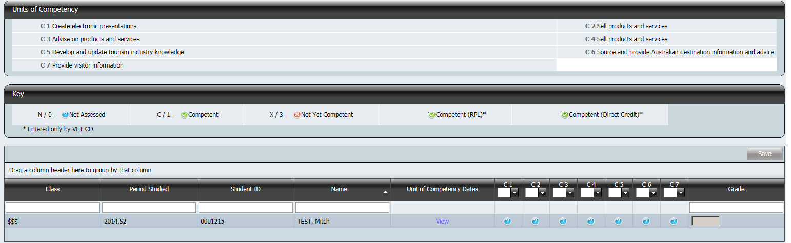

Referring to the screen above
- All competences associate with the unit appear at the top of the screen
eg C 1 Work and communicate effectively in an IT environment
- The keys required to enter the outcome of the assessment in the competencies appear below the competencies
Type in N or 0 for Not Assessed shown on screen as
Type in C or 1 for Competent shown on screen as
Type in X or 3 for Not Yet Competent shown on screen as
Competent (RPL) and Competent (Direct Credit) are also shown but they may not be entered from this screen

Entering the Assessment Outcomes for the Competencies

Individual Student
- Click on the plus sign near the word class to expand to show all students in that class
- Click in the row for the student and the competencies. The active row has a gold background and the cell is highlighted by a red border as shown below

- After you have edited the assessment outcome of the competency the highlighted cell automatically moves to the next competency in the row
- When you are at the end of the row, editing the assessment outcome of the competency will move the highlighted cell to the first competency in the next row
- Alternatively pressing on the right arrow key on your keyboard will move the highlighted cell to the next competency
- Once you are at the end of the row, the right arrow key will move the highlighted cell to the first competency in the next row
- You will need to save your changes before leaving the screen. The Save button is at the top right of the grid

Multiple Students
- To make all students in the screen Not Assessed or Competent or Not Yet Competent for a particular competency
- Click on the down arrow next to the competency code as shown below e.g. C2
- Select the required option and the following message as shown below appears
- Click on OK to make all students Not Assessed or Competent or Not Yet Competent
- This saves automatically. The Save button is greyed out.

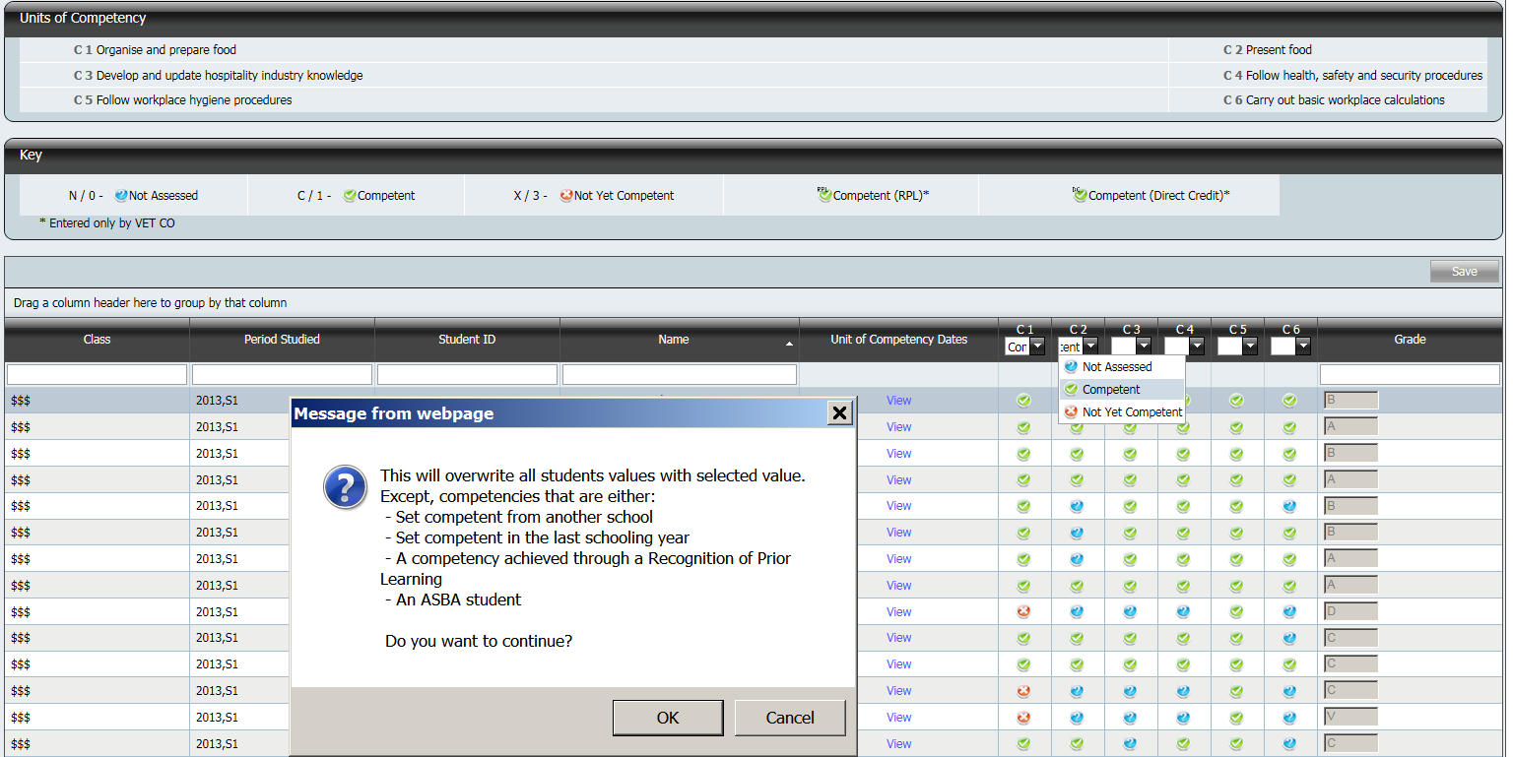

Note: TeachVET users will not be able to edit a competency that is competent if it is from the previous year. Competencies made competent by another teacher can only be altered by the SchoolVET user.

Student Competency Details
You can view the details of the awarding of a competency by selecting the View link. The teacher that awarded the competency, the RTO and the date and time should be displayed.
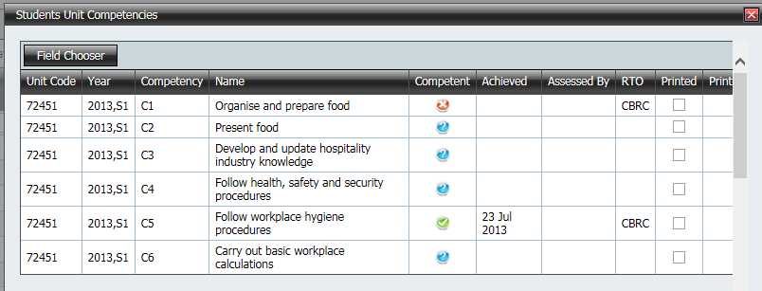

Adding a Grade to a C Unit
- Click Competencies by Unit in the ACS main menu to access the Competencies by Unit screen
- Navigate to the C course, unit and certificate and expand to see the competencies recorded for each student
- Click the View hyperlink to see the date the competencies were achieved for the student in that unit

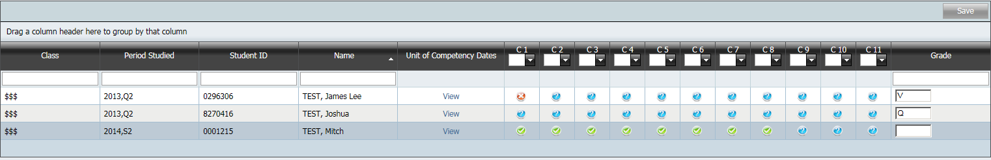

- Check that the student has achieved a competency in the current assessment period.
- After checking if the student has achieved competencies in the current assessment period award a in the right hand column.
- If the student has achieved competencies in the current assessment period award a P (Pass) grade.
- If the student has met only the attendance requirements for that unit and has not achieved any competencies in the current assessment period award a Q (Participate) grade.

Competencies Screen
- Under the VET heading in the menu pane select Competencies and the following screen will appear. The page defaults to Training Package.

Competencies by Training Package
- Click on the plus sign next to the Training Package.
- Click on the plus sign next to the certificate title to expand to the list of students as shown below
- ACS will not allow any edits to be performed to their competency status for any student who does not have a valid USI in ACS.
- Any student who is undertaking this certificate as an ASBA will be in RED.

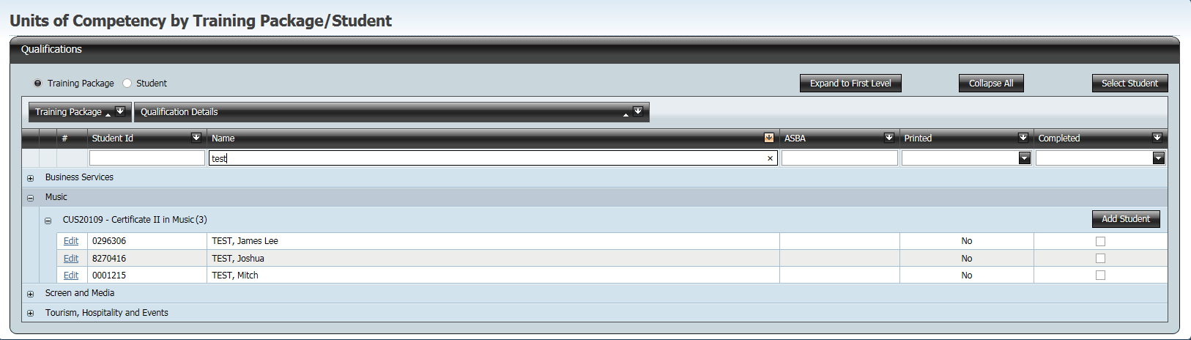

Entering Competencies
- Click on the word Edit next to the student name and the following screen will appear. The active competency has a gold background

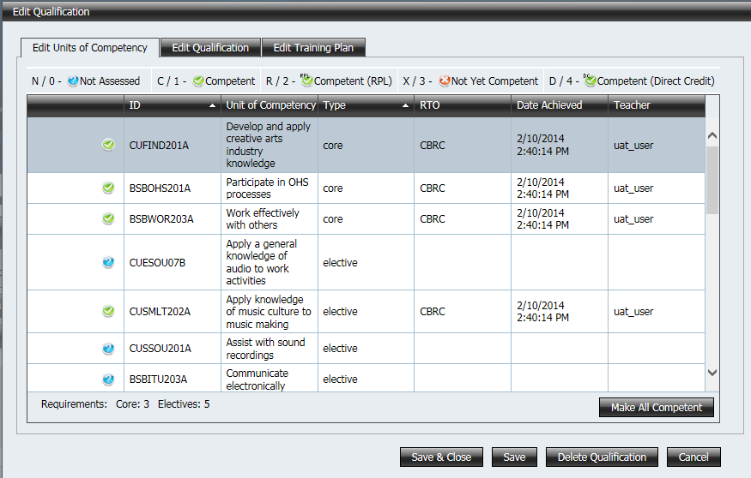

- To select a competencies click on the words of the competency
- Click in the icon box (column before Competency) as shown below to change the assessment outcome for the student

Assessment Outcome | Data Entry
Not Assessed | Enter N or 0
Competent | Enter C or 1
Competent (RPL) | Enter R or 2
Not Yet Competent | Enter X or 3
Competent (Direct Credit) | Enter D or 4

- After you have changed an assessment outcome for a competency the highlighted cell and active competency will automatically move to the next competency in the list
- Don’t forget to save before moving on to a new student

SchoolVET also has permission to make Units of Competency ‘Not Yet Competent’ if made Competent by another teacher, however you cannot edit the competency if it was ‘ticked’ in a previous year or it was made competent by another RTO.

Another thing to take note of is that the Competencies screen shows all certificates a student is enrolled in. This means that if they have come from another school and were enrolled there in a certificate you do not have scope for, it will still appear in this list. However, if you try and make a competency achieved of which you do not have scope you will get the following message.
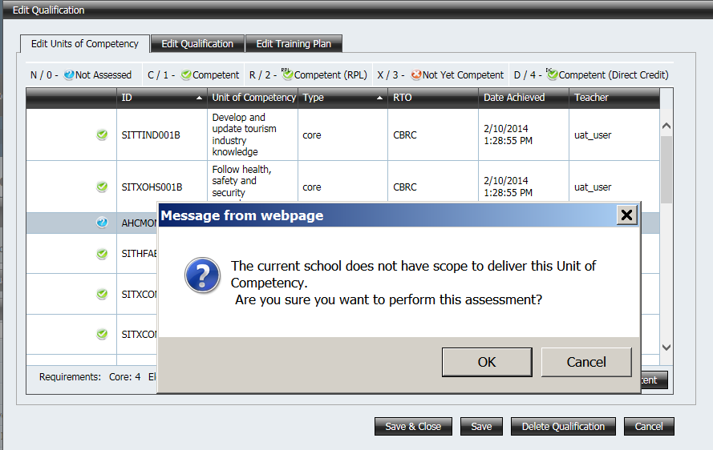

Removing a Student from a Certificate
- Click on the word Edit next to the student’s name
- To delete a redundant certificate for that student click on Delete Certificate. A certificate will only be deleted if all of the competencies that are marked as competent in this certificate also belong to other certificate(s)

Competencies by Student

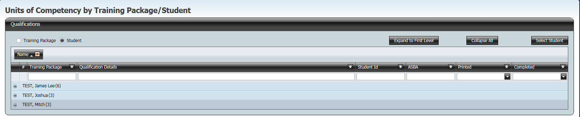

- Click on the student radio button to display a list of all students from your college with competencies
- Click on the plus sign next to the student’s surname to expand to the list of certificates for the student as shown below

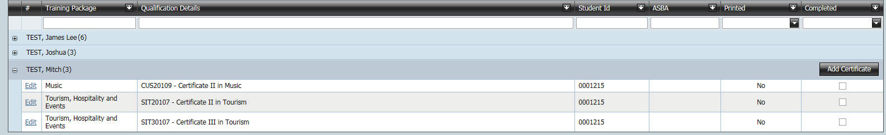

Entering Competencies
- Click on the word Edit next to the certificate title to edit the competencies for this certificate. The following screen will appear
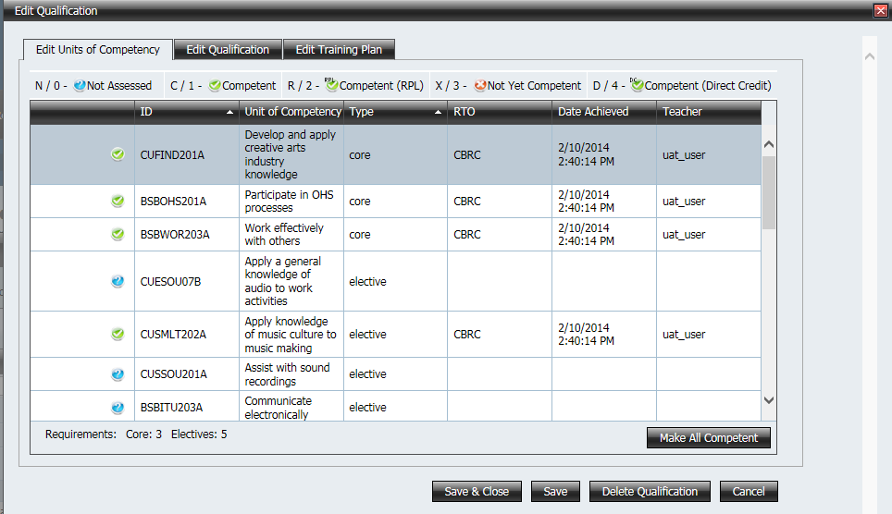

- To select a competencies click on the words of the competency. The active competency has a gold background
- Click in the icon box (column before Competency) of the active competency to change the assessment outcome for the student

Assessment Outcome | Data Entry
Not Assessed | Enter N or 0
Competent | Enter C or 1
Competent (RPL) | Enter R or 2
Not Yet Competent | Enter X or 3
Competent (Direct Credit) | Enter D or 4

- After you have changed an assessment outcome for a competency the highlighted cell and active competency will automatically move to the next competency in the list
- Don’t forget to save before moving on to another certificate or a new student

Note: You cannot edit the competency if it is competent and was ‘ticked’ in a previous year or it was made competent by another RTO.

Removing a Student from a Certificate
- Click on the word Edit next to the certificate title
- To delete a redundant certificate for that student click on Delete Certificate. A certificate will only be deleted if all of the competencies that are marked as competent in this certificate also belong to other certificate(s)

Certificate completion check
ACS users with SchoolVET role (usually VET Coordinators) have access to the certificate completion check page under the VET tab.

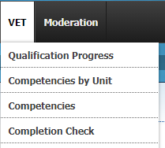

On the page there are options to run completion checks for just Year 10s, just Year 11s, the graduating cohort, or for all VET students at the school RTO.

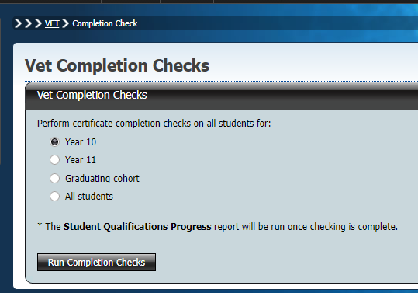

Choose the set of students for whom the check should be run by clicking on the corresponding radio button and then click on the Run Completion Checks button.

The check can take several minutes to complete, depending on the number of students and the number of certificates involved.

Once the check is complete the Student Qualifications Progress report is run for that set of students. The PDF file can be downloaded as a record of student VET achievement at that point in time.

A completion check can be run at any time. It is recommended that a completion check is performed once the school VET Coordinator believes that VET data have been finalized for a cohort, and before they are certified.

Creating an ASBA Certificate
If a student is undertaking an ASBA where the college is the RTO, there are additional obligations and responsibilities for the college.
- Colleges must have copies of Student Training Plan to complete these details
- Care should be taken to enter the correct details

Adding Training Contract Number
The ASBA details are entered using the Competencies by Student screen
- Click on the plus sign next to the student surname to expand to the list of certificates for the student
- Click on the word Edit next to the certificate to edit the properties for this certificate. The screen below will appear

- Click on the Edit Qualification tab and the following screen appears

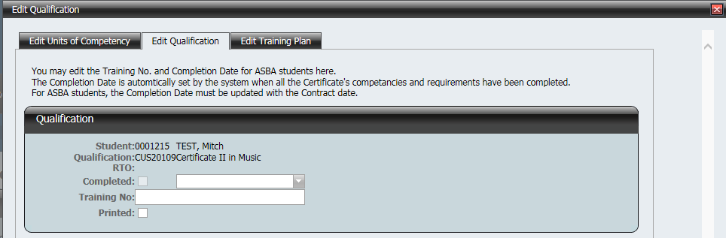

- Type the training contract number into the Training No box
- Press the Save button to save the changes to the database. The certificate will now appear in red font in the list of certificates for that student

Create the Training Plan in the database
- Click on the plus sign next to the student’s surname to expand to the list of certificates for the student
- Click on the word Edit next to the certificate title to edit the properties for this certificate
- Click on the Edit Training Plan tab and the following screen appears

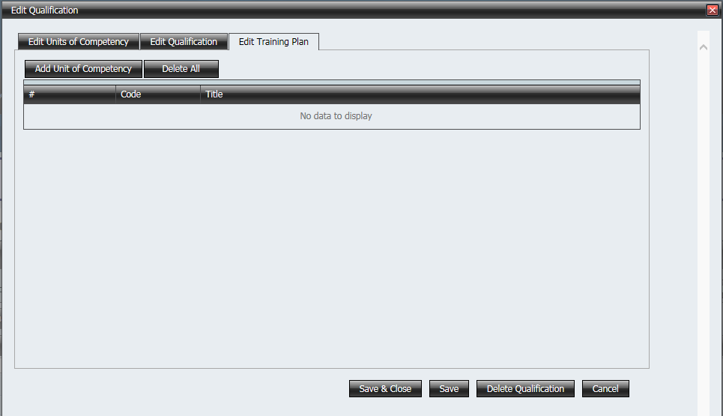

- To add competencies, push the Add Unit of Competency button
- Using the student’s Training Plan, select the competencies by clicking in the box to the left of the Competency Id as shown below. Note that the training plan must satisfy the minimum requirements of the certificate.

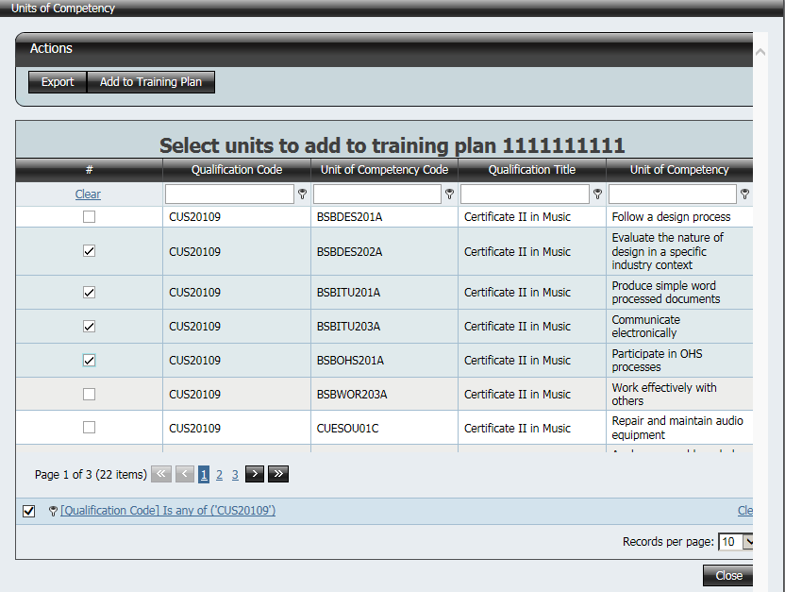
Note: By default, the list of competencies shown are those that are part of the normal certificate. If you require to add a competency from another certificate, the best way is to clear the Qualification Code filter
- Click on the text of the filter
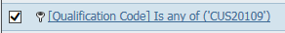
- The following window should appear
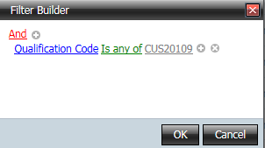
- Click on the ‘x’ icon to clear the filter of the qualification

- Click on Save or Save & Close
- The competencies should now appear on the Edit Training Plan tab

ASBA Completion Date
As soon as the last competency has been achieved for an ASBA certificate, the Completed flag should appear on the Edit Qualification tab. A completed date will automatically appear. This date is editable if required.

Removing an ASBA Certificate
If a student has had an ASBA contract cancelled
  - Remove the Training Plan by unticking the orange competencies in the training plan
  - Remove the Training Number
The student’s certificate record should no longer be red.

Adding a Certificate to a Student
- Using the Competencies by Student screen find the student by using the filter or click on the Select Student button
- Click on the plus sign next to the student’s name to expand to the certificates the student is studying as shown below

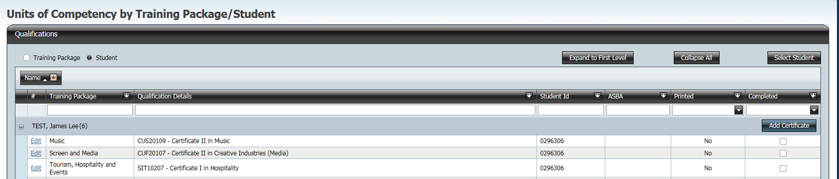

- Click on the Add Certificate button and the following screen appears

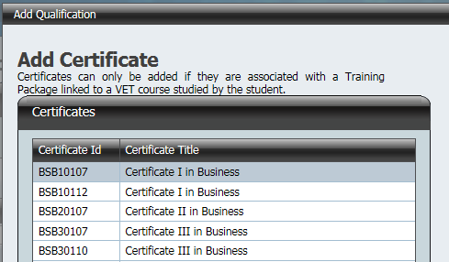
- You can only add a certificate to a student if the student is studying a BSSS course that has been accredited as a vocational program and the college has scope to deliver that certificate
- Select the certificate by clicking on the certificate title. The active row has a gold background
- Click on the Add button
- The certificate will appear in the list of certificates for that student

Vocational Certification of Year 10 Students
Many colleges are overseeing the awarding of competencies to students in year 10. This only happens when there is a formal agreement with the college, high school and BSSS that specifies the Certificate or Statement of Attainment that is to be delivered.

The initial step is to have the student’s details entered into the BSSS database. How to enter the year 10 student details is not covered in these instructions. Once the student details are entered, the student is added to the appropriate certificate, and then competencies are awarded to the student.

Adding a Student to a Certificate
  - Select Competencies under the VET menu and use Competencies by Training Package option.
- Click on the plus sign next to the Training Package. This expands to a list of all certificates in that Training Package that your college has scope to deliver
- Click on the plus sign next to the certificate title to expand to the list of students
- Click on the Add Student button as shown below

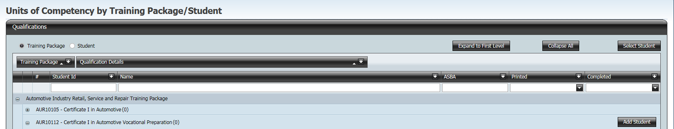

- Search Student screen will appear. In the Year Level filter box type in 10 and click the Find button as shown below

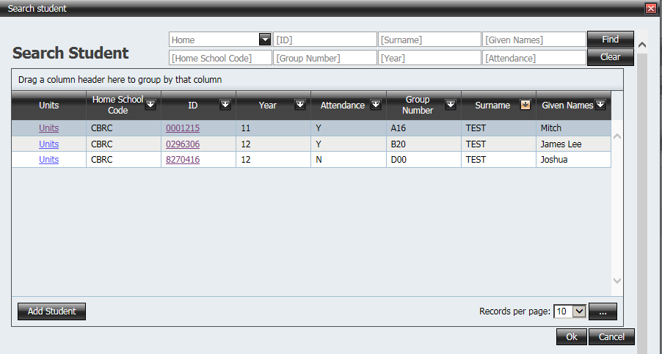

- Select the student by clicking on the Surname. The active row has a gold background.
- Select OK
- The student is now added to the list for that certificate

Entering Competencies
- Click on the word Edit next to the student’s name to edit the competencies for this certificate. The following screen will appear

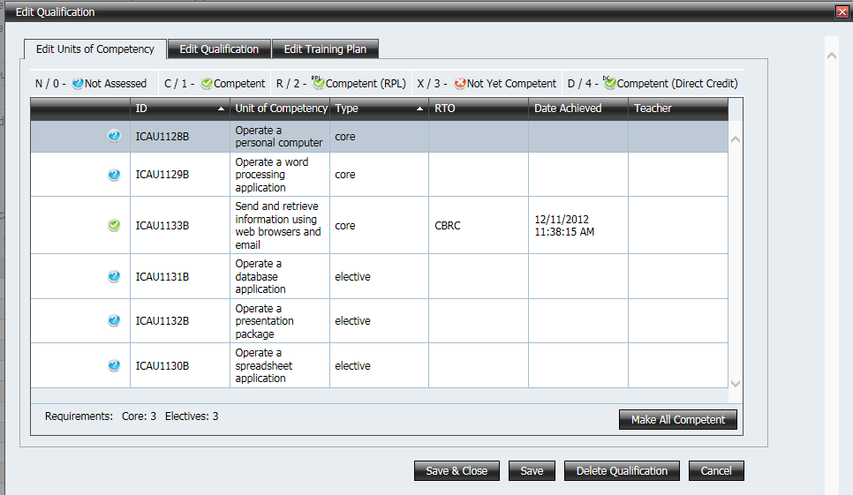

- To select a competencies click on the words of the competency
- Click in the icon box (column before the Competency) of the selected competency. The selected competency has a gold background. Change the assessment outcome for the student
Assessment Outcome | Data Entry
Not Assessed | Enter N or 0
Competent | Enter C or 1
Competent (RPL) | Enter R or 2
Not Yet Competent | Enter X or 3
Competent (Direct Credit) | Enter D or 4

- After you have changed an assessment outcome for a competency the highlighted cell and active competency will automatically move to the next competency in the list
- Don’t forget to save before moving onto a new student

Running a completion check
See the section Certificate completion check.

