Ensure that the unit outline for the unit has been started and that dates have been entered for the assessment item that you are creating the coversheet for.
In ACS, go to ‘Unit Information’ and then ‘Unit Outlines & AI Coversheets’, enter the year and assessment period that you need and click ‘Find’.
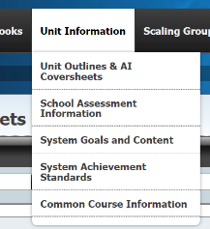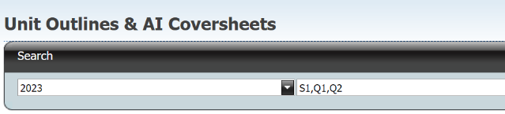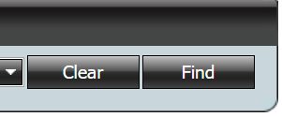
Scroll down the list of courses to the one you want, select the correct unit, then expand to find the right assessment item and then click on the coversheet link for that assessment item.
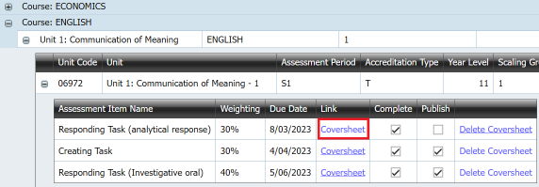
Save the now open coversheet.
If there is a related coversheet for a different unit in the same markbook, you will see this:
You can use the drop-down to select the one to reuse. This will copy across all the information.
If there is no related coversheet:
- Select the optional fields that you want (mark/grade, student name, teacher name);
- Add additional date information (e.g. draft submission dates, test dates for different lines);
- Select relevant assessment polices (academic integrity and/or late submission policy);
- Enter the assessment conditions;
- Enter submission information (e.g. font sizes, required referencing style) – note that this can come from a school policy that is entered by the certification officer or faculty head; and
- Enter assessment instructions or additional information (e.g. a link to something that needs to be read before attempting the assessment, or what needs to be done in an assignment)
Note that all of the above will be published to Student Profiles Online (SPO). Therefore, do not enter any test questions in any of the above fields (or anything else that you do not want students to see prior to the assessment.)
Now add any attachments. If you are creating the coversheet for a test, here is where you can add test questions (create in word and then upload as a pdf file). You can also attach other files – for example, excel or word documents – but these will be links, so more useful in take-home assignments.
The most important thing is to decide what to publish. Don’t publish test questions before the test!
If the assessment is a test or you want students to see the assessment date and conditions but not the assessment task, you need to tick ‘Coversheet Only Published to SPO’: If the assessment is an assignment and you want students to see all of the task, you need to tick ‘Coversheet and Attachments Published to SPO’.
To complete the publishing process, you now need to save the coversheet.
For more detailed information on all of this, see the extended help document here:
AI Coversheets Help Document.pdf

