Generating Unit Outlines in ACT Certification System (ACS)

May 2021

Table of Contents
Pre-requisites 3
Access 3
Starting the Unit Outline 3
Select the course 3
Select the unit 4
Creating the Unit Outline 4
Unit Outline Summary 4
Unit Outline Settings 5
Unit Goals 5
Content Description 5
VET Competencies 6
Assessment Item Due Dates 6
Specific Unit Information 7
Extraneous formatting in pasted text 8
Saving and adding Additional Information 8
Cloning Assessment Dates 9

Pre-requisites
To generate a unit outline, it is required that a markbook has already been set up for that unit, with assessment item names and weights.

Access
Any ACS user who has access to the markbook that contains the unit will be able to access and edit unit outlines and assessment cover sheets for that unit. ‘Transfer’ and ‘User Control’ users are able to view and edit all coversheets at their school.

Starting the Unit Outline
Go to the Unit Outlines & AI Cover sheets page
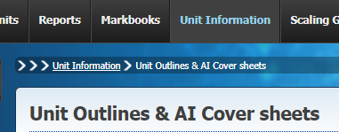

If the correct courses are not displayed on the page, select the correct year and assessment period in the search boxes and click Find.

Select the course
In this document we will use the creation of a coversheet for an assessment for the Photo Practice unit in the Photography course as an example.

If the number of courses displayed is large, you can
- sort the courses alphabetically by clicking on the Course button or column header
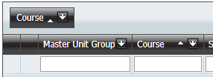
- Click on the down arrow next to Course, and select the course needed
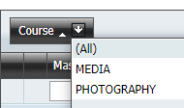
- Type the course name into the filter box along the top. You are also able to filter on any of the other columns visible.
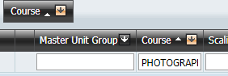

Select the unit
Click on the “plus” symbol next to the course to display the units being offered, and then click on the “plus” symbol next to the Unit Group name. These Unit Group names will in general be the same as the actual unit name. Sometimes when a unit name is long the group name may have abbreviations or modifications in it, but will allow identification of the group that contains the unit.
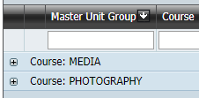

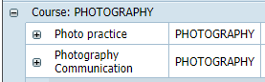

Expand the group to see the list of units. It is a good idea to check the
- Unit code
- Unit name and value
- Accreditation type
- Year level
to verify that you are generating the outline for the correct unit. Then click on the ‘UnitOutline’ link.

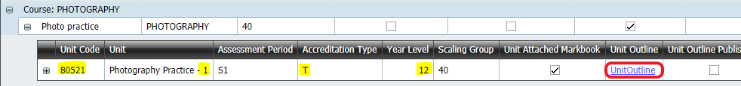

Creating the Unit Outline

Unit Outline Summary
The top section displays summary information for the unit outline.
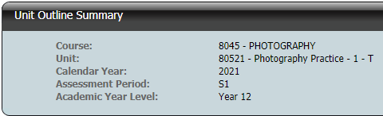
This information is displayed as the top section in the generated unit outline.

Unit Outline Settings
The Print and Save are active initially.
Print generates a pdf that can be downloaded and viewed or printed. For Year 11s, there is an additional option to ‘Print for O1 Students’ which will generate a pdf using the Year 12 Achievement Standards for students who are in the O1 year group (Abridged Package).
Is Published allows students to access the Unit Outline via Student Profiles Online. The coversheet must be Saved after the checkbox is ticked or unticked.
Publishing the Unit Outline will disallow the user from making any changes. If a change is needed to the Unit Outline after it has been published, first unpublish the Unit Outline by ticking the box and saving the unit outline. Changes can then be made and the Unit Outline can be published again.

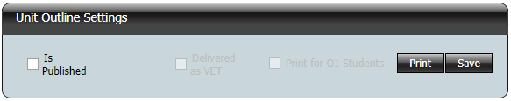

Unit Goals
This section displays the Specific Unit Goals of the unit. For half units, it is possible to remove some of the goals so they will not appear on the unit outline when they are not being delivered in that half unit. To do this, untick the ‘Included’ box against the goals. For full units, all goals must be included.
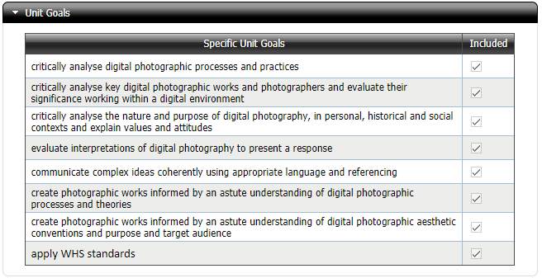

Content Description
This section displays the Content Descriptions and their groupings. As with Unit Goals, for half units it is possible to remove some of the descriptions so they will not appear on the unit outline when they are not being delivered in that half unit. For full units, all descriptions must be included.

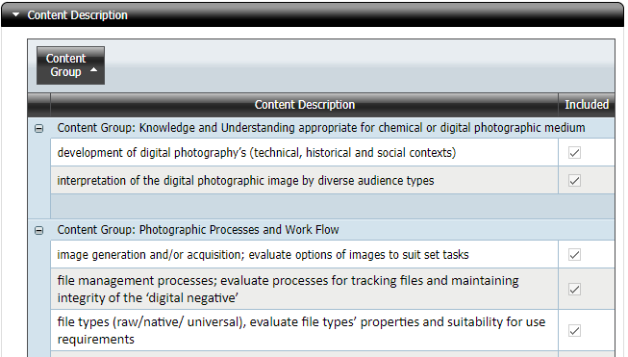

VET Competencies
This section is only visible when the unit is being delivered as a VET unit. It lists each VET competency that is attached to the unit, its Code and the Qualification Code that the competency belongs to.

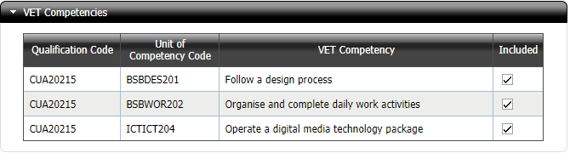

It is possible to remove individual competencies from the Unit Outline by unticking the ‘Included’ box next to it. This is to facilitate half units where not all competencies will be delivered in the half unit or to remove competencies where the delivering RTO does not have scope. Where units are being delivered as a VET unit, at least one unit of competency must be included.

Assessment Item Due Dates
This section allows the user to specify the due dates of the assessment items for the unit. The Assessment Item names and weightings are from the Markbook that has the unit attached. The only mandatory field is an End Date. Where required, it is possible to enter a range of due dates and a description of. This will enable the user to specify a range of dates to cover situations where either the precise due date is unknown (e.g. for a test where the exact date within a scheduled test week is unknown at the time the unit outline is generated or where different lines have different due dates). Note that the Start Date is the beginning of the due date period and is not intended to indicate the date when the assessment is handed out to students.

Click on the drop down to choose a date and optionally enter a Date Description.

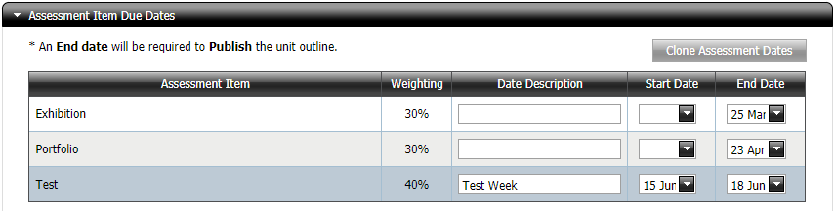

Specific Unit Information
This section is optional. Use this space to provide any additional information to the students enrolled in the unit. Some limited formatting of this section is possible.
These consist of

- Font styling: Bold, Italics and Underline
- Lists: Bulleted and Numbered
- Layout: Indent and Outdent

It is possible to insert hyperlinks by clicking on the link icon. The icon to the right of it removes a selected link.

A pop-up window opens where the URL can be entered. It is also possible to enter alternative text description and a tool tip (the text that is displayed when the mouse cursor hovers over the link).

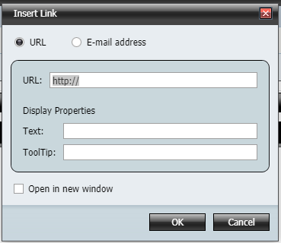

Extraneous formatting in pasted text
If the text is entered into text boxes by copying and pasting from another document (e.g. a Word document), then it is highly recommended that the Convert to plain text feature be used, by clicking on the red document icon after text has been pasted.

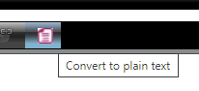
There are often tags belonging to the parent document format (e.g. Word), that may not be visible when pasted into the text box, but affect formatting when the PDF document is generated. It is safer to convert to plain text first, and then re-apply any of the available formatting if desired.

Saving and adding Additional Information
After adding Assessment Item Due Dates and (optionally) Specific Unit Information, save the Unit Outline. This can be done by pressing the Save button at either the top (Unit Outline Settings) or bottom (following the Specific Unit Information) of the page.
Once the Unit Outline has been saved, an additional section will appear at the bottom of the page titled Additional Information. This allows the user to upload a PDF file to append to the end of the unit outline. When the Print button is pressed, a single PDF file will be generated where the appended file follows the unit outline. This feature can be used to, e.g., attach a planner or timeline to the Unit Outline.

Note that:
- Only a single PDF file may be uploaded.
- There is a size limit of 1 MB.
- Once a file has been uploaded, the page displays a link with the file name of the uploaded document. This link can be used to check that the uploaded document is the correct one.
- A second ‘Remove’ link also appears allowing the user to remove the uploaded file. Uploading a second PDF overwrites any existing uploads.

Cloning Assessment Dates
When creating a unit outline for a half unit where the corresponding full unit’s unit outline has already been created and published, it is possible to copy the assessment item due dates from the full unit. When this is a possibility, a ‘Clone Assessment Dates’ button will appear in the Assessment Item Due Dates section.

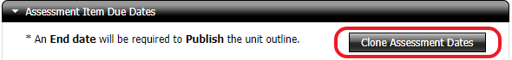

Pressing this button will copy the due date information, including Start Dates, End Dates and Date Descriptions from the full unit’s Unit Outline.

