User Access Levels in the

ACT Certification System (ACS)

May 2017

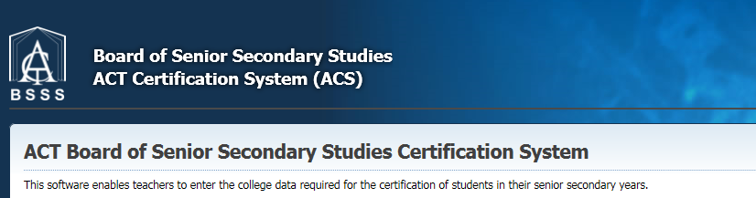
Table of Contents
User Roles 3
User Control Managing Users 5
Create User 5
Users Screen 6
Add User 6
Reset Password 6
Unlock 6
Lock All 6
Unlock All 7
Edit User Details 7
Edit Profile Details 7
Delete Users 8

User Roles

All ACS users need Basic level.

Other roles can be added depending on a person’s responsibilities at a college.

User Role | Allowable Functions
- Basic | Create Assessment Items in Markbook  Enter marks and adjustments  Enter grades in non-tertiary units  Calculate temp scores from historical parameters or backscaling  Generate raw scores  Change password  Print reports  View unit and course codes  Create Moderation presentations  Review Moderation presentations
- Faculty Head | Create and manage Markbooks for their faculty  Add and remove units and half units from markbooks  Calculate Temp scores from historical parameters or backscaling
- Edit | Edit individual student details and unit/course studied records  Manage Scaling Group Lists  Manage markbook access  Run EOY processes  This role includes Faculty Head functions
- Transfer | Transfer temp unit scores to final unit scores  This role includes Faculty Head and Edit functions
- User Control | Add/manage users and their roles  Usually the BSSS Certification person in each college  These accounts are created by the Technical Adviser.  This role includes Faculty Head, Edit and Transfer functions.
- Moderation Coordinator | This role is for the college Moderation Coordinator  Submit Moderation Presentation  Apply for course exemptions  Print college Moderation reports
- Principal | Edit individual student details and unit/course studied records  Print reports including college Moderation reports  Enter marks and adjustments in markbooks  Add/manage users and their roles  Manage scaling group lists  View Moderation presentations and course exemptions
- TeachVET | This role is for VET teachers.  Enter vocational competencies via the Competencies by Unit screen  Print VET reports
- SchoolVET | This role is for the school VET coordinator.  Enter vocational competencies for Training Package or Student via the Competency screen  Create ASBA  Enter year 10 competencies
- DataSync | Allows access to the Datasync website to manage to flow of date  between ACS and the school administration system database:  https://acs.bsss.act.edu.au/ACSDataSync  Set Datasync dates for each assessment period  Track Datasync errors

User Control Managing Users
The ACS system has users with different roles – each role has different functionality. The top level of access in each college is User Control. Only users with the access level of User Control will be able to use the Create User and User menu options. The Technical Adviser is the only person who can assign the access level of User Control. This access is usually given to the BSSS Certification person in each college. It is then this person’s responsibility to create and manage users in their college.

Create User
- From the menu select Admin – Create User and the following screen will appear

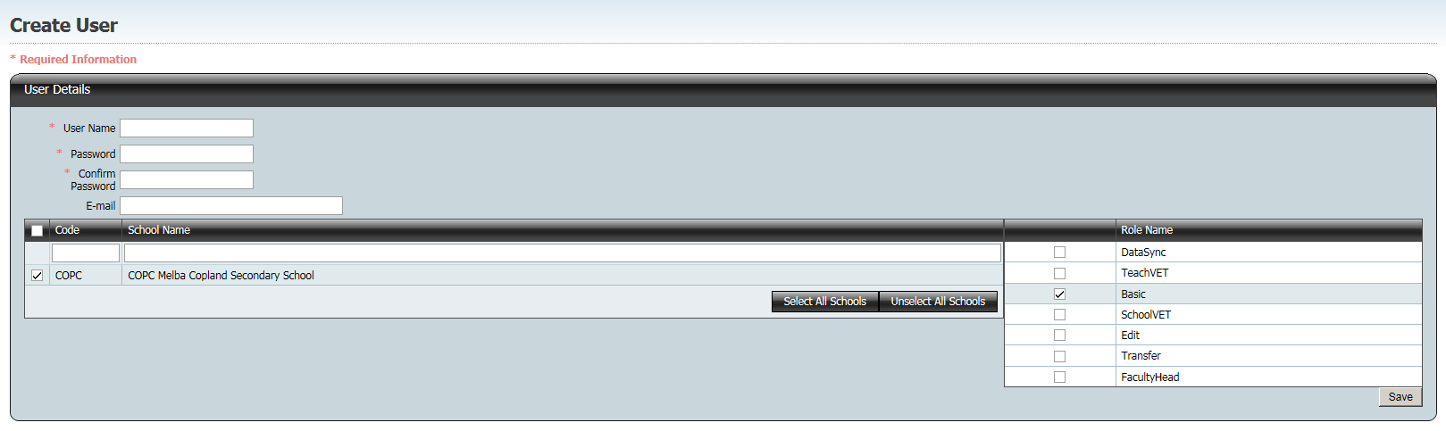

Enter in the required details as follows:
- User Name firstname_lastname
- Password minimum of 7 characters and 1 character that is not a letter or number
- E-mail address is optional
- Assign a role by clicking in the check boxes. All users need Basic role.
- You must select the appropriate responsibility roles to allow the desired user function. The screen below assigns an edit role to the user

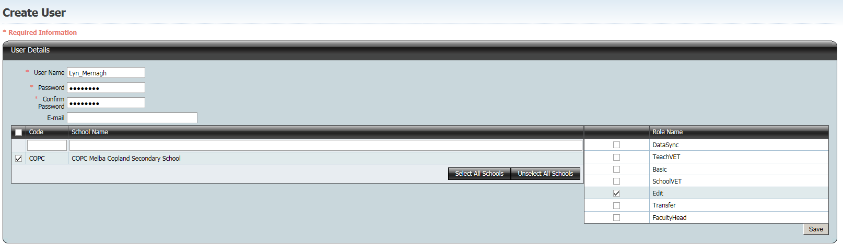

- Press save
- Should a User Name already exist in the database (all colleges) the following message will appear



- If this happens check with the user if they already have an ACS account with that user name at a different college. If they do, contact the Technical Adviser to change their ACS school. Otherwise the preferred options are to include the middle initial or lengthen/shorten first name
- College access defaults to the User Control’s college
- The new user will need to be notified of their user name and password

Users Screen
- From the menu select Admin – Users and the following screen will appear

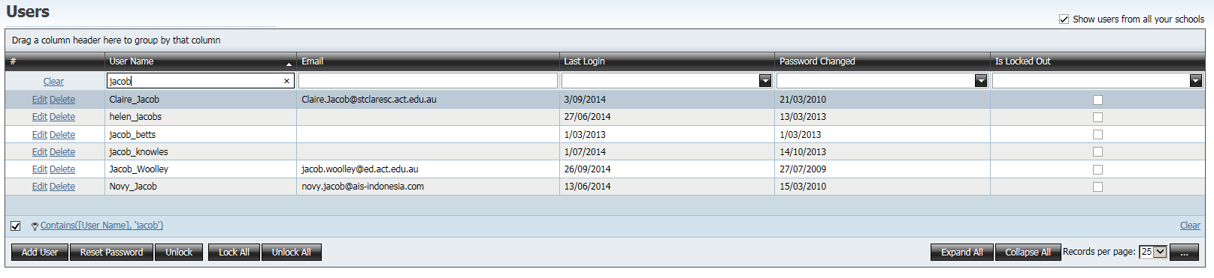

The five main action buttons on this screen are:
- Add User taken to Create User screen
- Reset Password
- Unlock
- Lock All
- Unlock All

Add User
Select this button to move to the Create User screen

Reset Password
- Select the user by clicking on the User Name. The active row now has a blue background
- Click Reset Password button
- Confirm that the user’s password is to be reset
- The screen below will appear. The user’s password is displayed on the screen. In this case the new password is 7r*JT%1

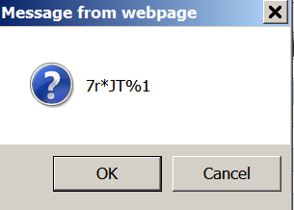

Unlock
- Use this button to unlock the selected user. A user is locked out if they have three unsuccessful attempts at logging in. A user who is locked out due to entering the wrong user name and/or password must be unlocked before they can access the database.

Lock All
At certain time during the year the BSSS Certification person may decide to lock out all users at their college from the accessing the database.
- Click on the button Lock All to lock all users from accessing the application
- This will lock out all users except those with User Control access
- If a ‘locked-out user’ tries to login to the system, a message “The system is unavailable as all school users have been locked out” will be displayed.

Unlock All
- To unlock all users click on the Unlock All button

Edit User Details
- Click on the hyperlink Edit and the screen below appears

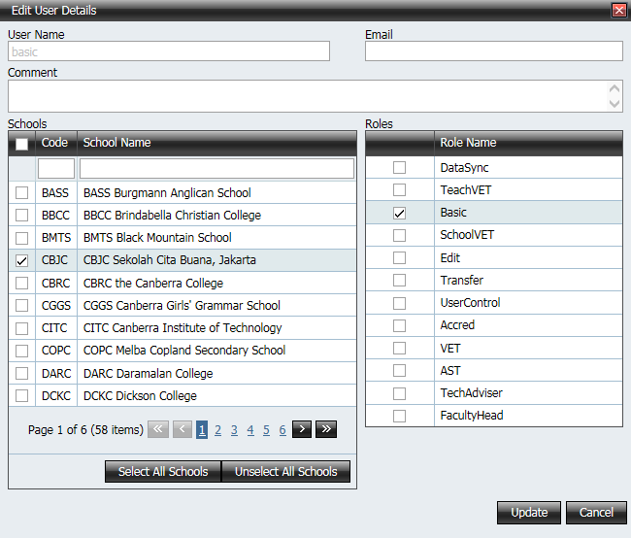

The user’s role and/or email address can be changed in this screen
Click on the Update button to save changes

Edit Profile Details
- Click on the hyperlink View Profile and the screen below appears

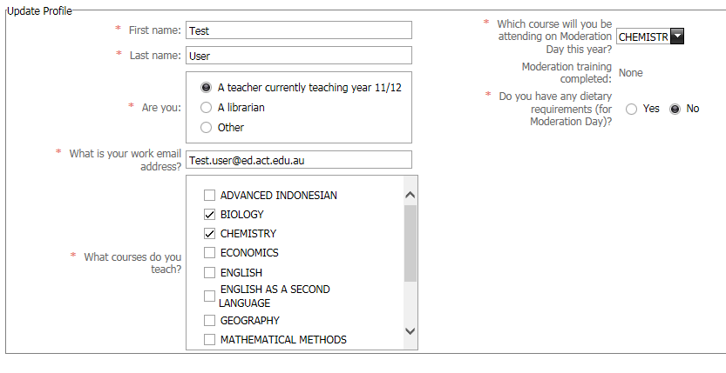
This shows personal details, including name and email address as well as what courses they can teach and what subject they will be attending on Moderation Day.

It is important that all teachers update this profile regularly. First and last names will be used on Moderation Day documentation, so please ensure that they are accurate, and not just initials.

If a staff member is on leave for Moderation Day please mark their status as “Other” and remove their subjects and Moderation Day subject attendance, so they do not appear on Moderation Day attendance lists.

Delete Users
- Click on the hyperlink Delete and the screen below appears

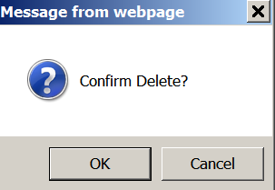

Click OK and the user will be deleted
As staff leave a college their account should be deleted.
ACS is a web system and if accounts remain for ex-staff they will still have access to your college’s data anywhere at any time.
As there is only one database leaving ‘out of date’ users in the system will cause problems when creating log ins for new staff or when staff move colleges.
Note: Please do not delete OBSSS users from your school

