Data Sync in the

ACT Certification System (ACS)

May 2021

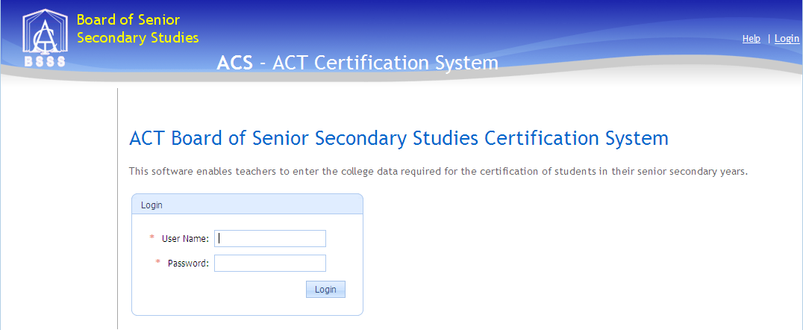

Table of Contents

Data Sync 3

Access to Data Sync 3

Logon to Data Sync 3

Settings 4

Client Settings 4

Assessment Periods 5

Logs 6

Sync Alerts 6

Understanding the Alert Messages 6

UnitStudied Delete 6

FK Violation 7

Student Deleted 7

Student Moved 7

Sync Packages 7

College Clients 8

Sync Package Admin 9

Details 9

Unit Studied Business Rules 10

Inserting New Unit Studied records in ACS 10

Updating Existing Unit Studied records in ACS 10

Deleting Existing Unit Studied records in ACS 10

Schedules 10

Diagrams 11

# Data Sync

Data Sync brings student and unit studied data from school administration systems (SAS) into the ACS database. Data Sync takes course and unit data from ACS and updates the corresponding tables in the SAS for public colleges or produces output files for all other users. Unit studied data is extracted from ACS and placed in the file on the SAS server for import into College reporting programs and SAS. Data Sync also provides the manual file upload for colleges without SAS that are connected to ACS.

Data sync comprises a number of components including

* Server side ACS database (server SQL-ACS\SQL_ACS db ACS)
* Server side staging database (server SQL-ACS\SQL_ACS db ACSDataSync_XXXC)
* Client side(College) staging database
* Client side (College) SAS

The automate synchronisation replicates the data from the client staging database to the server side staging database. SQL Server Integration Services packages extract the information from the server side staging database into ACS. These packages are schedule to operate automatically but they can be run on demand.

## Access to Data Sync

User Controls automatically have access to the Data Sync website. To allow other users access to Data Sync, the role Data Sync needs to be added to the user via ACS. Currently Data Sync is accessed via the [website](https://acs.bsss.act.edu.au/ACSDataSync).

## Logon to Data Sync

* Open the browser on a computer connected to the internet
* Type in the internet address for [ACS Data Sync](https://acs.bsss.act.edu.au/ACSDataSync) (https://acs.bsss.act.edu.au/ACSDataSync)
* A logon box will appear and look similar to this

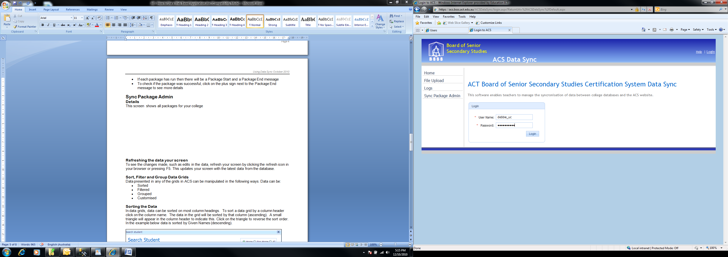

* Enter the User Name and Password and the home page below will appear

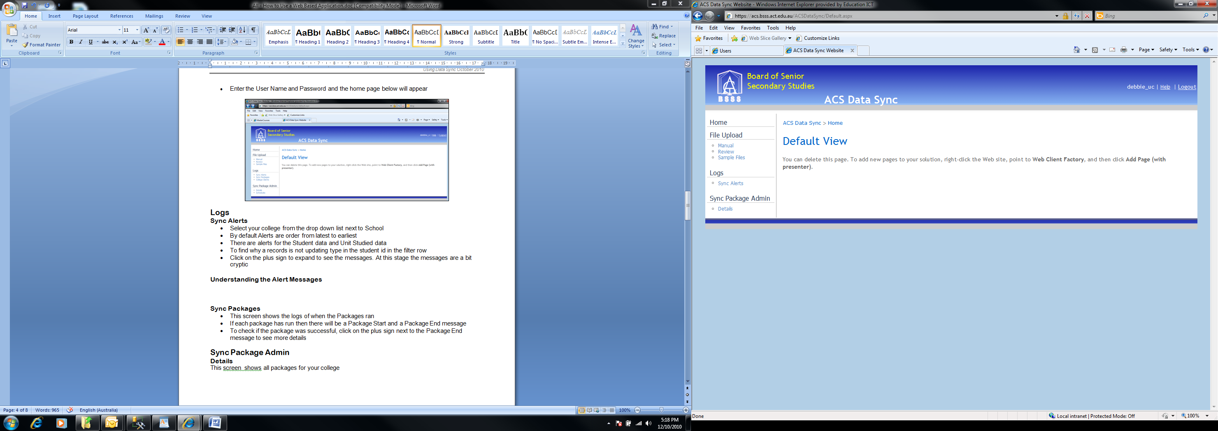

# Settings

## Client Settings

This screen shows the packages which are enabled for the selected school. Use these to control which packages ‘sync’ on a school by school basis.

Note that for a package to run

* it must be enabled
* the assessment period data sync start and end dates must be set (See *Settings > Assessment Periods*)
* the current date must lie between the data sync start and end dates

In the example shown below all packages have been enabled.

* ***“Download”*** refers to data transfer from ACS to the College SAS
* ***“Upload”*** refers to data transfer from the College to ACS

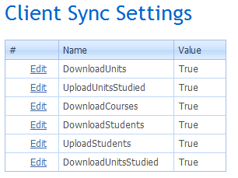

***DownloadUnits***

This package transfers unit data (codes, title, value, accreditation type, accreditation period) to a MAZE college.

***UploadUnitsStudied***

This package transfers unit studied data (studentID, unit code, course code, assessment period, year studied, grade, scores) from the college SAS to ACS

***DownloadCourses***

This package transfers course data (codes, title, accreditation type, accreditation period) to a MAZE college.

***DownloadStudents***

This package transfers student data ACS to a college (client side staging database only).

***UploadStudents***

This package transfers student data from a college SAS to ACS.

***DownloadUnitsStudied***

This package transfers unit studied data (studentID, unit code, course code, assessment period, year studied, grade, scores) from ACS to the file output. This was previously known as LBSSY.txt and is now the STMA.txt

These files are produced as the last step in the data syncing process.

The file is deposited on the output server and access needs to be arranged. The STMA.txt file contains differences between ACS and MAZE.

The package appends the data to the STMA.txt file, so to get a current data file delete the STMA.txt file such that the next append will be the required data.

## Assessment Periods

* Each college has specified assessment periods for S1, S2, Q1, Q2, Q3, Q4, M2 and Y1.
* Not all of these periods need to be specified.
* Q1, Q2, Q3, Q4 dates may not overlap.
* Data Sync will run for any assessment period that includes the current date.

A sample Assessment Period schedule is shown below.

* The assessment period start and end dates are set in ***ACS > Assessment Periods*** – they cannot be edited here.
* The Data Sync Start and End Dates are set so all Data Sync packages which are enabled will run between these dates.
* Data Sync packages will not run until
  + Data Sync start and end dates have been entered (click on the edit hyperlink to do this) and
  + the current date lies between these dates.

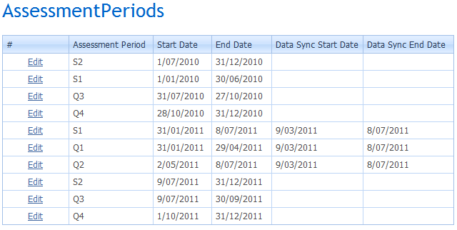

Note that the Start and End Date for the Assessment Periods appear to be editable here, but they are not – changes will not save. To change Start and End Date for the Assessment Periods use ACS application – not Data Sync.

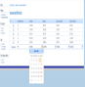

# Logs

## Sync Alerts

* Select your college from the drop down list next to School
* By default Alerts are order from latest to earliest
* There are alerts for the Student data and Unit Studied data
* To find why a record is not updating type in the student id in the filter row
* Click on the plus sign to expand to see the messages. At this stage the messages are a bit cryptic
* Once you have solved the issue click on the ***Mark as Handled*** hyperlink to remove the alert from the list
* It is not necessary to monitor this every day. The alerts are provided so that you can try and understand why data is not coming into ACS

## Understanding the Alert Messages

### UnitStudied Delete

* This alert occurs when a unit studied records was deleted from SAS and cannot be deleted from ACS.
* Click on the plus sign to show error details

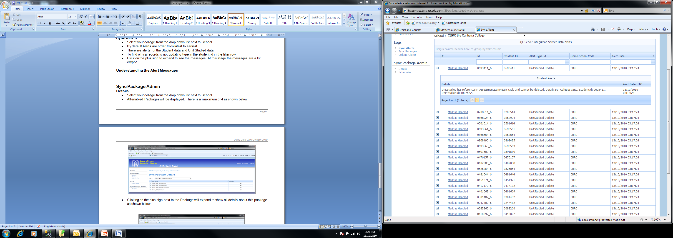

### FK Violation

* This alert occurs when a unit studied record had been added to SAS but the unit code or course code does not exists or is expired in ACS
* Click on the plus sign to show error details

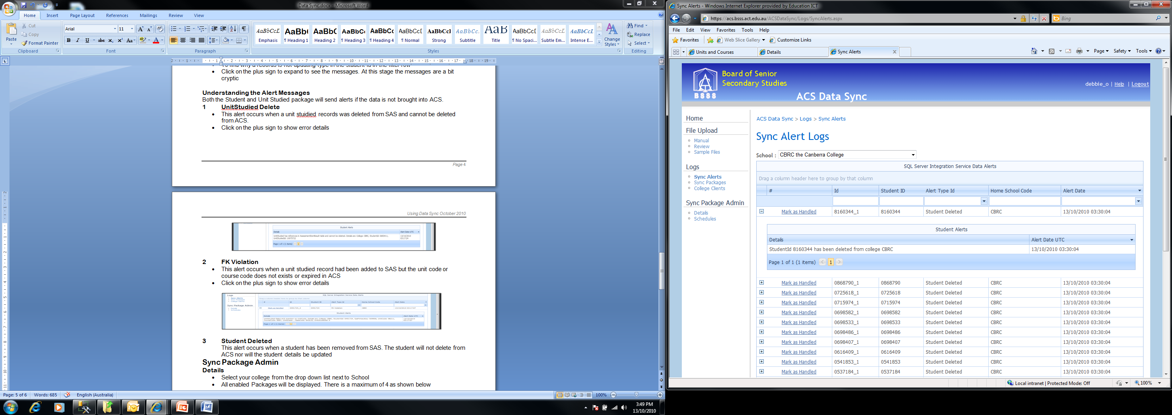

### Student Deleted

* This alert occurs when a student has been removed from SAS. The student will not delete from ACS nor will the student details be updated

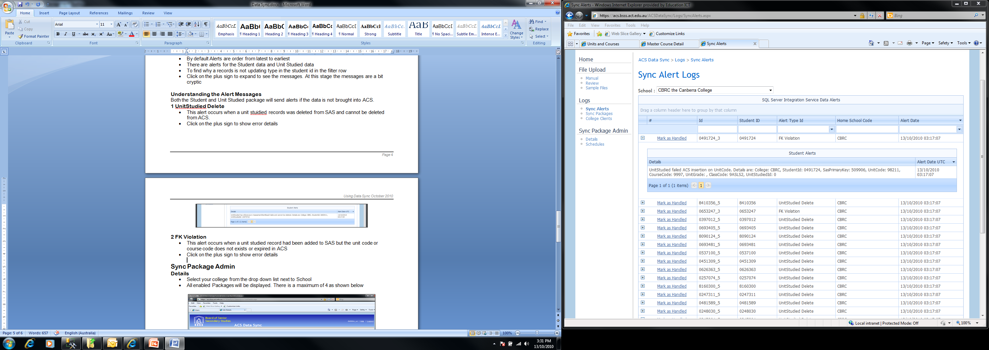

### Student Moved

* This alert occurs when a student moves to another ACT college.

## Sync Packages

This screen shows the execution of packages between the server side college staging database and ACS. In the example below UnitStudiedSync_MKCC failed because there was no data sync start and end data for the package.

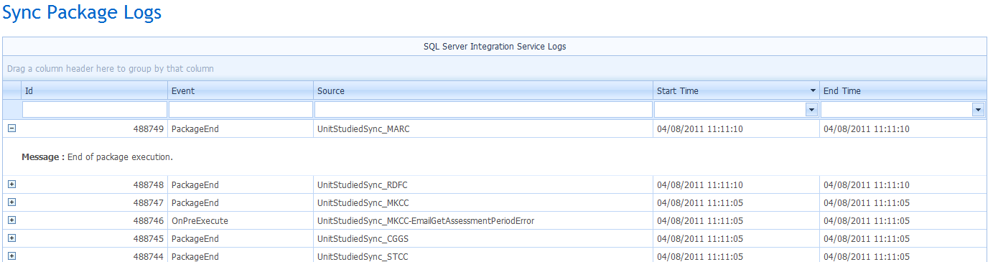

## College Clients

This screen shows which clients are connected to data sync via Web Service Connections. In the example below three colleges are not connected.

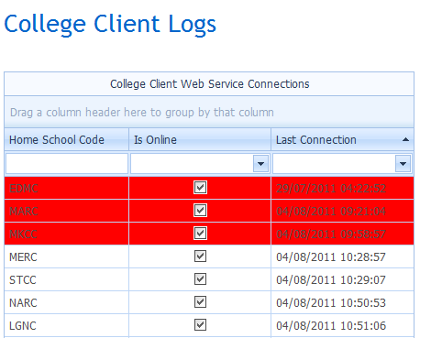

This screen also shows a log of communication.

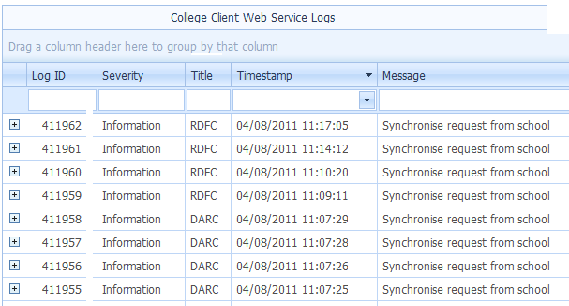

When the web service connection runs (every 12 minutes) the packages that are enabled copy data to and from the client side staging database. Synchronisation between the client side and severer side staging databases occurs (this may take a few cycles – certainly within the hour provided web service connection is maintained.

# Sync Package Admin

## Details

* Select your college from the drop down list next to School
* All enabled Packages will be displayed. There is a maximum of 4 as shown below

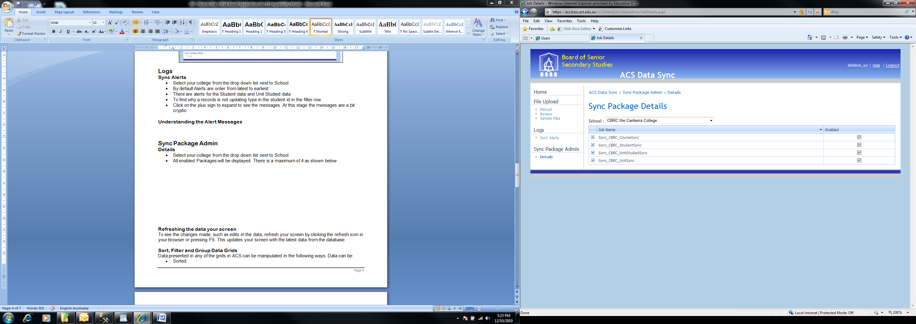

* Clicking on the plus sign next to the Package name to expand to show all details about this package as shown below

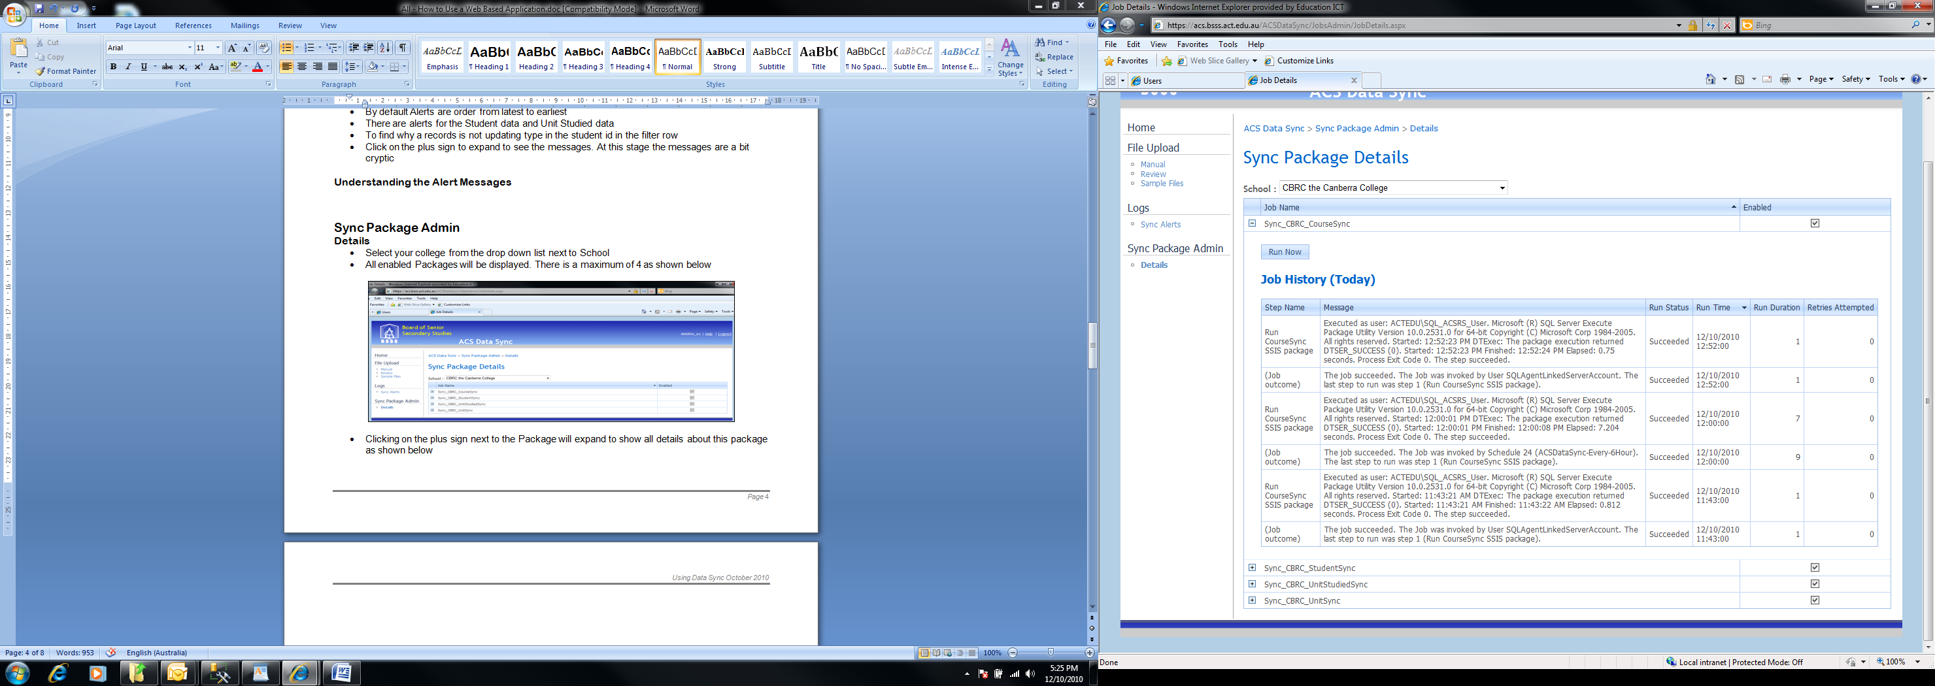

* Click on the ***Run Now*** button to manually run the package.   
  Press F5 or the refresh icon to see the outcome

## Unit Studied Business Rules

The Unit Studied business rules and associated logic are essential to ensure only valid data is copied to ACS and that data is not lost from ACS (i.e. assessment item results in a Markbook).

### Inserting New Unit Studied records in ACS

A ***new*** Unit Studied record will not be inserted by the Unit Studied package from the server side staging database into ACS unless:

* The assessment period is valid (Y1, S1, S2, Q1, Q2, Q3, Q4)
* The assessment period is a current assessment period
* The unit code is valid (adopted by the college) and not expired
* The unit course is valid (adopted by the college) and not expired
* The student number is valid and in ACS

### Updating Existing Unit Studied records in ACS

An existing Unit Studied record will be updated by the Unit Studied package from the server side staging database to ACS if all of the conditions above are met.

If there are assessment item results in a Markbook for that Unit Studied record then the existing Unit Studied record is copied and given the same TID (unique identifier number) but with a negative value.

For example, if the existing unit studied record below is updated from course code 1234 and unit code 12345 to course code 4567 and unit code 45678 and there are assessment item results in a Markbook the following unit studied records are produced.

|  |  |  |  |  |  |  |  |  |
| --- | --- | --- | --- | --- | --- | --- | --- | --- |
| **TID** | **StudentID** | **Assessment Period** | **Year** | **Course Code** | **Unit Code** | **Grade** | **Raw Score** | **Scaled Score** |
| 123456 | 9876547 | S1 | 2011 | 1234 | 12345 |  |  |  |

|  |  |  |  |  |  |  |  |  |
| --- | --- | --- | --- | --- | --- | --- | --- | --- |
| **TID** | **StudentID** | **Assessment Period** | **Year** | **Course Code** | **Unit Code** | **Grade** | **Raw Score** | **Scaled Score** |
| 123456 | 9876547 | S1 | 2011 | 4567 | 45678 |  |  |  |
| -123456 | 9876547 | S1 | 2011 | 1234 | 12345 |  |  |  |

The negative TID Unit Studied record will have to have assessment item results moved from the Markbook for unit 12345 to the Markbook unit 45678. When this is done then data sync will delete this Unit Studied record. (See ***Moving Assessment Item Results*** in the User Manual)

### Deleting Existing Unit Studied records in ACS

An existing Unit Studied record will be updated by the Unit Studied package from the server side staging database to ACS if there are no assessment items in a Markbook for that Unit Studied record.

If there are assessment items in a Markbook for that Unit Studied record then an alert will be generated and the record not deleted.

## Schedules

* Colleges can nominate the schedule they would like for any of the 4 packages
* Current schedules:

|  |  |
| --- | --- |
| **Interval** | **Operation** |
| 10 minute | 7:57 to 20:00 |
| 15 minute | 8:04 to 20:00 |
| 30 minute | 8:00 to 20:00 |
| 1 hour | continually for 24 hours |
| 6 hour | continually for 24 hours |
| 12 hour | continually for 24 hours |

* Colleges should contact the Technical Advisor should they wish to alter a Package schedule.

The screen below shows the packages scheduled every 30 minutes.

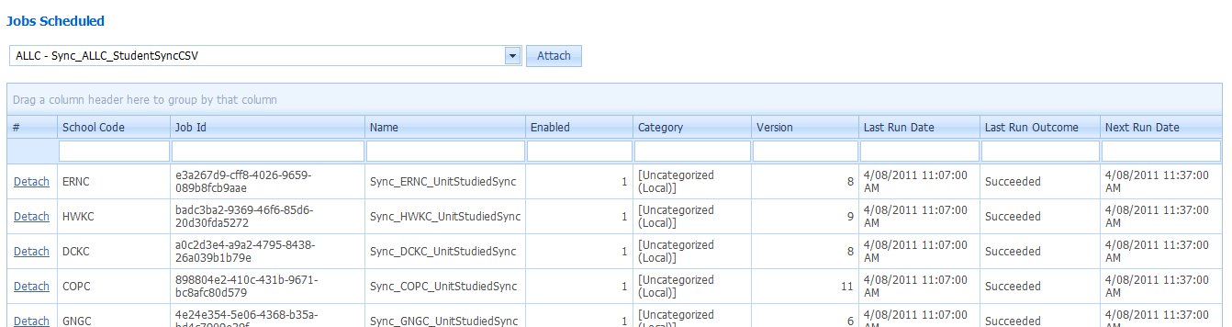

To remove a package from this schedule click the detach hyperlink.

To add a package to this schedule select a package from the pull down menu and click the ***Attach*** button.

# Diagrams

Course and Unit (MAZE) relationship diagram showing data flow between databases.

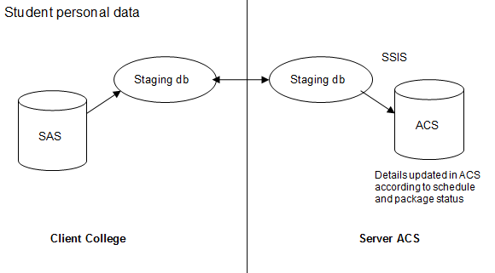

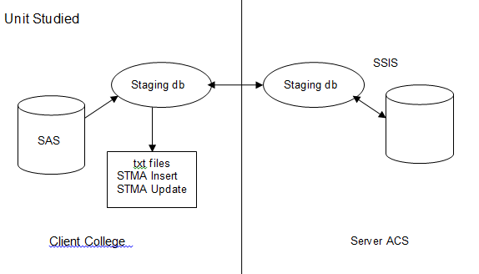

Note that unit studied records can be entered into ACS directly, but these will not sync back to the SAS.