Markbooks in ACT Certification System (ACS)

October 2020

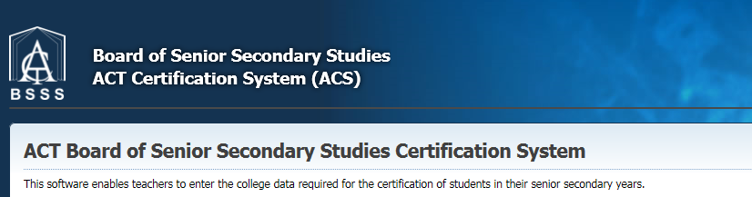

Table of Contents
Definition of a Markbook 3
The Markbook List Screen 3
Markbook Permissions and Security 4
Creating a Markbook 4
Creating Yr 11 & Yr 12 Combined Markbooks 4
Locking and Unlocking Markbooks 5
Manage Markbook 5
Entering Assessment Item Details 6
Publish an Assessment Item’s results 7
Edit/Remove an Assessment Item(s) 7
Add/Remove Units 7
Defining Half Unit AIs 8
Enter Assessment Item Marks 9
Entering Assessment Marks and Grades 9
Enter Marks for an Assessment Item 10
Enter Grades for an Assessment Item 11
Using Grades Cut Off for Assessment Item Grades 11
Mark Adjustments and Special Provisions 12
Colour Code for Mark Adjustments and Special Provisions 12
Adjusting an Assessment Item Result 12
Late (Including <7 Days Late (Notional Zero) and >7 Days Late (Notional Zero)) Penalty 13
Academic Integrity 14
Not Submitted (Notional Zero) 14
Estimate 14
Temporary 15
Removing Temporary 15
Insubstantial (Notional Zero) 15
Special Provisions 15
Move assessment item results within the same Markbook 16
Unit Scores 18
Set Notional Zero Button 18
Calculating Raw Unit Scores 18
Adjusting Raw Unit Scores 19
Entering Grades 19
Entering A – E Grades 19
Edit Unit Grade Checkbox 19
Grade Cut Off Button 20
Entering a V, S or Z Grade for the Unit 21
Entering Grades for R units 21
Copy a Markbook 22

Definition of a Markbook
Markbooks can be created for either a unit or units in a scaling group. In determining what units can be included in a Markbook, colleges must use the following:
- Year 11 and Year 12 students must be in separate Markbooks for T units
- Only units from course(s) within the same scaling group can be in the same Markbook.
- A Markbook is defined for a given calendar year and assessment period
- All units in a Markbook must have the same number of assessment items and have the same names, weightings and maximum marks for each assessment item
- The marks for each assessment item must be comparable (achieved via meshing/moderating).

The Markbook List Screen
Under the Markbooks heading in the menu pane select Markbook List and the following screen will appear

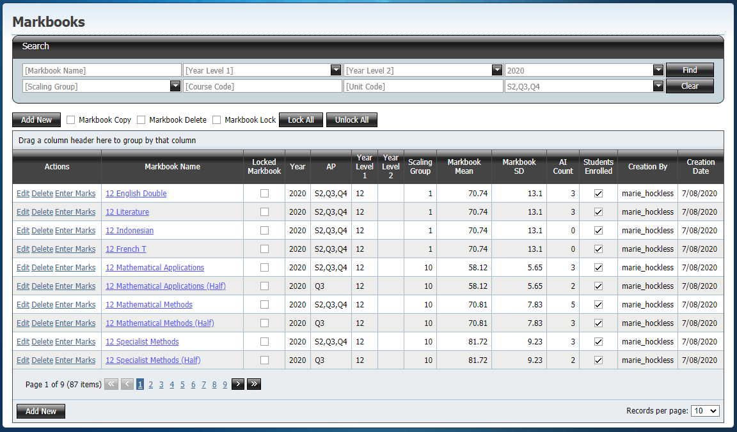

This screen has two sections:
Search
- To search for a particular Markbook, type in part or some of the text into the Markbook Name, Course Code and/or Unit Code. Year, Assessment Period, Cohort and Scaling Group criteria are selected from the drop down menus.
- Click the Find button to run your search.
- Click the Clear button to clear the filters
Markbook Grid
- List of the Markbooks that have been created and you have access to.

Note: The year and assessment period will default to the current year and current assessment period.

Markbook Permissions and Security
You will only be able to create, see, edit and use markbooks that belong to a scaling group you have permission to access. See 6. Scaling groups on how to set scaling group permissions.

Creating a Markbook
Markbooks can only be created/copied by Faculty Head Level users and above.

- Click the Add New button as shown above. This places a new row in the grid ready for the definition of a Markbook. The following screen will appear

- Enter a Markbook Name, Year, Assessment Period, Cohort, Scaling Group, Markbook Mean and Markbook Standard Deviation. All fields are compulsory. The Markbook Mean and Markbook SD are the parameters applied when using weighted z-scores to calculate unit scores. This is for meshing.

- Select the Save hyperlink to save your Markbook definition

Creating Yr 11 & Yr 12 Combined Markbooks
Units in scaling group 94 (“A” courses), scaling group 96 (Recognition courses) and scaling group 95 (Registered or “R” units) can have a combined Yr 11 and Yr 12 markbook.

When defining a new Markbook Year Level 1 and Year level 2 can be selected as shown below.

The saved Markbook definition appears as below.

Note:
- If scaling group 94 or 95 is not selected the following error message appears.

- If Year Level1 is set to 12 and Year Level 2 to 11, then no assessment results will be displayed once the current Year 12 cohort graduates. It is therefore recommended to set Year Level 1 to 11 and Year Level 2 to 12.

Locking and Unlocking Markbooks
Markbooks can be locked so that users cannot make any changes to them. There are two different levels of lock.
Individual/Grouped Lock (Faculty Head users and above):
- On the Markbook List screen, click on Markbook Lock shown below. This makes the Lock and Unlock buttons appear.
- Select all the markbooks you want to lock, then press the Lock button.
- Follow the same method to unlock the markbook.
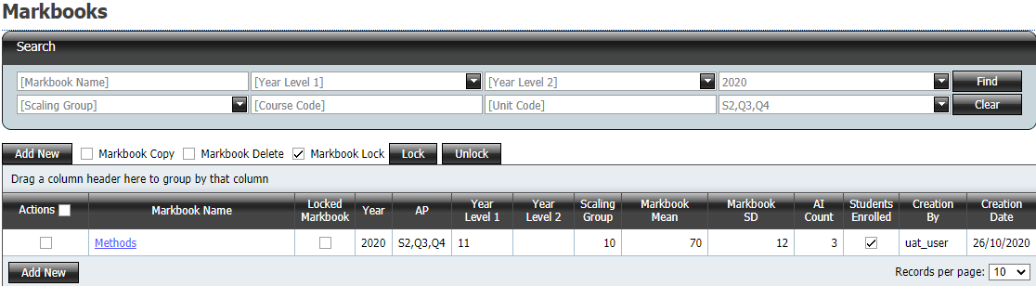

Lock All (Transfer and User Control users):
- Press the Lock All button on the Markbook List screen
- Faculty Head and Edit users cannot unlock markbooks that have been locked in this way.
- Transfer and User Control users can unlock markbooks that have bene locked in this way either individually or by using the Unlock All button.

Manage Markbook
- Click the Markbook Name hyperlink. The Manage Markbook screen will appear as shown below

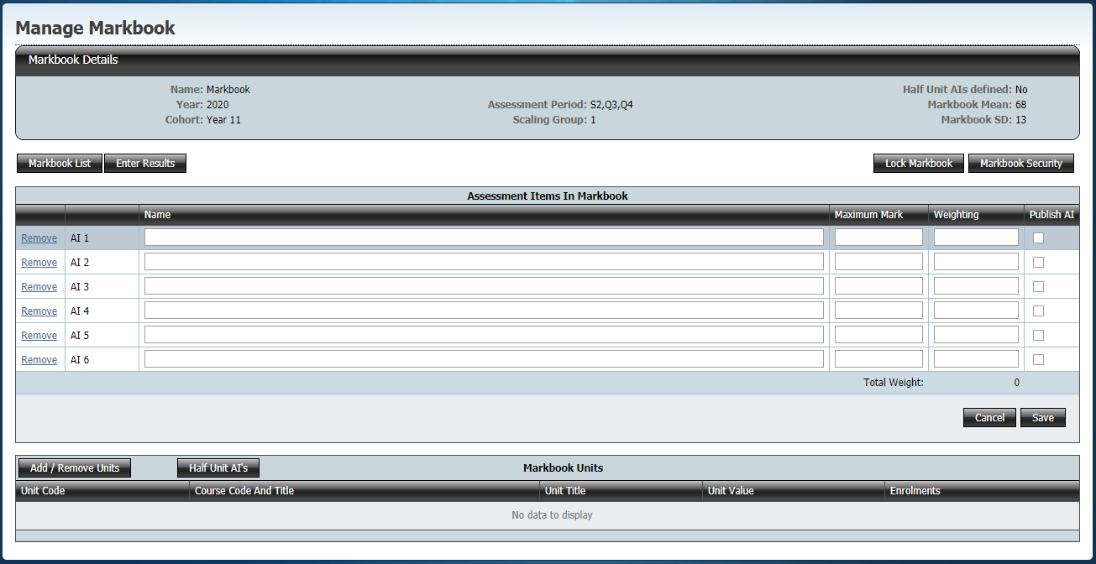

This screen has four sections:
- Markbook Details
- Shows the Markbook definition criteria as specified as above in the Markbooks screen

- Markbook buttons
- Markbook List - Click these buttons to view the list of available Markbooks
- Enter Results - Click this button to enter results in the current Markbook
- Lock Markbook –
  - (Faculty Head users and above) Click this button to lock the markbook
  - This is an alternative method to locking and unlocking markbooks from the Markbook List screen
- Markbook Security – (Transfer/User Control users) Click this button to manage individual teacher permissions to the markbook

- Assessment Items Grid
- List the assessment items in the current Markbook

- Markbook units
- All units that are in this Markbook

Entering Assessment Item Details
- Type in a name, maximum mark and weighting for each assessment item.The assessment item name and weighting are required fields. Between two and six assessment items can be entered to account for the specified 2 – 3 assessment items for half units and 3 – 5 assessment items for a semester unit. The maximum mark must be entered before marks can be entered but can be left as zero before this.
- After marks have been entered the maximum mark cannot be changed. To change the maximum mark for an item all marks (and adjustments) for that item must first be removed (this is why it is recommended that the maximum mark be left as zero if not known).

Note: The information typed in this grid is used to populate the moderation report - Individual Student Profile

- Click the Save button
- An error message is displayed if the Save button is clicked and all of the required information is not entered
- The total of the weightings is displayed at the bottom of the weightings column as shown below

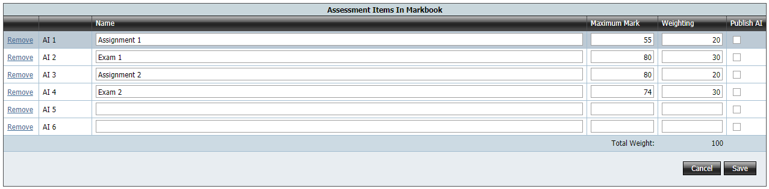

- After pressing the Save button, an error message is displayed if the total weightings does not equal 100

Publish an Assessment Item’s results
- Click on the checkbox under Publish AI and click save to ‘publish’ the assessment item’s results to students. This allows students to view their raw score, percentage, grade, assessment item mean, SD, top mark and z-score in Student Profiles Online. For assessment in T markbooks their standardised score is also published.

Edit/Remove an Assessment Item(s)
- For each assessment item the Name, can be edited at any time. The Weighting and Maximum Mark can be edited provided there are no marks in the Markbook for that assessment item
- An assessment item can be removed provided there are no marks in the Markbook for that assessment item
- Click on the Remove hyperlink to remove that Assessment Item

Add/Remove Units
- Click the Add/Remove Units button
- This brings up the Add/Remove Markbook Units window

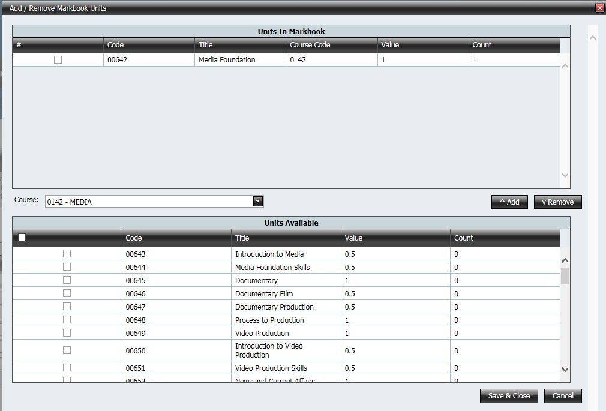

- Choose the desired course from the drop down box
- Check any units and half units you wish to be in this mark book (Note that units with students enrolled will have the number of students in the Count field
- Click the ^ Add button to push the units to the top box. These units are the defined units for this Markbook
- Click Save & Close

If you have a combination of 1.0 and 0.5 units in your markbook then the next message will appear

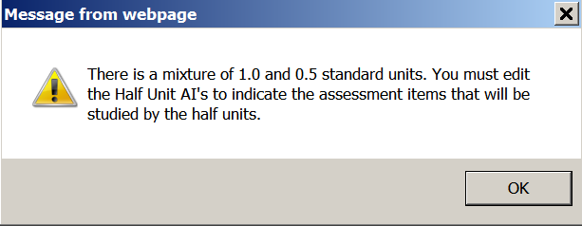

Defining Half Unit AIs
Defining Half Unit Assessment Items is useful when you have a semester unit with its two corresponding half units. ACS will use this definition to know which AIs are in which half unit. All relevant units and half units should be defined in the Markbook Units section before defining half unit AIs.
Note: Ensure that there is at least one 1.0 unit defined in the Markbook otherwise ACS will not know that the 0.5 units are half units of the Markbook
- Click the Half Unit AIs button
- Check the relevant AIs against the half unit

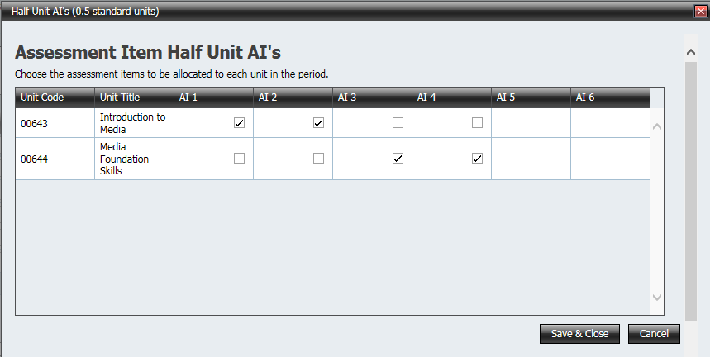

Enter Assessment Item Marks
- From the Manage Markbook screen click on the Enter Results button or under the Markbooks heading in the menu pane select Markbook List in the Actions column click on Enter Marks hyperlink and the following screen appears

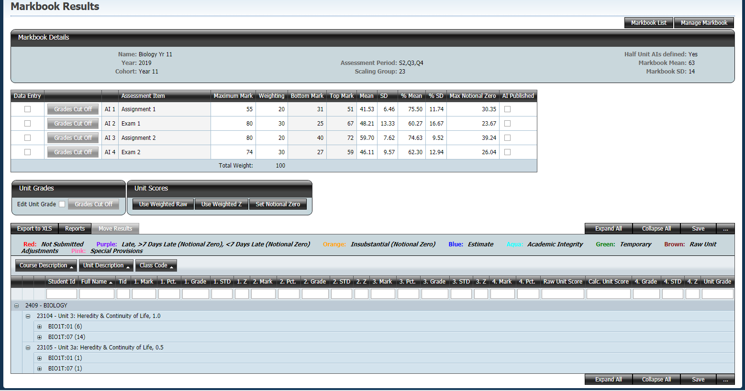

This screen has a number of sections:
- Navigation buttons
- Markbook Details – definitions used to create the Markbook
- Assessment Items grid
- Unit Grade and Unit Scores
- Data Grid – list of all classes and students who are studying the unit(s) as defined in the Markbook definition
- Markbook buttons

Entering Assessment Marks and Grades
Abbreviations used in the following pages
AI Assessment Item
Mark Raw assessment item mark
STD Standardised raw assessment item mark. Only appears if Markbook Mean and Standard Deviation have been entered and the Save button has been pressed
Z Z score. Only appears after the Save button has been pressed and is calculated on the marks that have been entered
Pct Percentage. Only appears after the Save button has been pressed and is calculated on the marks that have been entered

Assessment items in T units must have Marks and can optionally have Grades. Assessment items in A and M units can have Marks, Grades or both. Best practice is to use both for all assessment.

- To open the markbook in Data Entry mode, in the Assessment item details section click the check box in the Data Entry column for Assessment Item results you will be entering as shown below (The user has selected to enter the results for the Assignment 1)

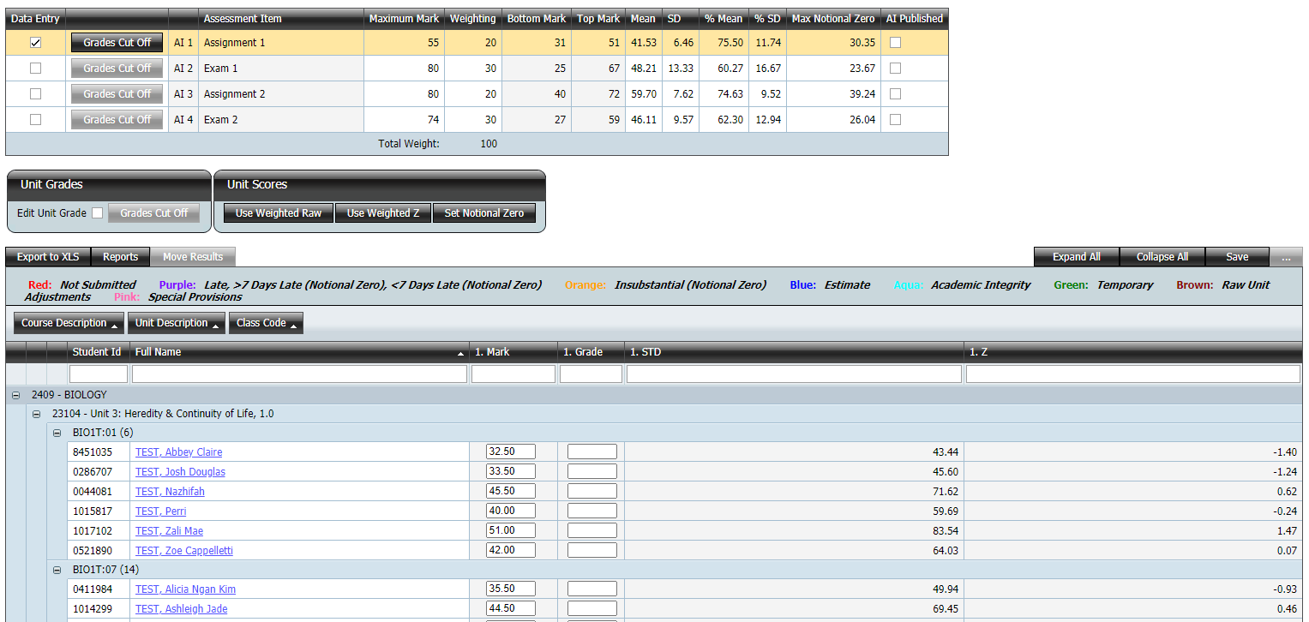

- Not selecting any Data Entry options will open up the entire data grid (view mode) Mark, STD, Z columns for each assessment item for the selected class/classes.
- To open up the grid either click on the Expand All button or click on the plus sign next to the class for whom you are entering the marks
- Under the Mark or Grade column click a cell to make it active.

Enter Marks for an Assessment Item
- Enter the mark (up to two decimal places) for the first student and press the tab key to move to the next row
- Once you have entered all the marks, click on the Save button. There are located at the top and bottom of the screen and the following message appears

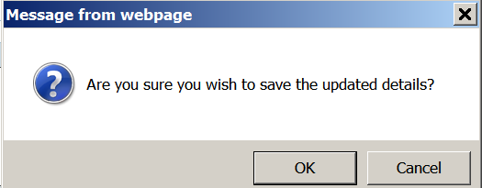

- Once you have saved, the percentage, standardised item mark and the Z score are calculated as shown below

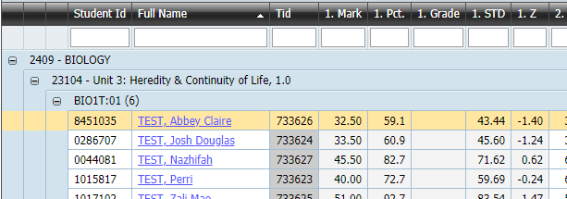

- If you enter a mark greater that the maximum mark then the cell is highlighted in red and you will not be able to save until you enter a valid mark
- Unselect the Data Entry option to go back to view mode

Enter Grades for an Assessment Item
- Under the Grade column click in the first cell to make it active.
- Enter the grade for the first student and press the tab key to move to the next row
- Invalid grades will generate an error
- Grade entry is automatically capitalised
- Once you have entered all the grades for the class (at the end of the list of students that are opened in the grid pressing tab again will move you to the Save button)

Using Grades Cut Off for Assessment Item Grades
- Once you have entered all the marks for the class you can use the Grades Cut Off button in the Assessment Item details section to aid in the data entry of grades

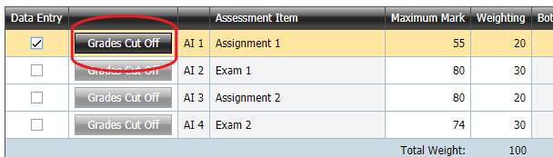

- A popup window will appear. Enter the lowest raw mark for each grade.

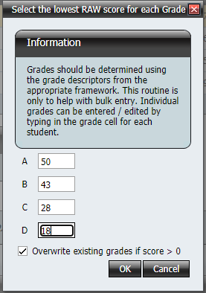

- This will then populate the Grade cells with the desired grades.
- Once you are happy with the grades you must click the Save button to save.

Mark Adjustments and Special Provisions
Markbook has the facility to adjust assessment item marks in line with current BSSS guidelines for the following
- Lateness
  - Days less than 7.
  - Days less than 7 resulting in a notional zero.
  - Days greater than 7 resulting in a notional zero.
- Academic Integrity
- Non-submission
- Estimate

Colour Code for Mark Adjustments and Special Provisions
Red – not submitted (notional zero and not counted for 70% assessment requirement)
Purple – Late
Blue – Estimate
Orange – Insubstantial (notional zero and not counted for 70% assessment requirement)
Aqua – Academic Integrity
Green – Temporary
Brown – Adjusted unit score
Pink – Special Provisions
- All adjustments and special provisions are colour coded and when the Markbook is in view mode (not data entry mode), a tool tip is displayed when hovering over the adjusted mark which displays the adjustment type

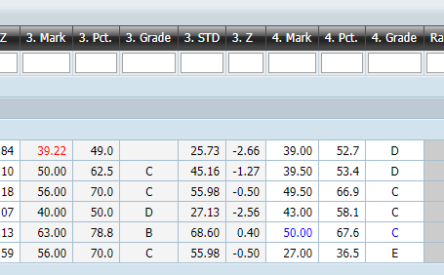

- For any adjustment type notes must be entered in the comments text box

Adjusting an Assessment Item Result
- Click on the Student name hyperlink in either data entry or view mode and the screen shown below should appear
- Where an original score has been entered click on the Edit hyperlink in the assessment item row to adjust the mark for the assessment item
- Where there is no original assessment item result (such as not submitted, estimate) click on Add hyperlink in the assessment item row to adjust the mark for the assessment item

- Select the type of adjustment to be made from the Adjustment Type drop down menu

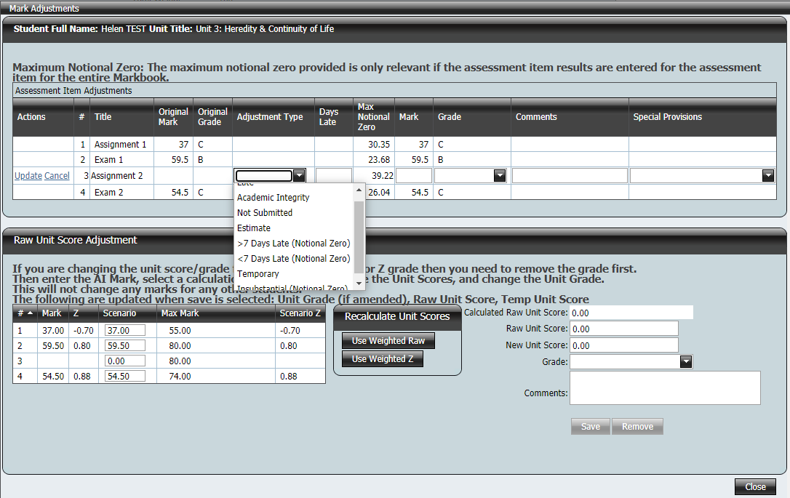

Late (Including <7 Days Late (Notional Zero) and >7 Days Late (Notional Zero)) Penalty
- The non-adjusted mark should be entered through the normal method of entering marks (this example will use Assignment 1 not Assignment 2 as that does not have a mark entered)
- Select Late from the Adjustment Type pull down menu
- Enter the number of days late in the Days Late column and add notes to the comments text box
- Click on Update hyperlink

- For the late penalty, the adjusted mark will be the original mark less a penalty of 5% of the available marks per day late. In this example, the teacher awarded a mark of 37 but was 1 day late. Applying the penalty of 5% of 55 drops the mark to a 34.25. As the work was a low C the teacher judges that the penalty to the grade would make it a D.

- If the number of days late entered is greater than 7 the following error message appears. Use the > 7 Days Late (Notional Zero) option. This will award the maximum notional zero (but can be made lower) as the mark but still counts towards the 70% assessment requirement.

- If the adjusted mark falls below the current notional zero (even if it is less than 7 days late), the following error message appears. As can be seen, applying the policy of 5% of available marks subtracted each day puts the score at 28.75 which is below the maximum notional zero of 30.35. Use the < 7 Days Late (Notional Zero) option. This will award the notional zero (but can be made lower) as the mark but still counts towards the 70% assessment requirement.

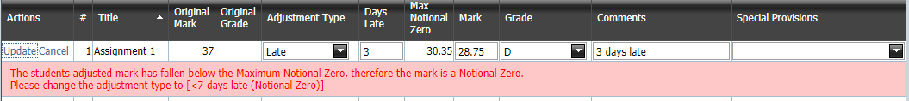

- Click the Close button
- The adjusted mark will be written in purple

Academic Integrity
- Select Academic Integrity from the Adjustment Type pull down menu
- In the Mark column type in the mark using the appropriate penalty from the BSSS policy
- Add notes to the comments text box to explain the reason for the adjustment
- Click the Update hyperlink and the adjusted mark will be saved
- Click the Close button
- The adjusted mark will be written in aqua

Not Submitted (Notional Zero)
- Select Not Submitted from the Adjustment Type pull down menu
- The maximum notional zero value will be placed in the Mark column
- The adjusted score may be changed to a lower score than the max notional zero if this is not appropriate (for instance, in markbooks with few students)
- Add notes to the comments text box to explain the reason for the adjustment
- Click the Update hyperlink and the adjusted mark will be saved
- Click the Close button
- The adjusted mark will be written in red

Estimate
- Select Estimate from the Adjustment Type pull down menu
- The message below appears indicating a suggested estimate. This estimate is purely based on their z-score in all other assessment tasks in this markbook. For this reason it should be modified after all AI results are in and using professional judgement considering past unit performance
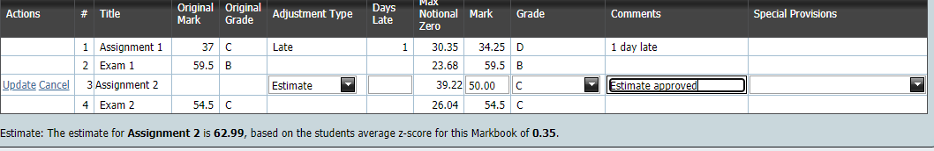

- Enter a mark in the Mark column. In this example, although the markbook suggested a mark of 62.99, the student’s poor result in Assignment 1 and performance in past semesters suggested that this student would have received a score around 50 instead. Ensure you keep a record of how estimates have been calculated.
- Add notes to the comment cell to explain the reason for the adjustment
- Click the Update hyperlink and the adjusted mark will be saved
- Click the Close button
- The adjusted mark will be written in blue

Temporary
To assist with the documentation of assessment results throughout the assessment period an adjustment type of “Temporary” can be used. This is used as a reminder that this result needs to be checked prior to the unit score being calculated.
- Select Temporary from the Adjustment Type pull down menu
- The mark displayed in the Markbook will be the original mark where one was entered
- Add notes to the comments text box cell to explain the reason for the adjustment
- Click the Update hyperlink
- Click the Close button
- The adjusted mark will be written in green

Note: Unit scores will not be calculated if there are any Temporary adjustment types in the Markbook.

Removing Temporary
- Click on the Student name hyperlink in either data entry or view mode
- Where no original score has been entered click on the Remove hyperlink in the assessment item row to remove any record that a temporary adjustment had been applied.

Insubstantial (Notional Zero)
- Select Insubstantial (Notional Zero) from the Adjustment Type pull down menu
- The maximum notional zero value will be placed in the Mark column and the item does not count towards the 70% assessment requirement
- The adjusted score may be changed to a lower score than the max notional zero
- Add notes to the comments text box to explain the reason for the adjustment
- Click the Update hyperlink and the adjusted mark will be saved
- Click the Close button
- The adjusted mark will be written in orange

Special Provisions
Special Provisions are additional to adjustments and it is possible for a student to have both a special provision and an adjustment.
- Click the Special Provisions drop down menu
- Select as many special provisions as are applicable

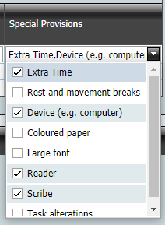
- The cells of the assessment item with special provisions appear highlighted in pink.

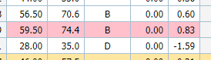

Move assessment item results within the same Markbook
This function is to facilitate moving assessment item results where a student has moved from one unit to another within the same markbook. If a student is moving from a full unit to a half unit, then the assessment item marks that are not specified for the half unit are deleted.
Users will not be able to move assessment item marks (the Move button is disabled) if unit scores have been calculated.

Before assessment item marks can be moved the student must have two records in the Markbook; the old one with marks and the new one without marks as shown.

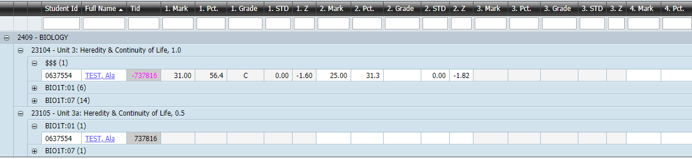

- Open up the Markbook Results and click the Move Results button located just above the markbook grid

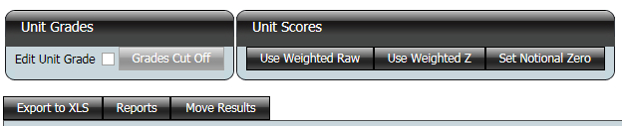

- The screen will show all students who appear more than once in the Markbook
- Click on the plus sign next to the student from whom you will be moving results. Assessment items that are not in a half unit have their cells red.

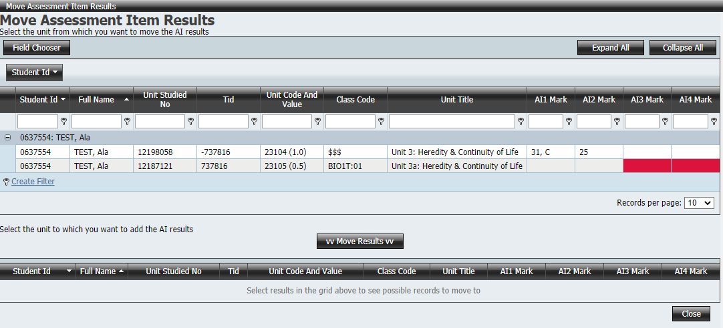

- Select the old unit in the top half of the grid, the new unit will be shown in the bottom grid.
- Click vv Move Results vv button to move the results to the new unit.

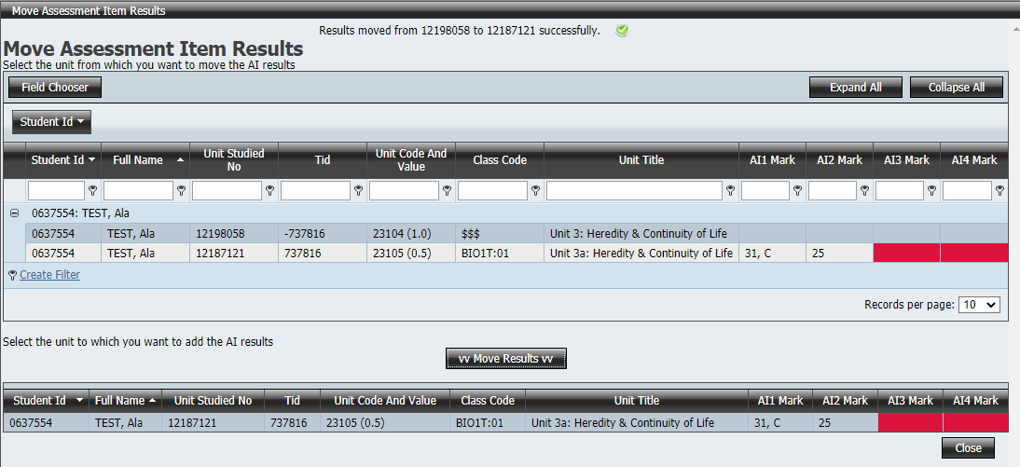

- Click Close to save your changes
- The next time the data sync runs the old unit will be deleted from the database (and Markbook). If your college is not on data sync, ask someone with edit permission to delete the unit studied records from the student’s package.
- Take care as there is no undo.

Unit Scores
T units must have a score. A and M units may have a score calculated to assist in the determination of grades.
Unit scores can only be calculated once all marks are entered for all assessment items and any adjustments added (except Temporary which must be removed). Students awarded status, pending or V grades should be added first (See Entering a V, S or Z Grade for the unit).

Set Notional Zero Button
- In the Markbook Unit Scores section the Set Notional Zero button recalculates any notional zero adjustments in the Markbook to the maximum notional zero value

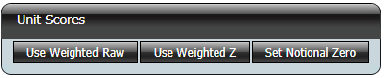

- There can be no missing marks in the Markbook
- When the Set Notional Zero button is pressed notional zeroes are recalculated to the maximum notional zero value based on the current genuine scores.
- Adjustments affected are
  - Not Submitted
  - > 7 Days Late (Notional Zero)
  - < 7 Days late (Notional Zero)
  - Insubstantial
- Assessment item marks now awarded the max notional zero should be reviewed to ensure that this is what was intended. There may be instances where the max notional zero is not awarded such as markbooks with low student numbers.

Calculating Raw Unit Scores
- In the Markbook Unit Scores section use the Use Weighted Raw or Used Weighted Z buttons to calculate the raw unit score.
Weighted Z is recommended for any markbook containing over 10 students (and may even be possible for 5-10 students) as this method will produce scores based on the desired parameters for the markbook which is a prerequisite for statistical meshing. Assessment items with different means and spreads will also be standardised in this method so as to not distort the value of the student’s z-score achievements. There may be instances with smaller markbooks where the Weighted Raw method may be necessary.
- Unit score will not be calculated if there are missing marks or temporary adjustments in the Markbook
- Press save
- The raw unit scores are now in the database and will appear in the Unit Grades and Scores page for the scaling group.
- Raw units scores still need to be backscaled/standardised to the historical values for the scaling group.
- Once scores for this unit/course have been saved to the Temp column in Unit Grades and Scores the Unit Score calculation will be disabled. If there are errors in the data, open up the Unit Grades and Scores the unit is in and using standardise to set the temp scores to zero.
Notes
- If the historical mean and standard deviation are zero, using Weighted Z will result in all students receiving zero
- For more information on scaling groups see 6. Scaling Groups

Adjusting Raw Unit Scores
There must be reasons why a unit score is being adjusted rather than automatically calculated and the method for calculation documented.

- If a student’s raw unit score needs to be adjusted, click on the student name hyperlink in either data entry or view mode. The Mark Adjustment screen will open.
- Under the section Raw Unit Score Adjustment type in the value for the Raw Unit Score. The calculated unit score cannot be changed
- Add a comment to the text box to explain the reason for the adjustment
- Press Save
- If you make a mistake press the Remove button which clears all changes

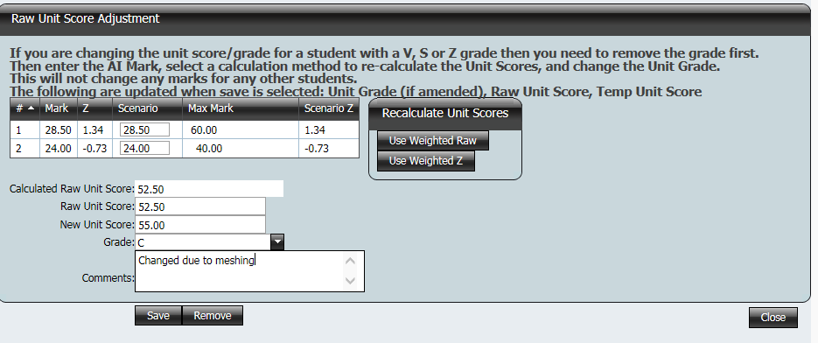

Entering Grades

Entering A – E Grades
There are two primary ways of entering grades through the Markbook. The Edit Unit Grade checkbox and the Grades Cut Off button.

Edit Unit Grade Checkbox
- Grades can be entered in a markbook by checking the Edit Unit Grade checkbox on the Enter Marks page.

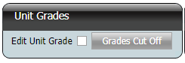

- When the checkbox is ticked, an empty field should appear next to each student and unit grades can now be entered.

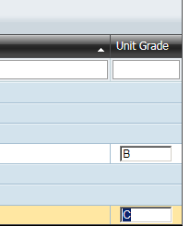

- Click Save to save the unit grades
- Uncheck the Edit Unit Grade checkbox

Grade Cut Off Button
If marks have been entered for each assessment item, unit scores can be generated and grade cut offs used.
- On the Markbook Results page, ensure that all V,S or Z grades have been entered.
- Generate unit scores as detailed above
- Tick the Edit Unit Grade checkbox
- Click the Grades Cut Off button
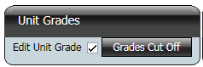

- A popup box should appear where you can enter the lower limit for each grade

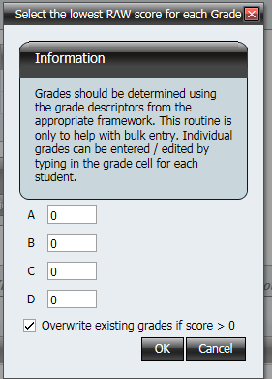
- Click OK and unit grades will appear next to each student following your limits
- Uncheck the Edit Unit Grade checkbox and click Save to save these unit grades.

Entering a V, S or Z Grade for the Unit
- In the Markbook Results screen click on the student name hyperlink to access the Mark Adjustments screen
- Using the grade pull down menu enter the grade for this student.

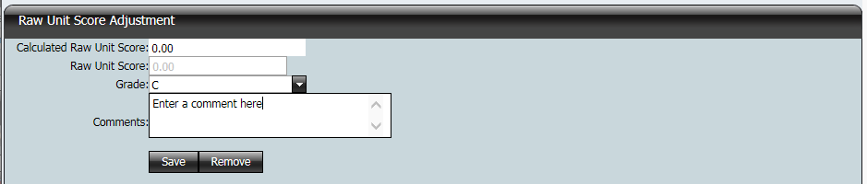

- Add notes to the comments text box to explain the reason for the adjustment
- Note that this student
  - is no longer included in the calculation of z-scores
  - does not have weighted raw scores
  - is not included in the calculation of the Markbook’s assessment item mean and standard deviation

Entering Grades for R units
All R units for both year 11 and 12 could theoretically be in one Markbook. However, the number of students in a Markbook should be considered when creating R unit Markbooks.

- From the Markbook List screen select the Markbook
- R Unit Markbooks do not require any assessment items
- In the Actions column click on Enter Marks hyperlink and the following screen opens

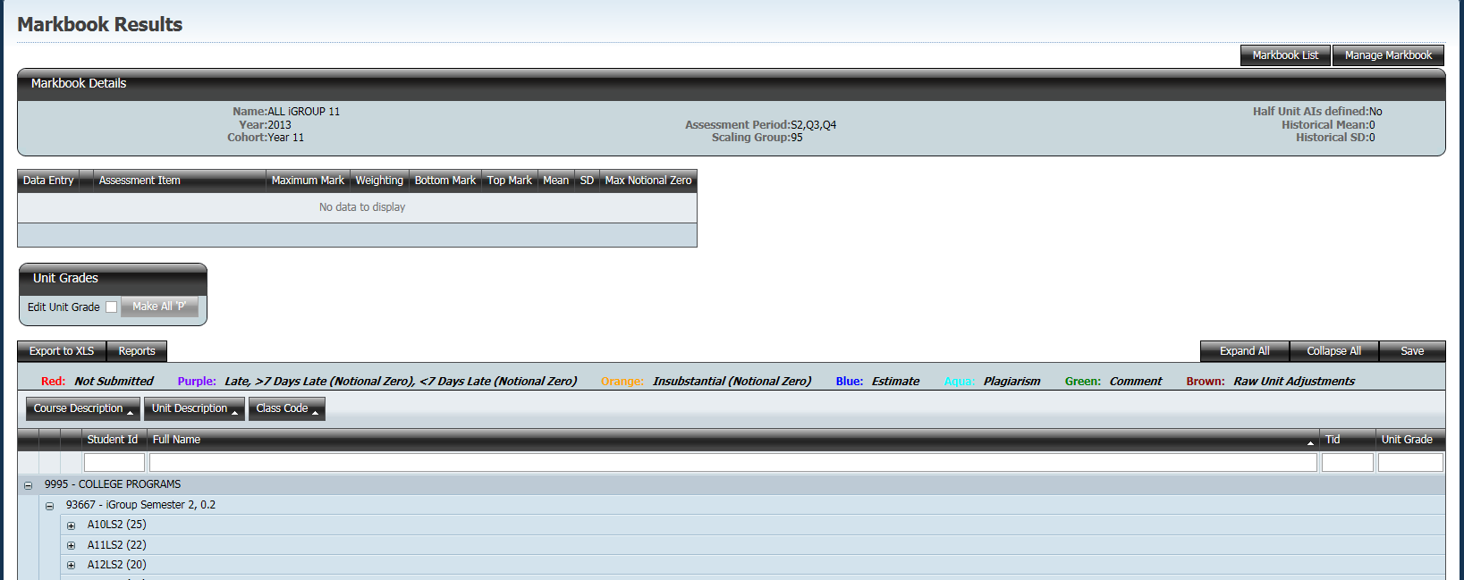

- Under the Unit Grade section click in Edit Unit Grade check box. This will enable the Make All ‘P’ button
- Clicking this button awards the P grade to all students. It will overwrite any existing grade. You can still change the grade by clicking in the cell

Copy a Markbook

Copying a Markbook provides a facility to quickly generate Markbooks for a new assessment period. In the Markbook List check the Markbook Copy checkbox, select the Markbook(s) to be copied and click the Copy button.

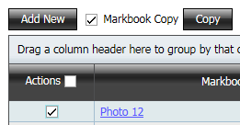

Specify the new assessment period as shown below.

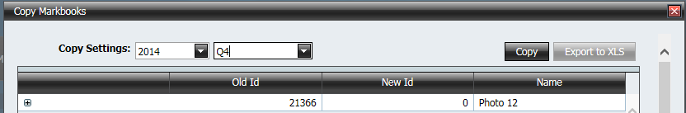

Once the Markbook has been copied check the items which have been successfully copied.

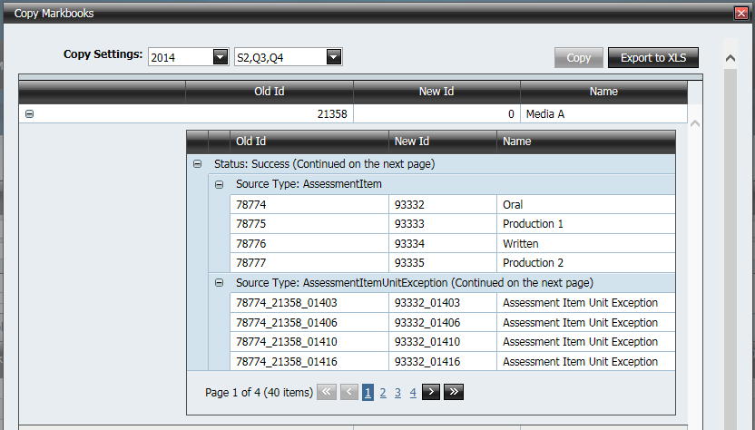

The new Markbook will have the same units and assessment items. Units will not copy if they are already allocated to another Markbook in the new assessment period. Student enrolments in the new assessment period will appear in the new Markbook. The new Markbook will need to be edited to ensure the AI’s total marks and weightings are correct.

