Introduction, My Profile and Logging in to the

ACT Certification System (ACS)

April 2024

Table of Contents
The ACT Certification System (ACS) 3
System Description 3
Central Database 3
Logging onto ACS 3
Problems with Logon 3
Login failed - incorrect user name or password 3
Forgotten Password 4
Lock Out 4
Change Password 5
Change Password fails 5
Change Password Successful 5
Logout of ACS 5
Automatic Logout 5
My Profile in ACS 6
General Usage 7
Manipulating Grids in ACS 7
Sorting 7
Filtering 7
Grouping 7
Reordering Columns 8
Adding a Column 8
Removing a Column 9
Saving Your Data in ACS Using a Web System 9
Setting the Screen 9
Whole Screen View 9
Setting Screen Zoom 9
Task Bar 9
Use of the Mouse 9
Hyperlinks 9

The ACT Certification System (ACS)

System Description
The purpose of the ACT Certification System (ACS) is to provide data to facilitate the certification of senior secondary students in the ACT. All data for students in years 11 and 12 is stored in a central database. This data is processed at the end of the year for the graduating cohort to produce scaled course scores, ATAR and certificates. Vocational qualifications are produced for students in years 10, 11 and 12.

Central Database
ACS is a web application using one centralised database. Data is entered and edited through the application by users in colleges or “swept” in from the schools’ administration system. Data from all colleges exists within this database. Once data is entered into the database by colleges or OBSSS, all users who are authorised will see the data immediately.

Logging onto ACS
- Log on to your school network and connect to the internet through your browser
- Type in the internet address for ACS, https://acs.bsss.act.edu.au
- A logon box should appear and look similar to this

- Enter your user name and password and the home page below will appear

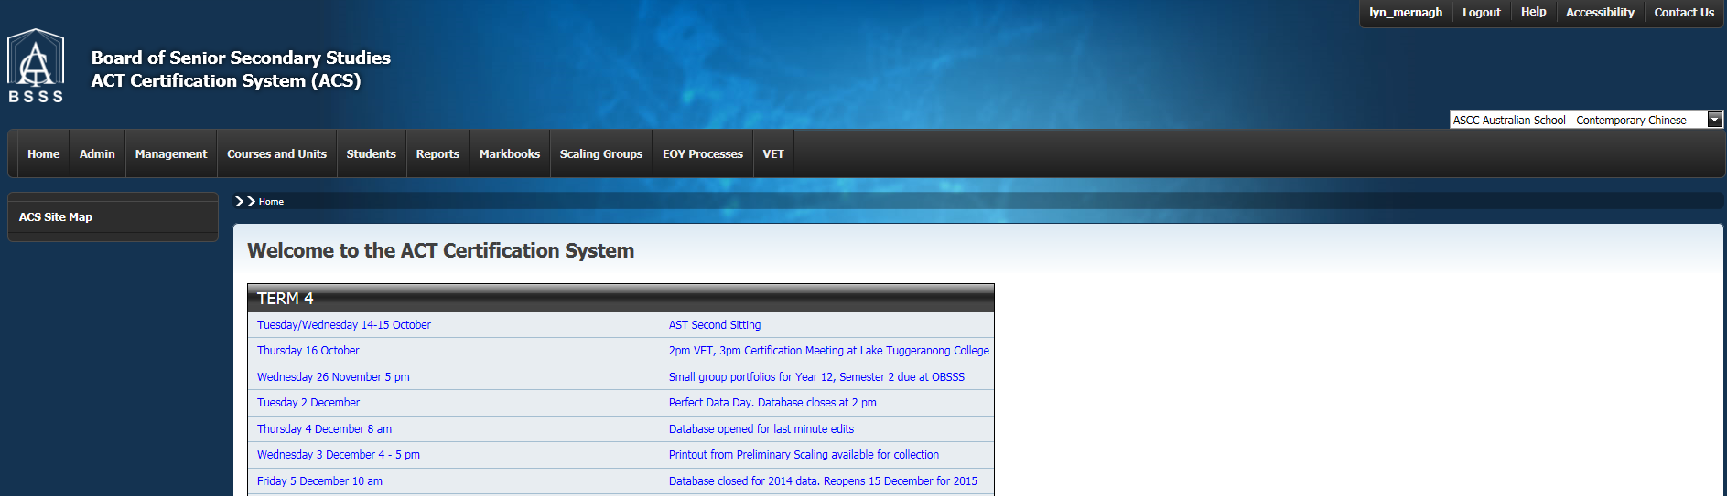

Problems with Logon

Login failed - incorrect user name or password
- If login fails due to an invalid User Name, the Login window is re-displayed with an error message as shown below
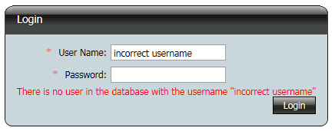
- Re-enter your User Name and Password
- Select the Login button
- The User Name is not case sensitive
- The Password is case sensitive.
- If login fails due to an invalid password, the Login window is re-displayed with an error message as shown below
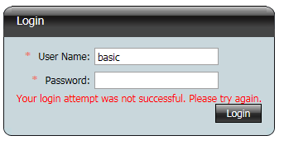

- Re-enter your User Name and Password
- Select the Login button

Forgotten Password
- If you have forgotten your password please contact the BSSS Certification person in your college who will reset your password.

Lock Out
- You will be locked out of the system after 3 failed attempts to login. The following error message will be displayed
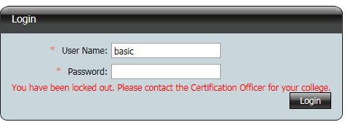

- You will need to contact the BSSS Certification person in your college who will reset your password.

Change Password
- From the menu select Change Password and the screen as shown below appears
- Enter your old password, a new password and verify the new password
- Click on the Change Password button.
- Password requirements are
  - Minimum length of 7 characters
  - At least one non alpha-numeric character (for example !@#$%^&*)

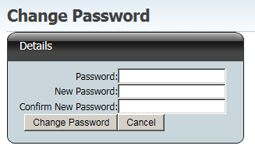

Change Password fails
- If changing your password fails, the Change Password window is re-displayed with all fields emptied and either of the following messages:

Change Password Successful
- If the password has been successfully changed the window below will be displayed.

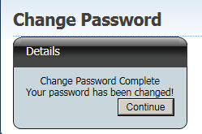

Logout of ACS
- To logout of ACS select the logout link (top right hand corner of the screen). You will be directed back to the login screen.

Automatic Logout
If ACS remains idle for 5 minutes you will be automatically logged out. On the next action you perform you will be directed back to the login screen. After logging in you will return to your last screen. You must return to the home page before continuing to use ACS.

My Profile in ACS

The Admin, My Profile section of ACS shows your personal details, including name and email address as well as what courses you can teach and what subject you will be attending on Moderation Day.

It is important that all teachers update this profile regularly. First and last names will be used on Moderation Day documentation, so please ensure that they are accurate, and not just initials.

If you have an active ACS profile but are not teaching BSSS courses, select ‘Not currently teaching BSSS courses’.

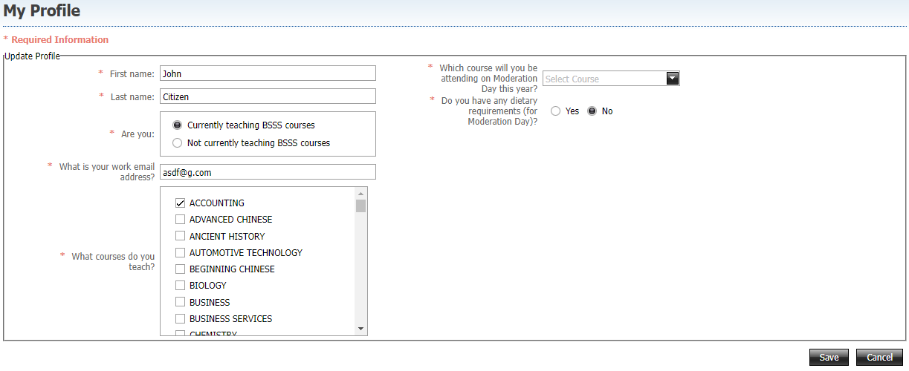
If you have dietary requirements for Moderation Day, please select those so that they can be passed on to the venue. You may select multiple requirements and enter anything not listed under ‘Other Allergies’.
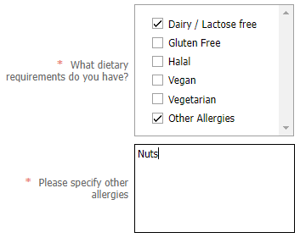

If you will be on leave for Moderation Day, speak to your Moderation Coordinator to apply for attendance exemption.

General Usage

Manipulating Grids in ACS

All grids in ACS can be sorted, filtered and grouped. Columns can be removed and added.

Sorting
This unit lists grid is currently sorted by List Name (ascending). Note the small triangle to the right of List Name.

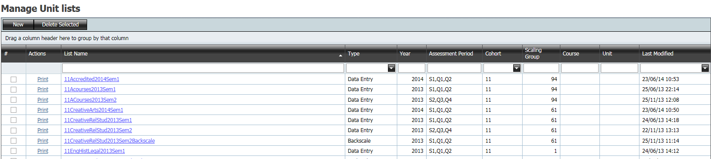

The same list is now sorted by Last Modified date descending. Note the small triangle.

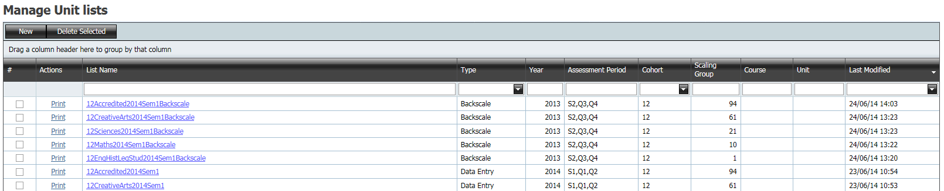

Sorting is applied by clicking anywhere in the column heading. Each time the heading is clicked the sort order is reversed.

Filtering
Filtering is a process to display only those records you are looking for. To filter records type criteria into the filter boxes and then click the Find button. In the example below Markbooks are displayed for 2011 S2, Q3, Q4; Year 11 and scaling group 10. Clicking the Clear button removes the filter criteria.

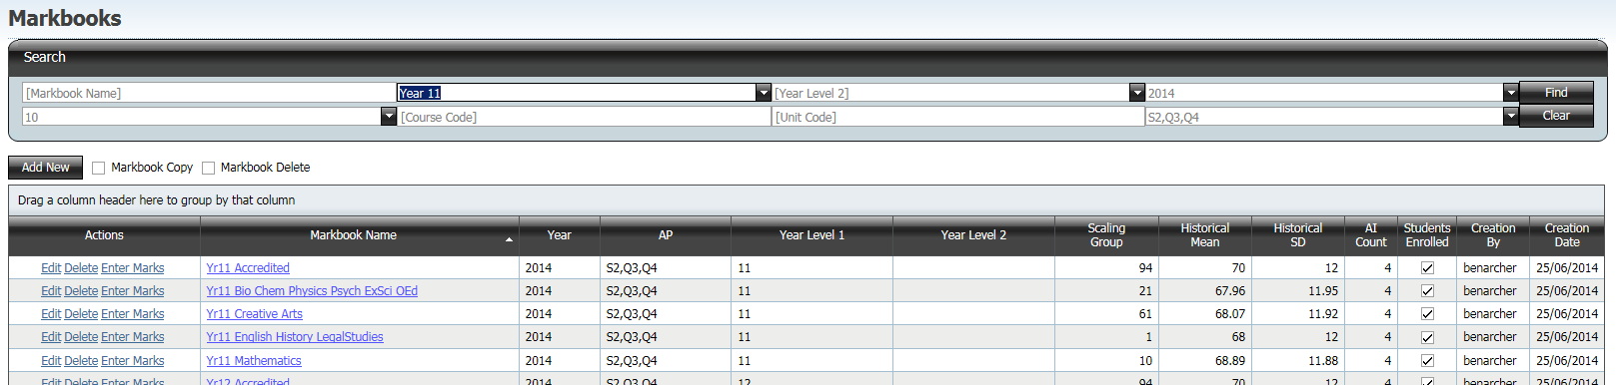

Grouping
Grouping is a process of collecting like records together.
The grid below has no grouping.
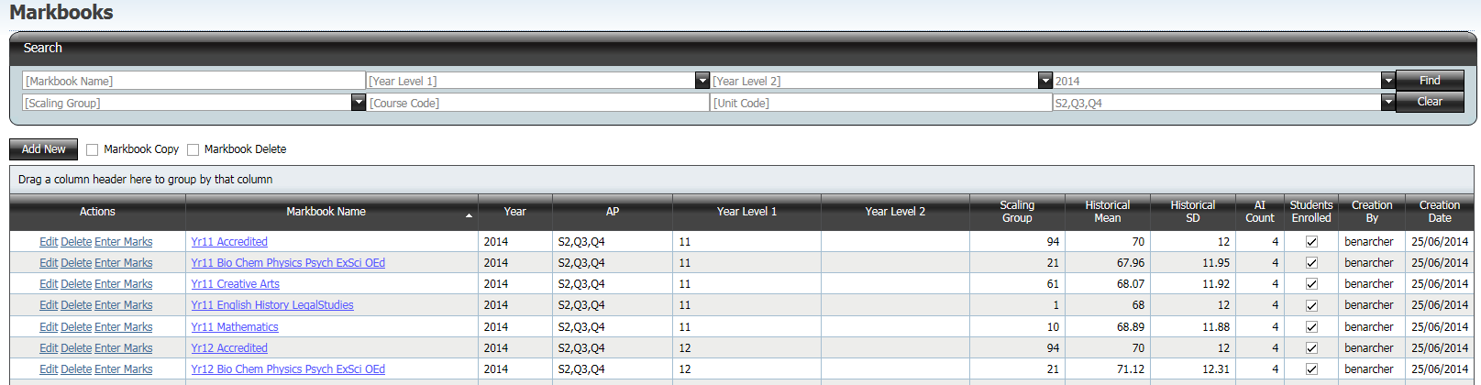
By dragging the Scaling Group column heading to the top of the grid the grid is ‘grouped’ by scaling group. A group can be expanded by clicking on the plus sign.

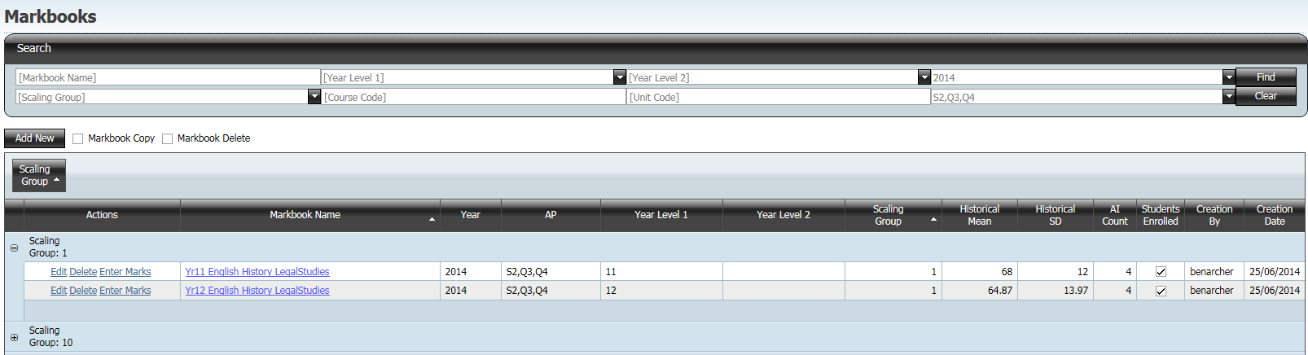

A secondary grouping can be achieved by dragging the Year Level 1 heading to the top of the grid as shown below.

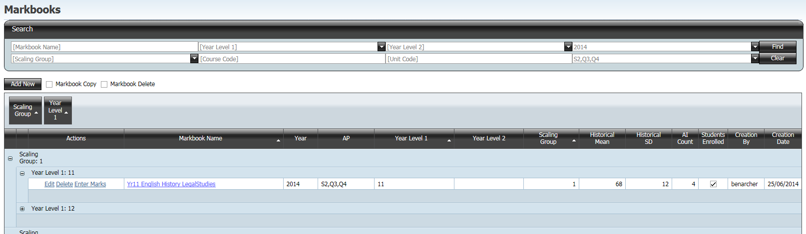

To remove the groupings drag the column heading back to where they were.

Reordering Columns
Columns can be reordered by dragging the column heading to a new position. In the example below Year Level 1 has been moved to the left.

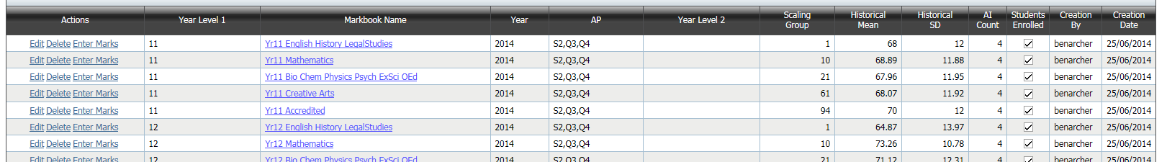

Adding a Column
In some grids extra columns may be added by clicking the Field Chooser button at the top left of the grid. This opens the Field Chooser dialogue.

Drag the required column header from the Field Chooser dialogue to the header row to add the column.
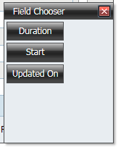

Removing a Column
To remove a column drag the unwanted column header from the header row back to the Field Chooser dialogue.

Saving Your Data in ACS Using a Web System

Setting the Screen
ACS has been designed for a minimum screen resolution of 1280 x 1024 pixels. If the screen resolution is less than this, then items will extend past the screen. Check the screen resolution by viewing the Properties of the screen. (Right click on the desktop)

Whole Screen View
Press F11 to maximise the browser view to full screen. On ACT government machines F11 may start the Hypersnap program. If this occurs exit Hypersnap and press F11 again to maximise your browser.

Setting Screen Zoom
The zoom setting is set by holding the control key (Ctrl) and
- rotating the mouse wheel or
- pressing the plus (+) or minus (-) keys

Task Bar
If the task bar at the bottom of the screen is too high then some items in the ACS software may be off the screen. Reduce the height of the task bar.

Use of the Mouse
In ACS there is no functionality provided by right clicking or double clicking the mouse. The mouse is used to select items, and then action buttons must be clicked to perform operations. Do not use the mouse scroll wheel to scroll as this will change values in the selected data field.

Hyperlinks
Hyperlinks provide easy access to some parts of the application. Hyperlinks in ACS are indicated by underlined text and appear in blue. Click on a hyperlink to be taken to the linked part of the application. To return to the part with the link click the back arrow in the browser. Note that leaving a page in the application using a hyperlink will not save any unsaved changes that have been made. Links that have been used are indicated in grey as shown.

